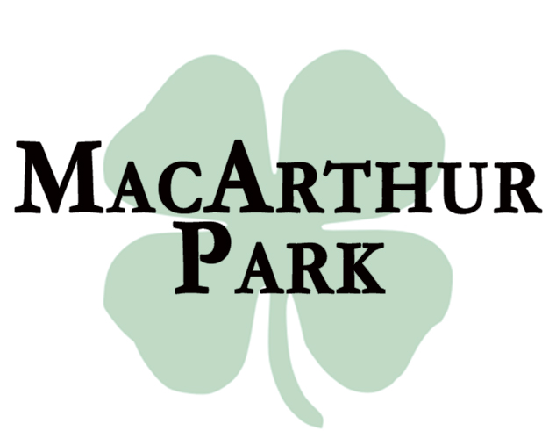

BRUNCH MENU
SUNDAY 11 AM TO 3 PM

Eggs Any Style 13.95  Three eggs cooked to your liking served with sliced steak, bacon or sausage,  home fries and toast  Three Egg Omelet 14.95  Served with home fries and toast  Choose three from the following:  Peppers  Onions  Tomatoes  Mushrooms  Spinach  Bacon  Sausage  Swiss Cheese  American Cheese  Mozzarella Cheese  $1.00 each additional ingredient  The Mex Omelet 14.95  Avocado, jalapeno,  red onion and cheddar jack cheese  served with  home fries and toast  Philly Cheesesteak Omelet 14.95  Shaved steak, onions  and mozzarella cheese  served with home fries and toast  The BEC Sammy 13.95  Bacon, egg and American cheese  on a Kaiser roll  served with fries or home fries | Eggs Benedict or Florentine 14.95  Two poached eggs on a toasted English muffin with your choice of Canadian bacon, or sauteed spinach topped with hollandaise sauce and served with home fries  Pancakes 13.95  Stack of three, choice of original, blueberry or strawberry served with bacon or sausage  French Toast 13.95  Batter dipped thick cut challah bread with cinnamon and powdered sugar  served with bacon or sausage  Coffee 1.75  Tea 1.50  Cappuccino 4.00  Espresso 2.50  Bloody Mary 10.00  Mimosa 9.00  Screwdriver 9.00  Sangria 11.00

18% Gratuity Added For Parties of 6 or More
Appetizers  Pretzel Bites 12.95  Warm bite sized pretzel with  honey mustard and spicy cheese dipping sauces  Wings 12.95  Buffalo, BBQ, Thai Chili  or Kung Pao  Spinach and Artichoke Dip 12.95  A creamy blend of cheeses with tri color tortilla chips  Irish Nachos 11.95  Fried potato chips piled high with Dublin cheddar, bacon, scallions and sour cream  Sliders 12.95  Three mini cheeseburgers  with matchstick fries  Potato Skins 10.95  Loaded with cheddar jack and bacon  Signature Tid-Bits  Served with fries or rings  Steak Tid-Bits 17.95  Grilled sliced steak served on garlic bread topped with mozzarella cheese  with bbq dipping sauce  Chicken Tid-Bits 16.95  Grilled marinated chicken served on garlic bread topped with mozzarella cheese  With horseradish dipping sauce  Burger 13.95  ½ Pound 100% Angus Beef  Served on a sandwich size English muffin or roll with fries and rings  Choice of Cheese  American, Cheddar, Swiss, Mozzarella  or Bleu Cheese  Build Your Own Toppings 1.50 each  Applewood Smoked Bacon  Sauteed Mushrooms  Sauteed Onions  Fried Onions  Fried Egg  Avocado | Salads  Classic Ceasar Sm 10.95/Lg 13.95  Crisp romaine, parmesan croutons  and creamy caesar dressing  Goat Cheese Sm 13.95/Lg 15.95  Candied pecans, dried cranberries and goat cheese in a raspberry vinaigrette with a cabernet poached pear  Mac Park Chopped Sm 12.95/Lg 14.95  Romaine, fresh mozzarella, roasted peppers, raisins and walnuts chopped  in a honey balsamic dressing  Wraps & Paninis  Served with fries or rings  Roast Beef Melt 14.95  Thinly sliced roast beef with mozzarella  on garlic bread served with Au Jus  Crunch Chicken Wrap 14.95  Fried chicken tenders, bacon,  field greens and cheddar  with ranch dressing  Buffalo Chicken Wrap 14.95  Fried chicken tenders, hot sauce  with bleu cheese dressing,  lettuce and tomato  Pesto Chicken Panini 15.95  Grilled pesto marinated chicken,  roasted pepper, fresh mozzarella  with chipotle mayo  Grilled Eggplant Panini 14.95  Grilled eggplant, roasted pepper,  fresh mozzarella  with roasted pepper sauce  Grilled Chicken Wrap 14.95  Grilled chicken, fresh spinach,  roasted pepper, fresh mozzarella  with Italian dressing  Mac Park Chicken Sandwich 15.95  Grilled chicken, Swiss cheese and bacon on garlic bread with horseradish sauce

