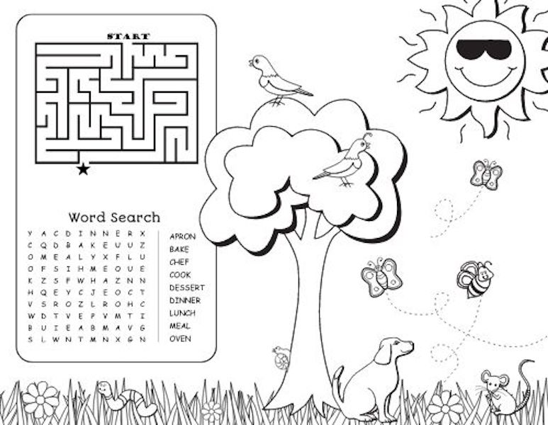
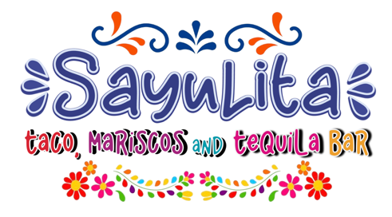
Kids Steak Taco $8
Served with rice and beans
Kids Cheese Quesadilla $6
Served with rice and beans
Kids Fish Tenders $8
Served with fries
Kids Chicken Nuggets $6
Served with fries

