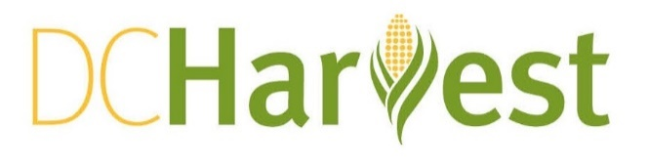
FALL Event Menus
All prices will have 10% tax and 20% gratuity added
Menus are subject to seasonal changes
OPTION #1/$30 per person
Appetizers
DC grown shoots salad | concord grapes | candied smoked nuts | blue cheese | sherry vinaigrette

DCH cherry wood smoked bacon & asiago "doughnuts" | creole mustard

Entrees
crispy quinoa cakes | seasonal vegetables | roasted beet puree | goat cheese

smoked chicken breast | crispy smoked paprika potatoes

Add dessert $7 per person
S’mores chocolate pot du crème | dark chocolate custard | toasted house-made marshmallow | graham cracker cookie

OPTION #2/$40 per person
Appetizers
DC grown shoots salad | concord grapes | candied smoked nuts | blue cheese | sherry vinaigrette

DCH cherry wood smoked bacon & asiago "doughnuts" | creole mustard

local oysters on the half shell | seasonal mignonette
Entrees
crispy quinoa cakes | roasted beet puree | goat cheese

smoked chicken breast | crispy smoked paprika potatoes

whole wheat pappardelle | mom's short rib bolognese | kale | toasted garlic bread crumbs

Add dessert $7 per person
S’mores chocolate pot du crème | dark chocolate custard | toasted house-made marshmallow | graham cracker cookie

OPTION #3/$50 per person
Appetizers
DC grown shoots salad | concord grapes | candied smoked nuts | blue cheese | sherry vinaigrette

local oysters on the half shell | seasonal mignonette

artisan cheese plate | concord grapes | DCH sour pickle | smoked nuts | whole grain toast
Entrees
smoked chicken breast | crispy smoked paprika potatoes

spinach rigatoni | honey nut squash | smoked broccoli | shitake | sage brown butter | parmesan

grilled lamb paillard | roasted cabbage slaw | garden beans | lemon | honey | crispy chickpeas

Add dessert $7 per person
plum meyer lemon ice box cake | meyer lemon mousse | gluten free ladyfingers |
plum jam | thai basil

OPTION #4/$60 per person
Appetizers
artisan cheese plate | concord grapes | smoked nuts | DCH sour pickle | whole grain toast | olive tapenade | bacon shallot | dried plum compote

DCH cherry wood smoked bacon & asiago "doughnuts" | creole mustard

beet cured coho salmon gravlax | zucchini pickles | dill crème fraiche | whole wheat crackers
Entrees
smoked chicken breast | crispy smoked paprika potatoes

cornmeal encrusted chesapeake blue catfish | young bok choy | wild rice |
toasted walnut romesco

grilled sirloin cap steak | red quinoa | smoked broccoli | onion herb cream sauce

Add dessert $7 per person
plum meyer lemon ice box cake | meyer lemon mousse | gluten free ladyfingers |
plum jam | thai basil

