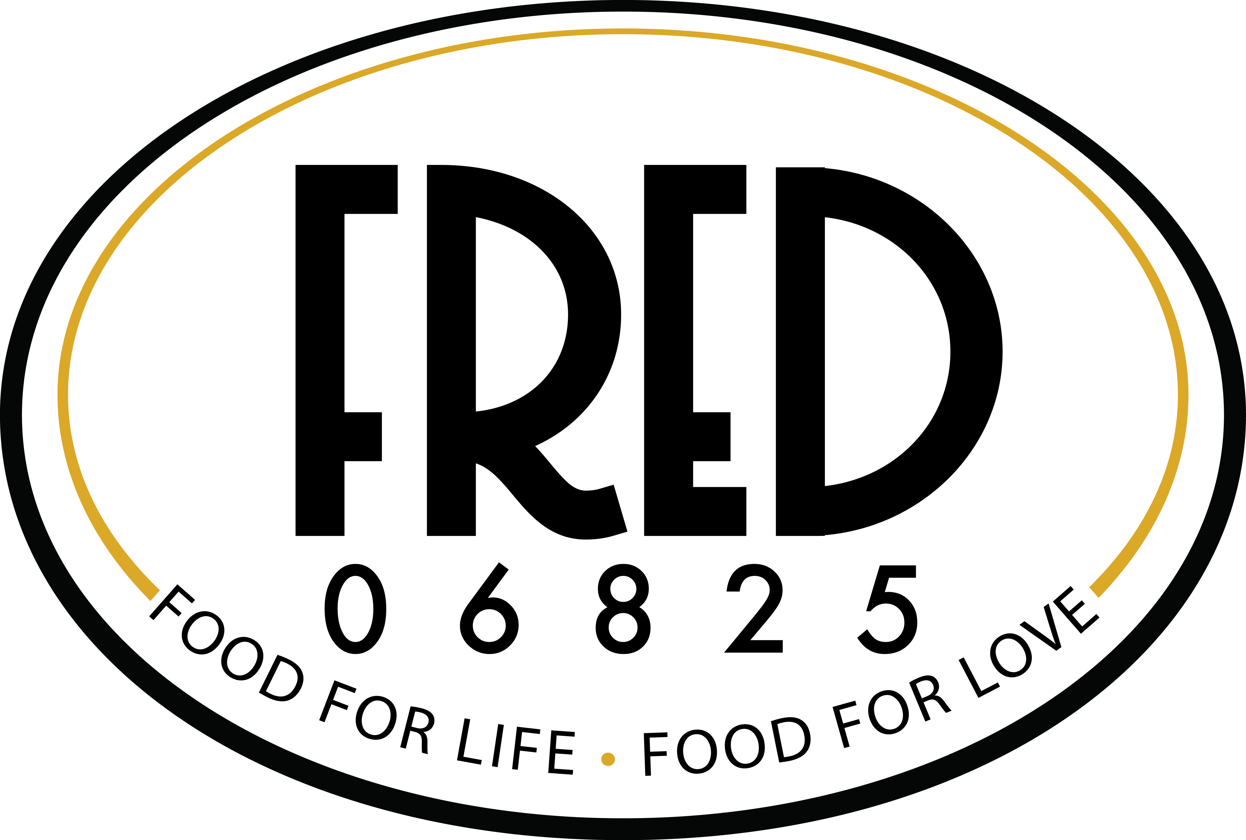

www.FREDSFOODCT.COM

CATERING MENU

Hors D’oeuvres

Minimum Hors d’oeuvres Order is 3 Dozen - Each Hors D’oeuvres are priced per Dozen
Tuscan Bruschetta $18.00
sundried tomatoes, artichokes, olives, zucchini, yellow squash, olive oil, & garlic served on focaccia toasts
Chicken Yakitori $20.00
tender chicken breast served on mini skewers with scallions and sesame seeds, marinated in a soy glaze
Sesame Shrimp Toast $24.00
shrimp, scallions, ginger, and garlic deep-fried to a golden brown, served with a sweet chili sauce
Mini Homemade Pizzas $18.00
a variety with goat cheese, asparagus, roma tomatoes
Homemade Potato and Zucchini Pancakes $18.00
freshly grated yukon gold potatoes, crisp zucchini and onions, fried until golden brown and served
with sour cream and caviar
Scallops Wrapped in Bacon $27.00
large diver scallops wrapped in maple glazed bacon and dusted in brown sugar
Kyoto Beef Rolls $27.00
tenderloin of black angus beef wrapped around scallions, marinated in mirin sauce, garnished with
white and black toasted sesame seeds
Indonesian Chicken Satays $20.00
skewered on lemon grass, marinated in garlic, cumin, soy sauce, ginger & lime with a
peanut butter dipping sauce
Swedish meatballs $18.00
served in a sour cream bordelaise sauce
Mini Chicken Saltimbocca $20.00
boneless chicken skewered with prosciutto and fresh sage served with garlic aioli
Miniature Maryland Crab Cakes $28.00
made from blue crab, fresh white bread crumbs, old bay seasoning, sautéed until golden brown,
and served with an avocado salsa
Steamed Pork Dim Sum $20.00
served with soy glaze
House made Mini Cocktail Franks $20.00
wrapped in a flaky puff pastry
Norwegian Salmon Satay $25.00
fresh salmon strips marinated in yogurt, ginger, lime juice, and scallions, grilled and
served with ginger lime mayonnaise
House Cooked Shrimp Cocktail $36.00
with housemade cocktail sauce
Smoked Salmon $30.00
served on cocktail breads with herbed cream cheese, capers and bermuda onion
Coconut Crusted Shrimp $36.00
with sweet chili dipping sauce
Prosciutto de Parma $ 28.00
wrapped melon balls on skewer
Shrimp and Goat Cheese Quesadillas $28.00
with mango poppy dip
Pepper Crusted Filet $32.00
with goat cheese on grilled garlic crostini
Mini Quiche $20.00
delicious custard filling in a flaky crust

S A L A D S & V E G E T A B L E S

Antipasto $4.95 per person
assortment of Italian meats, cheeses, olives, roasted peppers, marinated artichoke hearts and mushrooms
Tossed Field Greens Salad $3.95 per person
with alfalfa sprouts, cherry tomatoes, carrot curls and cucumbers. choice of 2 dressings
Caesar Salad $4.95 per person
romaine, brick house croutons and parmesan in a classic caesar dressing
Caesar Salad with Grilled Chicken $8.00 per person
grilled chicken, romaine, brick house croutons, parmesan in a classic caesar dressing
Caesar Salad with Grilled Shrimp $12.00 per person
grilled shrimp, romaine, brick house croutons, parmesan in a classic caesar dressing
Cobb Salad $9.00 per person
grilled chicken, bacon, blue cheese, hard-boiled eggs, tomatoes and romaine tossed in a sherry vinaigrette
Nicoise Salad $10.00 per person
fresh tuna, mesclun greens, green beans, hard-boiled eggs, tomatoes, potatoes, peppers and olives in a mustard vinaigrette
Grilled Vegetable Napoleon with Fresh Mozzarella $9.00 each
grilled veggies stacked with fresh mozzarella

P L A T T E R S
Fresh Fruit Platter - $4.00 per person
An array of seasonal fruits and berries
International Cheese Display $7.00 per person
imported cheeses served with baguettes, Carr’s water crackers, and garnished with fresh fruits of the season
Hummus de Tahini $ 35.00 PLATTER (12 people)
a blend of chick peas, garlic, lemon juice, parsley, and tahini sauce, served with lavash crackers
Crudite of Crisp Garden Vegetables - $5.50 per person
broccoli, cauliflower, grape tomatoes, Belgian endive, & vegetables of the season served with
Chef’s special dips

S P E C I A L T Y E N T R E E S
Herb Crusted Beef Tenderloin $175.00 (15- 20 people)
roasted potatoes and horseradish cream
Cedar Plank Salmon (whole) $150.00 (15-20 people)
Israeli couscous salad, grilled asparagus and dill cream sauce

F A V O R I T E S
♦Vegetable Stir Fry ♦ Rice & Orzo Pilaf ♦ Manicotti ♦ Stuffed Shells ♦ Baked Ziti
♦ Roasted Red New Potatoes ♦ Creamy Mashed Potatoes
½ Pan $35.00 / Full Pan $65.00

♦ Vegetable Lasagna
½ Pan $38.00 / Full Pan $70.00

♦ Penne Alla Vodka
½ Pan $40.00 / Full Pan $75.00

♦ Chicken Marsala, Franchese, Piccata or Chasseur
♦ Meatball Marinara ♦ Sausage & Peppers
½ Pan $45.00 / Full Pan $90.00
Kiddush
We’re experts in planning for your Big Event. From sundown to sun up, let us be your guide to …
♦ Shabbat Dinner Menus ♦ Oneg Shabbat Menus ♦ Kiddush Menus ♦ Extended Kiddush Buffets
♦ The Out of Towner’s Sunday Brunch!

FRED 06825
WWW.FREDSFOODCT.COM
203-612-6597

