Temperature Holding
Meat should be held in a 150 degree oven (or the warm setting) until just before carving.

Brisket Carving
Place brisket on a large cutting board and use a long, serrated knife to carve

Identify the Point vs. the Flat

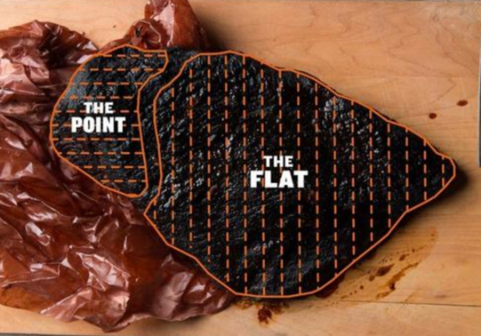
Cut the brisket in two pieces, separating the Point from the Flat
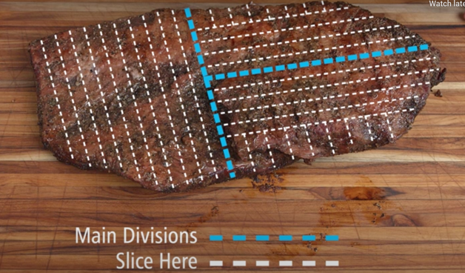
Slice the Flat on an angle against the grain in ¼ inch thickness

Trim the fat from the Point

Optional: Carve off the ridge and tip from the Point for Burnt Ends

Divide the Point in two pieces, slicing in half lengthwise

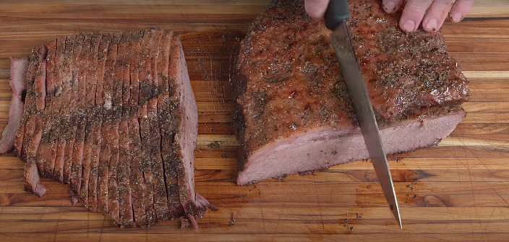

Each half of the point should be carved in 3/8 inch slices against the grain

