CATERING MENU

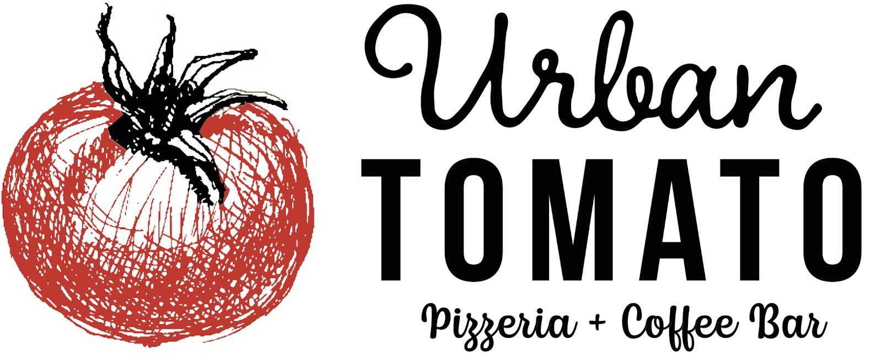

Palisades Park, NJ 201-346-4600
Edgewater, NJ 201-941-5001
urbantomato@icloud.com

PIZZA 16 INCH (8 Slices)
MARGERITA $21
House made fior Di latte, mozzarella, and basil

Spicy Honey $21
Provolone béchamel, Mikes Hot Honey, parmesan reggiano

Fungi $25
Mozzarella, Provolone Béchamel, shiitake mushrooms, truffle oil, parmesan reggiano

Buffalo Chicken $25
Tomato sauce, spicy chicken, blue cheese,

Parma $21
Tomato sauce, gorgonzola, mozzarella, parmesan reggiano

Artichoke Pizza $25
Mozzarella, Artichoke béchamel, artichoke, parsley, lemon

Vegetable Pizza$25
Mozzarella, Roasted eggplant, kale, olives, onion, arugula, parmesan reggiano

Kale & Sausage $25
Provolone béchamel base

Brushetta Pizza $24
Tomato Sauce, mozzarella, chopped tomato, garlic oil EVVO

Super Supreme Combination$27
Pepperoni, sausage, onion, pepper, olives, shitake, extra mozzarella

SALADS + BOWLS SM LG
Kale Caesar Salad $35 $65
(Choice of Kale or Romaine)
Chopped Salad $35 $65
(Mixed greens, tomato, onion watermelon radish vinaigrette)
Shawarma Bowl $60 $100
(Chicken, arugula, kale, quinoa, cherry tomato, tahini dressing)
Buratta Salad $60 $100
(Arugula, tomato, honey, pistachios, vinaigrette)

SIDES SM LG
Brussels Sprouts $45 $65
Broccolini $50. $100
Eggplant & Tomato Sauce $45 $65
Spicy Honey Chicken $50 $90
(Mikes Hot Honey)
Buffalo Wings $55(40pc) $100(80 pc)
Meatballs $65 $120

SANDWICHES
Burger Sliders $50(12) $100(24)
(Special sauce, pickles, onion, American cheese,seeded bun)
Buffalo Chicken Sliders $40 (12) $80(24)
(Buffalo sauce,mozz, pickled onion, tomato, seeded bun)
Panini or Wraps. $50 $100
(Assorted sandwiches or wraps)

PASTA & PROTEIN
Penne Vodka $50 $100
Pasta lamb ragu $75 $150
Mac & Cheese (Shitake mushroom & truffle oil) $60 $110
Chicken Parmesan $60 $120
Bucatini Caccio e peppe $50 $100
Chicken Francese $60 $120

*small feeds 5-6 people
*large feeds 10-12 people

