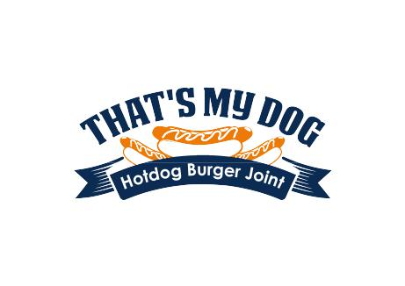
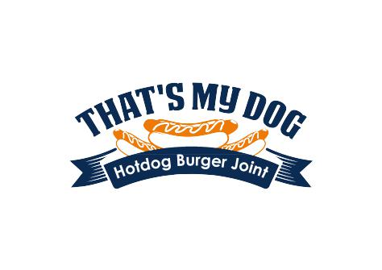
JOB APPLICATION

That's My Dog
125 West Chestnut St, Jeffersonville, Indiana 47172

812-725-8175

That's My Dog is an equal opportunity employer. This application will not be used for limiting or excluding any applicant from consideration for employment on a basis prohibited by local, state, or federal law. Should an applicant need reasonable accommodation in the application process, he or she should contact a company representative.

Please fill out all of the sections below:

Applicant Information

Applicant Name:

Address:

City, State and Zip Code:

Telephone Number:

Email Address:

Date of Application:

Employment Position
Position(s) applying for: Dog Handler

How did you hear about this position?

What days are you available for work?

What hours or shift are you available for work?

If needed, are you available to work overtime?

On what date can you start working if you are hired?

Salary desired:

Personal Information

 | Have you ever applied to or worked for That's My Dog before? |  | Yes | No
 | If yes, when?
 | Do you have any friends, relatives, or acquaintances working for That's My Dog |  | Yes | No
 | If yes, state name & relationship:
 | Are you 18 years of age or older? |  | Yes | No
 | Are you a U.S. citizen or approved to work in the United States? |  | Yes | No
 | What document can you provide as proof of citizenship or legal status?

Do you have any condition which would require job accommodations? Yes No

If yes, please describe accommodations required below.

Job Skills/Qualifications
Please list below the skills and qualifications you possess for the position for which you are applying:

(Note: That's My Dog complies with the ADA and considers reasonable accommodation measures that may be necessary for eligible applicants/employees to perform essential functions. )

Education and Training

High School
 |  |  | Name |  |  |  |  |  | Location (City, State) |  |  |  |  | Year Graduated |  |  |  |  | Degree Earned
College/University
 |  | Name |  |  |  |  |  | Location (City, State) |  |  |  |  |  | Year Graduated |  |  |  |  | Degree Earned
Vocational School/Specialized Training
 |  | Name |  |  |  |  |  | Location (City, State) |  |  |  |  |  | Year Graduated |  |  |  |  | Degree Earned

Military:

Are you a member of the Armed Services?

What branch of the military did you enlist?

What was your military rank when discharged?

How many years did you serve in the military?

What military skills do you possess that would be an asset for this position?

Previous Employment

Employer Name:

Job Title:

Supervisor Name:

Employer Address:

City, State and Zip Code:

Employer Telephone:

Dates Employed:

Reason for leaving:

Employer Name:

Job Title:

Supervisor Name:

Employer Address:

City, State and Zip Code:

Employer Telephone:

Dates Employed:

Reason for leaving:

Employer Name:

Job Title:

Supervisor Name:

Employer Address:

City, State and Zip Code:

Employer Telephone:

Dates Employed:

Reason for leaving:

References
Please provide 2 personal and professional reference(s) below:

Reference | Contact Information

AT-WILL EMPLOYMENT

The relationship between you and the That's My Dog is referred to as "employment at will." This means that your employment can be terminated at any time for any reason, with or without cause, with or without notice, by you or the That's My Dog. No representative of That's My Dog has authority to enter into any agreement contrary to the foregoing "employment at will" relationship. You understand that your employment is "at will," and that you acknowledge that no oral or written statements or representations regarding your employment can alter your at-will employment status, except for a written statement signed by you and either our Executive Vice-President/Chief Operations Officer or the Company's President.

Applicant Signature: Dated:

