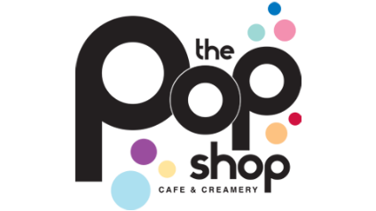
Winter Specials!

Peppermint Marshmallow Hot Chocolate 4.99
Hot chocolate topped with a homemade peppermint marshmallow, topped with whip & chocolate drizzle.
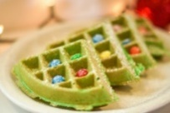
Christmas Tree Waffle 7.99
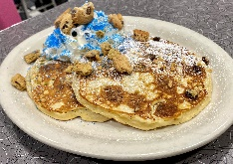
Green Waffle topped with M&M “ornaments” and powdered sugar.

Cookie Monster Bettys 8.99
Our from scratch Bettys filled with cookie dough pieces, topped with whipped cream, chocolate chip cookie crumbles and blue sprinkles!
Lobster Benedict 13.99
English muffin topped with lobster, roasted asparagus & a poached egg, topped with hollandaise, served with hash browns or tots.
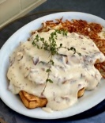
Creamed Chipped Beef 8.99
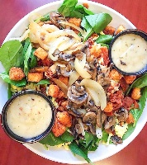
Made to order over choice of toast,
served with hash browns.

Warm Spinach Salad 10.99
Baby spinach, roasted mushrooms, caramelized onions,
hard-boiled egg, blue cheese crumbles, croutons
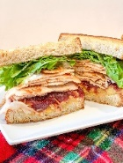
& warm bacon dressing.

Black Friday 12.99
Roasted turkey, stuffing, cranberry sauce, lettuce & mayo grilled on thin sliced sourdough,
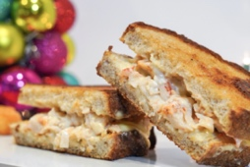
served with a side of gravy, fries or tots.

Lobster Grilled Cheese 15.99
Back by popular demand! Lobster meat, brie & garlic aioli
grilled on thick sliced sourdough, served with fries or tots.
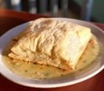
Chicken Pot Pie 13.99
White meat chicken, onions, peas, and carrots, topped with our flaky puff pastry
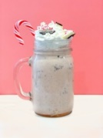
and served with a fresh side salad with tomatoes, onions and balsamic vinaigrette.

Peppermint Oreo Shake 6.99
Peppermint ice cream blended with Oreos, topped with whipped cream, crushed candy canes and a candy cane stirrer!
CHECK OUT OUR NEW BURGERS:

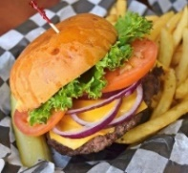
Pop Burger JR 7.99
Not so hungry? A smaller version (4oz) of our 100% beef deluxe burger topped with lettuce, tomato and raw onion, served with fries or tots. Perfect size for our young Pop Shoppers too!
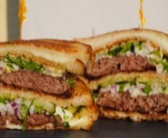
Mac Daddy Grilled Cheese Burger 15.99
A club style burger! Two beef patties topped with cheese sandwiched between two grilled cheeses topped with shredded lettuce, diced onions, pickles and 1000 Island, served with fries or tots & a pickle.

