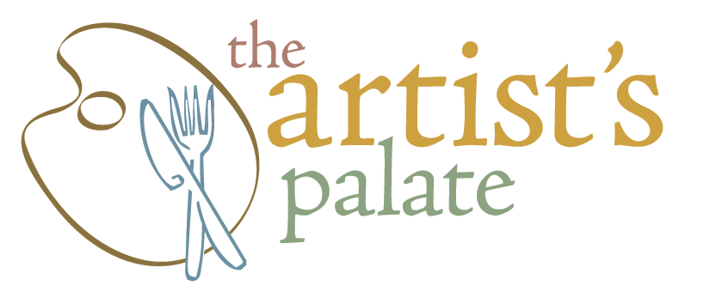

First Course Choice of:

H.F. Kabocha Squash Soup
Apple | Pecan Granola | Maple Cream
Duck Fat Toast
HV Goat Cheese | Roasted Mushrooms | Pecorino | lemon | Arugula | Truffle

Tuna Tataki
Cucumber | Avocado | Kimchee Aioli | Sesame

Hudson Valley Salad
Autumn Greens | Pickled Butternut | Burnt Orange Vinaigrette | Shaved Golden Beets

SECOND COURSE CHOICE of:

House Made Ricotta Dumplings
Tomato | Charred Onion | Local Corn | Pickled Eggplant | Pecorino

Lamb Shank
Hoisin | Baby Bok Choy | Sticky Rice

Pan Roasted Cape Shark / Rock Salmon
Spinach | Bacon | Lentils | Shallot Chimichurri

THIRD COURSE CHOICE OF:

Deconstructed Apple Pie
Puff Pastry | Caramel |Warm Spices | Gelato
~
Pumpkin Bread Pudding
Vanilla | Cognac | Maple | Whip
~

