COCKTAILS
“BALLER” MANHATTAN 16 ST. GEORGE’S BALLER WHISKEY, SWEET VERMOUTH, BITTERS, CHERRY DROP
JAPANESE OLD FASHIONED 15 MARS SHINSU IWAI WHISKY, LUXARDO SYRUP, BITTERS
MUGI NEGRONI 14 MUGI SHOCHU, AMARO, SWEET VERMOUTH, BITTERS
KANPAI 14 SAPPORO (12oz) ACCOMPANIED WITH JAPANESE WHISKEY ‘IWAI’ OR SHOCHU ‘MUGI’
TOKYO TEA 12 OUR TAKE ON THE LONG ISLAND TEA W/ VODKA, RUM, GIN, TEQUILA, TRIPLE SEC, & MIDORI
BOURBON BERRY SMASH 13 BOURBON, BLACK RASPBERRY, LEMON, SIMPLE
IWAI HOT TODDY 13 IWAI WHISKEY, HONEY SIMPLE, LEMON
CORPSE REVIVER 14 GIN, LILET BLANC, TRIPLE SEC, LEMON, SPLASH OF ORANGE JUICE, ABSINTHE RINSE
PECHE PARAIZO 14 VIDA MEZCAL, PECHE LIQOUR, LILLET ROSE, LEMON JUICE
DRAFT BEER
SAPPORO 8 (16oz) // 14 (32oz)
LAGER – USA, 5.0% ABV
ROTATING SEASONAL BEERS (12oz) 8
(ASK SERVER FOR DETAILS)
CANS & BOTTLED BEER
SAPPORO BLACK LAGER (21oz) 12
ORION RICE LAGER (21oz) 14
KIRIN, LIGHT LGER 7
KONA LIGHT, BLONDE ALE 7
WINE
ROUGH DAY ROSE, BULGARIA 9 / 38
CHLOE SAUVIGNON BLANC, NEW ZEALAND 10 / 39
DRESSAGE PINOT NOIR, CALIFORNIA 9 / 35
POEMA CAVA BRUT CHAMPAGNE, SPAIN 10 / 38

HAPPY HOUR
5PM-7PM MONDAY – FRIDAY
$1 OFF BEER / SAKE / SHOCHU
$2 OFF COCKTAILS
$3 OFF WINE

EXCLUDING: DAILY SPECIALS ITEMS &
BUCKET SPECIALS

$1 OFF CALAMARI AND CRISPY PIG EARS
SAKE
CUPS, CANS, & CARAFES
HAKUSHIKA JUNMAI TANUKI CUP (200ML) 12
JOTO ONE CUP ‘GRAFFITI CUP’ (200ML) 12
KUNIZAKARI NIGORI CUP (200ML) 12
SOTO JUNMAI CAN SAKE (180ML) 14
OZEKI CARAFE SAKE (HOUSE SAKE 10oz) 15
(HOT OR COLD)
SAKE BOTTLES
KIKU-MASAMUNE JUNMAI “TARU” 15% ABV (300ML) 38
CEDAR CASK AGED. SAKE FOR THE WHISKEY LOVER
KIKUSUI “PERFECT SNOW” NIGORI GENSHU (300ML) 38
JAPAN’S #1 NIGORI. FINISHES SWEET 21% ABV
TAISETSU “ICE DOME” JUNMAI GINJO (300ML) 41
ITS GENTLE AROMA IS THE PERFUME OF THE WORL AND ITS MELLOW, YET CLEAN FLAVOR IS EARTH’S GIFT TO US ALL.
KIKUSUI JUNMAI GINJO (300ML) 39
A SAKE THAT VODKA AND GIN DRINKERS WILL ENJOY. SHARP AND SMOOTH WITH SWEET FRUIT TONES AND DRY FISHISH.
SUIGEI TOKUBETSU “DRUNKEN WHALE” (720ML) 60 FOR THE SERIOUS SAKE DRINKER. BALANCED AND SMOOTH.
YAKUKAGE TOKUBETSU “SNOW SHADOW” (720ML) 64
SAKE SUNDAYS 25% OFF ALL BOTTLES OF SAKE

JAPANESE WHISKEY
MARS SHINSU IWAI BLACK WHISKY 10
SUNTORY TOKI JAPANESE WHISKY 11
MARS SHINSU IWAI WHISKY TRADITIONAL 12
EISASHIMA AKASHI JAPANESE WHISKY 12
NIKKA COFFEY GRAIN WHISKEY 14
NIKKA COFFEY MALT WHISKEY 16
ICHIRO’S MALT AND GRAIN 18
KAIYO “THE SINGLE” 7-YEAR-OLD, OAK FINISHED 19
WHISKEY WEDNESDAYS $3 OFF
ALL JAPANESE WHISKEY
SHOCHU
YOKAICHI MUGI SHOCHU - BARLEY 9
BENIOTOME SHOCHU - SESAME 11
SATSUMA SHIRANAMI SHOCHU - SWEET POTATO 11
JOUGO KOKUTO SHOCHU – BROWN SUGAR 11

Please note there is now a 20% service charge, which includes tips. This helps us to better support all of our hard-working employees. Thank you for your support. If you would like this adjusted, please ask for the manager on duty.
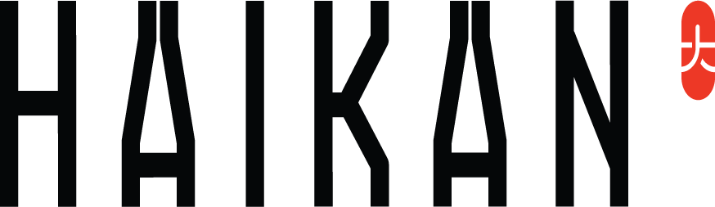

NON-ALCOHOLICS
MEXICAN SPRITE OR COKE 4
TOPO CHICO BOTTLE 3
CALPICO CAN 4
MELON CREAMY SODA 5
MANGO CREAMY SODA 5
UCC GREEN TEA 3
UCC KONA COFFEE 4
UCC CAFFE LATTE 5
UCC MATCHA LATTE 5
CAN SODA 3
COKE, DIET, SPITE, GINGER ALE
FLOWERING TEA 8 SOFT YET INTOXICATING FLORAL NOTES WELL BALANCED WITH FRESH FUJIAN GREEN TEA
BARTENDER’S CHOICE MOCKTAIL 8

BUCKET SPECIALS
ALL DAY FRI-SUN
GOOSE ISLAND SHANDY (5 VARIETY) 20
BUD LIGHT SELTZER (5 VARIETY) 20
KIRIN LIGHT (5) 25
SAKE ONE CUP (5) 50

DRINK MENU

