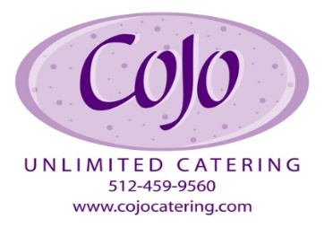
Charity Donation Request Form
- Requests must be submitted 60 days prior to your event to allow time for review and approval.
- Applicants must be a current 501(c) organization to be eligible for consideration.
- Please submit your request and this form to sarah@cojocatering.com
______
_____
______

Organization Information
Na me/Organization: Na me/Organization: EIN/ Tax ID # : Mailing Address: ___________________________________________
501(c) Status: City, State, Zip:
Website: Contact: Cell: Email:
Has this organization received a CoJo Catering donation in the past? No If yes, when? Are you willing to recognize CoJo’s contribution? _____If yes, briefly describe: ___________________________________________________________________________________________________
Are you/organization a CoJo client? If yes, who is the contact?
If no, how did you find us? Please circle one: Friend/Referral/Google Search
Friend/Referral Name ____________________________________

Event Information
Event Name: Date a nd Time: _________________
Location of Event: Event Web site: _________________ Purpose of the Event: ______________________
How will the funds raised be used: _ Community the event will serve: ____________Expected # of Attendees: _______________
Request Type: Silent Auction GC Food Donation Event Sponsorship/ In-kind
Please list any and all food & beverage requests: ________________________________________________________________________________________

Signature of Applica nt: Date: __________________________________________
By signing this form, I verify that I am an authorizing agent of the requesting non-profit and this organization qualifies for 501(C)3 status as defined under the IRS and is in full compliance with the USA Patriot Act

For CoJo Catering Use Only
Da te Received: Donation Awa rded: ______________________________
Gift Certificate # : Notes: _______________________________
Authorized By: Delivery Informa tion: ______________________________

Due to a high volume of requests, we must gather very specific information to determine which opportunities we are able to participate in. Friends and clients of COJO will receive priority consideration. Submission of this form does not guarantee that your request will be fulfilled.

