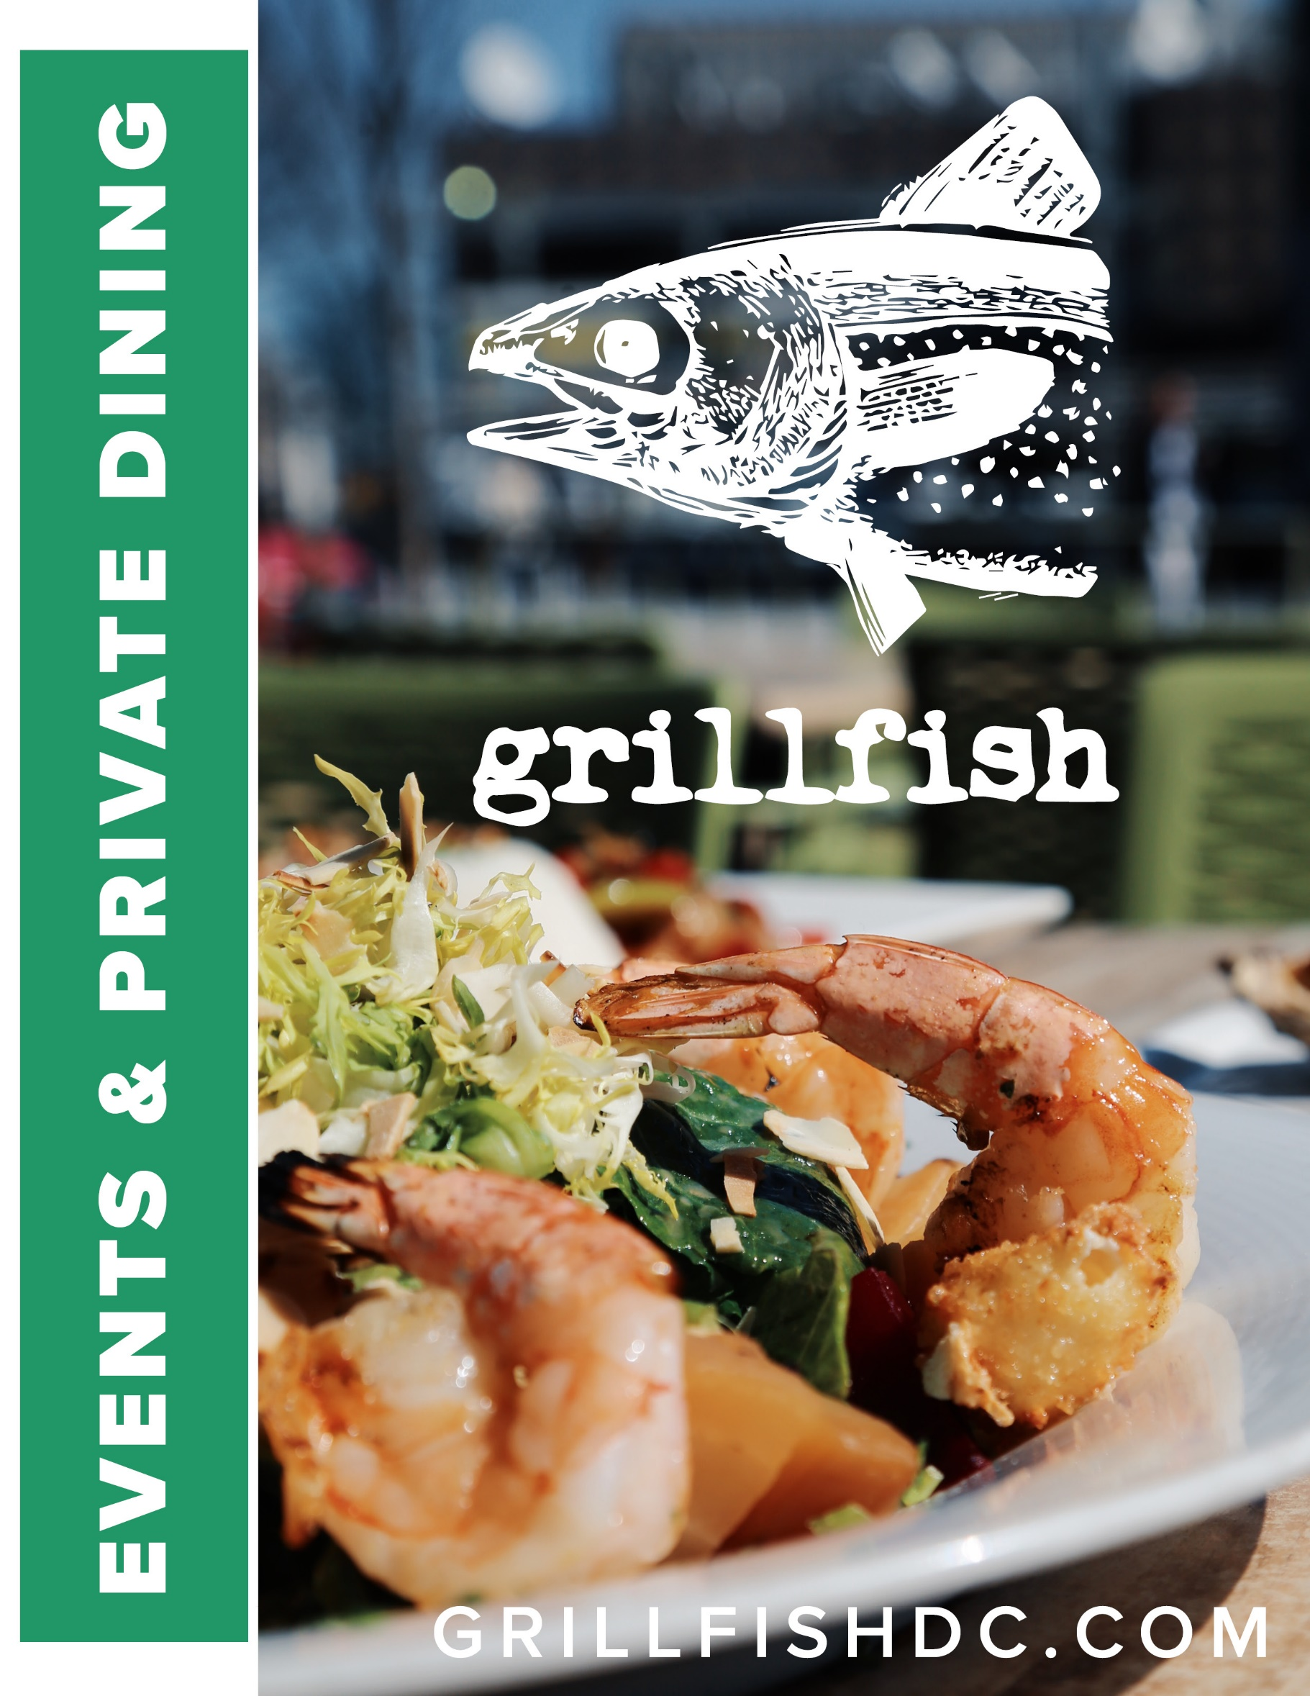

Grillfish only serves fresh, 100% sustainable seafood. We are local, seasonal, and feature vegetables from our farm in La Plata, MD. Our plates are designed for sharing and are inspired by rustic dishes from around the world. We create unique cocktails and offer American craft beers and eco-friendly wines. We strive to challenge and comfort you.

Explore & enjoy the experience.

Important  info | Address:  1200 New Hampshire Ave NW  Washington DC, 20036  Phone:  (202) 331-7310  Email:  grillfish@eatwelldc.com

private  event  details | All reservations of 14 or more must be coordinated through our Private Events Coordinator.  For more information, contact Ray Bracken at  rbracken@eatwelldc.com

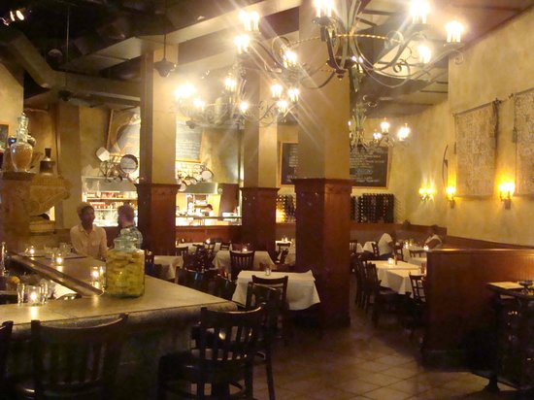
The Room
At Grillfish we source 100% sustainable seafood from local vendors and as well as vegetables from our own farm in La Plata Md to create handcrafted food and beverages. We specialize in seafood, steak and oysters but can accommodate almost any dietary desire or requirement.

We offer a wide selection of craft cocktails, local beers and a thoughtful wine selection.

Our setting is dramatic, unmatched and the best casual-upscale, neighborhood dining in DC’s West End.

Seated: 100 Standing: 100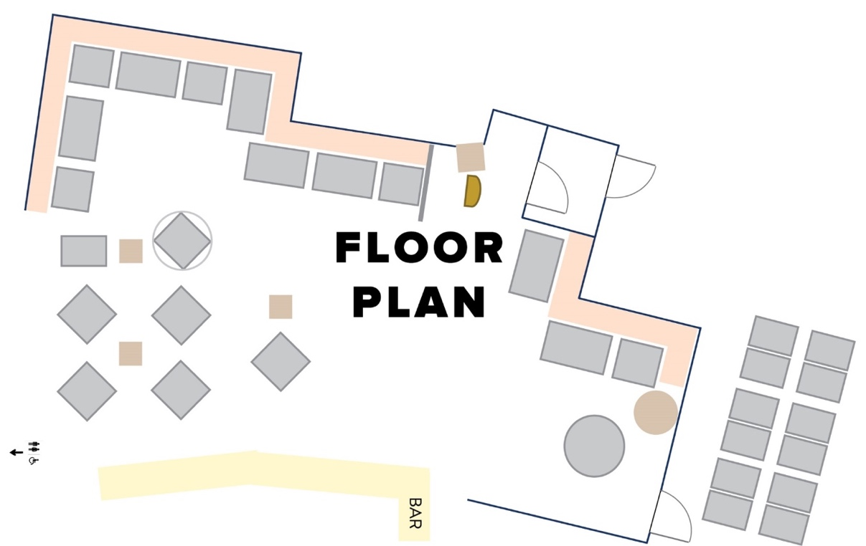

All prices are exclusive of tax and a suggested 20% gratuity. All soft drinks, tea and brewed regular and decaf coffee are included in the food pricing

Plated Dinner Tier 1...$32  Choice of (1) Family Style Appetizer and  (3) Entrées (excludes Strip, Surf & Turf, Mixed Grill) | Plated dinner Tier 2...$40  Choice of (2) Family Style Appetizers, (3) Entrées and (2) Desserts  (excludes Strip, Surf & Turf, Mixed Grill)  Plated Dinner Tier 3...$45  Choice of (3) Family Style Appetizers, Any (4) Entrées and (3) Desserts (no exclusions)
Appetizers
Local Oysters With mignonette and cocktail sauces
Buffalo Shrimp
Fried Risotto Balls with Manchego Cheese
Apple & Pear Salad Romaine, spiced pecans, match strip parsnips, honey vinaigrette
Kale Caesar Salad Shaved parmesan, cream cheese croutons
Tomato & Basil Bruschetta
Ginger Calamari Ginger, soy, honey, anise

entrées
Grilled Fish - Choice of Salmon, Catfish or Rainbow Trout. All sustainable, served with choice of side as well as choice of sauce: sweet onion, creamy garlic tomato or coconut-red curry
Shore Platter Fried shrimp, scallops, and haddock served with house made fries and slaw
Mixed Grill Swordfish, salmon, mahi mahi, scallops, and shrimp
Seafood Fra Diavlo Spicy marinara sauce | Creamy white wine sauce. Clams, mussels, shrimp, and calamari over linguine
Chicken Piccata Over Linguine
Homemade Ravioli of the Day (Vegetarian)
Strip Loin Steak (10 oz) With chermoula, broccolini, and mashed
Shrimp Surf & Turf Shrimp and strip loin with chermoula, broccolini, and mashed

desserts
Pineapple Carrot Cake
Chocolate Cake
Mango Key Lime Pie
Seasonal Sorbet

All prices are exclusive of tax and a suggested 20% gratuity. All soft drinks, tea and
brewed regular and decaf coffee are included in the food pricing

Plated LUNCH Tier 1...$21
Choice of (1) Appetizer and (3) Entrées

plated LUNCH Tier 2...$29
Choice of (2) Appetizers, (3) Entrées and (2) Desserts

Appetizers
Apple & Pear Salad Romaine, spiced pecans, match strip parsnips, honey vinaigrette
Ginger Calamari Ginger, soy, honey, anise
Fried Risotto with Manchego Cheese
Cup of Seasonal Soup
Local Oysters with mignonette and cocktail sauces

entrées
Kale Caesar Salad Shaved parmesan, cream cheese croutons with choice of protein (Chicken, Blackened Salmon, Grilled Shrimp, Grilled Steak (+$5)
Mixed Grill Swordfish, salmon, shrimp, scallop, and mahi
Blackened Chicken Sandwich With provolone and coleslaw and served with choice of fries or couscous salad
Salmon BLT Served with lemon aioli with choice of fries or couscous salad
Fried Haddock Sandwich Caramelized onions, coleslaw, cheddar, and Cajun mayo with choice of fries or couscous salad

desserts
Mango Key Lime Pie
Chocolate Cake
Seasonal Sorbet

All prices are exclusive of tax and a suggested 20% gratuity. All soft drinks, tea and
brewed regular and decaf coffee are included in the food pricing

plated brunch Tier 1...$21
Choice of (1) appetizer and (3) entrées

plated brunch Tier 2...$27
Choice of (2) appetizers, (3) entrees and (2) desserts

Appetizers
Crab Deviled Eggs
Crab Soup
Buffalo Shrimp
Mussels Sicilian
Shrimp Ceviche

Entrées
Crab & Shrimp Omelets Cheddar cheese, spinach, hollandaise
Huevos Rancheros Black beans, pico, cabbage, lime-sriracha, feta cheese
(Add Chicken or Chorizo Hash +$2)
Bananas Foster French Toast With seasonal fruit, butter brown sugar, dark rum and banana liqueur
Vegetarian Omelets Portobello, cheddar, cherry tomatoes, spinach
Strip Loin Steak (10 OZ) & Eggs your way, served with roasted red potatoes or spinach (+$7)
Brunch Platter Eggs your way, sausage, bacon, potato pancakes, biscuits, seasonal homemade jam
Open Faced Fried Catfish Sandwich Bacon, coleslaw, egg, Cajun mayo served with fries or roasted red potatoes
Blackened Chicken Sandwich Provolone, coleslaw with fries or roasted red potatoes

Sides
Brownie Sundae
Chocolate Cake
Seasonal Sorbet
Mango Key Lime Pie

All prices are exclusive of tax and a suggested 20% gratuity.

PACKAGE 1.... $25/PERSON
(for 2 hours; each additional hour $5/person)

Bud Light
Eggenberg Pilsner
Devils Backbone Vienna Lager
Victory Prima Pils
Alto Tierruca Cabernet
Mars and Venus Merlot
Cielo Pinot Grigio
Hugo Gruner Veltliner

PACKAGE 2.... $33/PERSON
(for 2 hours; each additional hour $8/person)

Bud Light
Eggenberg Pilsner
Devils Backbone Vienna Lager
Victory Prima Pilsner
Evo. Lot # 3 IPA
Alto Tierruca Cabernet
Mars and Venus Merlot
Julia James Pinot Noir
Cielo Pinot Grigio
Hugo Gruner Veltliner
Le Grand Calliou Sauvignon Blanc
Villa Jolanda Prosecco
Premium Rail Spirits

PACKAGE 3.... $40/PERSON
(2 hours; each additional hour $10/person)
Everything included in Tier 1 & 2 + all draft beers, specialty cocktails

