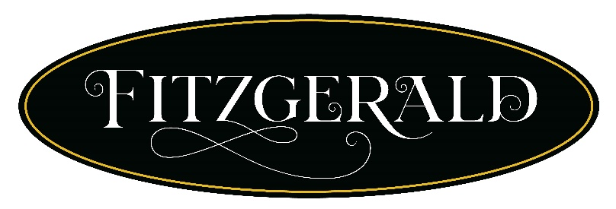
$49 Dinner Menu
Wine Pairing $30
FEDEX 4th Course – Crispy Fried Oyster Deviled Egg
1st course
Chilled Sweet Corn and Blue Crab Soup – Pickled Corn, Cotija Cheese, Cilantro
Torrontes
House Wedge Salad – Basil buttermilk dressing, Toasted pepitas, Tomato, Bacon, Blue Cheese, Green onions
Tuna Tartare – Ahi Tuna, Jalapeno, Togarashi, Soy Sauce, Tortilla
Whispering angel
2nd course
Blackened Redfish – Mexican Chorizo & Corn Succotash
Malbec
Pork Delmonico – Black Garlic Butter Glazed, Green Chili Grits, Braised Collard Greens
Skyside Pinot noir
Seared Ahi Tuna – Confit Potatoes, Green Beans, Chimichurri
Skyside Pinot Noir
3rd course
Flourless Chocolate Cake – Chantilly Cream, Fresh Berries
Nectar Rose Moet
Buttermilk Pie – Parker county Peach Compote, Bourbon Caramel
Sauterne
Banana Foster’s Banana Pudding – Rum Butter sauce, Bananas, Chessman Cookies
Sauterne

Signature Dinner Menu $99
Wine pairing $50
1st course
Fried Oyster Deviled Egg
Super Nova Sparkling Rose
2nd course
Choice of
Chilled Sweet Corn and Blue Crab Soup – Pickled Corn, Cotija Cheese, Cilantro
Rombauer Chardonnay
Pan seared Crab cake – Zesty remoulade, Creole-honey dressing, Arugula
Hedges La Blanc White
Shrimp Cocktail – Spicy Remoulade, Lemon, Cocktail Sauce
Alexander Vineyards White Graves
3rd course
Choice of
Blackened Redfish – Mexican Chorizo Corn Succotash, Basil
Sanglier Vineyards Pinot Noir
Ultimate Seafood Gumbo – Jumbo Shrimp, Jalapeno Sausage, Oysters, Crawfish Tails, Redfish, Our Delicious Dark Roux, White Rice. Served Table side
Berlucchi Franciacorta Cuvee Brut
Center-cut 8oz. Filet – Prime Angus Beef
Add grilled Lobster Tail - $25
Silver Ghost Cabernet Sauvignon
4th course
Flourless Chocolate Cake – Chantilly Cream, Fresh Berries
Nectar Rose Moet
Buttermilk Pie – Parker county Peach Compote, Bourbon Caramel
Sauterne
Banana Foster’s Banana Pudding – Rum Butter sauce, Bananas, Chessman Cookies
Sauterne

Lunch Menu
Choice of Starter
Petite Wedge – Iceberg lettuce, Basil Buttermilk Dressing, Toasted Pepitas, Tomato, Bacon, Blue Cheese, Green Onions
Cup of Chilled Corn and Melon Soup -Pickled Corn and Cotija Cheese

Choice of Entree
Cobb Salad – Slow Roasted Chicken, Hard Boiled Egg, Cheddar Cheese, Bacon, Honey Mustard Dressing, Mixed Greens
Louisiana Crawfish Roll – Toasted New England Bun, Celery, Mayo, Cajun Spices, Crawfish Tails
Delta Fried Catfish – Hand-breaded Mississippi catfish, Green Chile Grits, Jalapeno Sausage, Sauce Piquant

