Rolls
Traditional Fresh Spring Roll . . . . . . . . . .12
shrimp, pork belly, peanut sauce

Wagyu Fresh Spring Roll . . . . . . . . . . . . . . . 13
wagyu beef, pickled fresno, togarashi sauce

Fried Chicken Fresh Spring Roll . . . . . . . . . 12
fried t-racha chicken, dill, spicy mayo (H)

Vegetable Fresh Spring Roll . . . . . . . . . . . . 11
pickled seasonal vegetables, avocado, peanut sauce

Crispy Imperial Roll . . . . . . . . . . . . . . . . . . . 12
pork, wood ear, lettuce, cucumber, thick nuoc cham

Bao (2/Order)
T-Racha Chicken . . . . . . . . . . . . . . . . . . . . 11
spicy mayo, cucumber, cabbage (H)

Wagyu Beef. . . . . . . . . . . . . . . . . . . . . . . . .13
mushroom, cucumber, basil, togarashi sauce

Grilled Pork Belly. . . . . . . . . . . . . . . . . . .12
pickled onions, thick nuoc cham, cilantro

BBQ Green Jackfruit. . . . . . . . . . . . . . . . . . 11
avocado, fried shallot, scallion, cilantro (V)
_______________________________________
*(GF) denotes gluten-free item
*(V) denotes Vegetarian item
*Please notify your server of any food allergies
*(H) denotes Halal

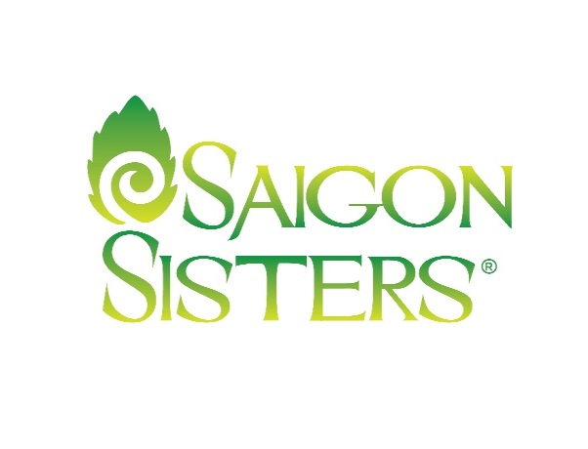

Banh Mi
Op La Classic . . . . . . . . . . . . . . . .14
prosciutto, chicken pate, Vietnamese pork, fried egg

“Chicago Style” Pho Dip . . . . .15
beef brisket, giardiniera, provolone, bean sprouts

The Pecking Order . . . . . . . . . . . .13
T-Racha chicken, spicy mayo, lettuce, tomato, cabbage, pickles

Sides
Stir Fry Vegetables (GF) . . . . . . . . . . . . 9
Broken Jasmine Rice (GF) . . . . . . . . . . .3

Desserts
Baognet . . . . . . . . . . . . . . . . . . . . . . . . . . 9
Fried bao, seasonal jam, Vietnamese coffee caramel

_______________________________________

- Popular Items

Salads
Traditional Green Papaya Salad. . . . 15
poached shrimp, pork, beef jerky, peanut (GF)
*Vegetarian Option Available 13

Vietnamese Vermicelli Salad . . . . . .18
grilled shrimp & wagyu beef, pork egg roll
*Vegetarian Option Available 15
Stir Fry
Shrimp and Pork Fried Rice . . . . . . . .16
kaffir lime, cucumber, shrimp paste (GF) *Vegetarian Option Available 13

Spicy Beef Noodle. . . . . . . . . . . . . . . .15
wagyu beef, mushrooms, togarashi, onion (GF)

Soups & Noodles
Beef Pho. . . . . . . . . . . . . . . . . . . . . . . . 14
oxtail, beef meatball, brisket (GF)
Bun Bo Hue. . . . . . . . . . . . . . . . . . . . . . 17
pork belly, brisket, rice noodles, sambal (GF)

Chicken Curry. . . . . . . . . . . . . . . . . . . .18
yellow curry, rice noodles, onion, basil (GF, H)
*Vegetarian Option Available
_______________________________________
*20% gratuity added to parties of 6 or more
*No separate checks for parties of 5 or more

Rare Tea Cellars
$6 Each

Litchi Noir (black)
Earthy, silky
Emperor’s Chamomile (D)
Pineapple, stonefruit
Fields of France Rooibos (D)
Lavender, elderberry
Emperor’s Genmaicha
Green, puffed rice kernels
Gingerbread Dream Rooibos (D)
Holiday spice
Moonlight Jasmine Blossom (D)
Soft, delicate

After-Dinner Drinks

Kelt VSOP. . . . . . . . . . . . . . . . . . . . . . . . . . . .16
Cognac, France
Maker’s Mark. . . . . . . . . . . . . . . . . . . . . . . . .12
Bourbon, Kentucky
Glenlivet Single Malt Scotch. . . . . . . . . . . . . 13
12 Years
Botran “Solera” Reserva. . . . . . . . . . . . . . . . 12
Rum
’10 Banyuls Domaine de la Vielle. . . . . . . . . 13
France
’10 Sauternes, Chateau Roumieu-Lacoste. . .15
France
Pineau des Charentes, Chateau D’ Orignac. 12
France

Craft Cocktails
$12 each

Perfect Storm
Botran Anejo Rum, Ginger Beer, Lime, Thai Basil

Saigon 75
North Shore Gin, Fresh lime,
Sparkling Rose, Thai Basil
Sweet Home Kentucky
Maker’s Mark Bourbon,
lemon, brown sugar, ginger

Sista Rita
Tequila, Fresh lime, Jalapeno, Cucumber

Balthazar
Cognac, tamarind, cardamom, brown sugar, orange juice, beef jerky

Beer
Stella Artois. . . . . . . . . . . . . . . .6
Belgium
Beerlao Lager. . . . . . . . . . . . . .7
Lao Brewery, Laos
Beerlao Dark. . . . . . . . . . . . . .7
Lao Brewery, Laos
La Chouffe Ale. . . . . . . . . . . 11
Brasserie d’Achouffe, Belgium
Houblon Chouffe, IPA. . . . . .11
Brasserie d’Achouffe, Belgium

Wine List
White
‘15 Sauvignon Blanc . . . . . . . . . . . . 12/48
Allan Scott, Marlborough, New Zealand
‘15 Viognier,. . . . . . . . . . . . . . . . . . . .11/44
Dom Montrose, Cotes de Thongue France
‘14 Pinot Gris . . . . . . . . . . . . . . . . . . 11/44
Domaine Spechte, Alsace, France
‘15 Chardonnay, . . . . . . . . . . . . . . . .12/48
Milou, Pays d’Oc, France
’15 Riesling . . . . . . . . . . . . . . . . . . . 11/44
Max Ferdinand Richter, Mosel, Germany
‘14 Pouilly Fume . . . . . . . . . . . . . . . . . . 65
Regis Minet, Loire, France

Red
‘15 Pinot Noir . . . . . . . . . . . . . . . . . . 14/56
Evesham Wood, Willamette, Oregon
‘13 Cotes du Rhone . . . . . . . . . . . . . .13/52
Dom. Chaume-Arnaud, France
‘15 Malbec . . . . . . . . . . . . . . . . . . . . .12/48
Punto Final, Mendoza, Argentina
‘13 Pinot Noir . . . . . . . . . . . . . . . . . . . . .52
Les Hexangonales, Loire, France
‘12 Lirac . . . . . . . . . . . . . . . . . . . . . . . . .52
Dom. de Marcoux, France
‘13 Cahors . . . . . . . . . . . . . . . . . . . . . . . 47
Clos La Coutale, France
‘12 Bordeaux . . . . . . . . . . . . . . . . . . . . . 48
Chateau Petit Freylon, France

Sparkling
NV Francois Montand Brut . . . . . 14/56
Rosé, France
NV Ayala Brut Majeur . . . . . . . . . . . .75
Champagne, France

Sake
Nigori , Perfect Snow (300mL) . . . . . . . . .10/30
Junmai, Shichi Hon Yari (300mL) . . . . . .12/36
Junmai Ginjo, Yuki No Bosha (300mL) . 14/42

