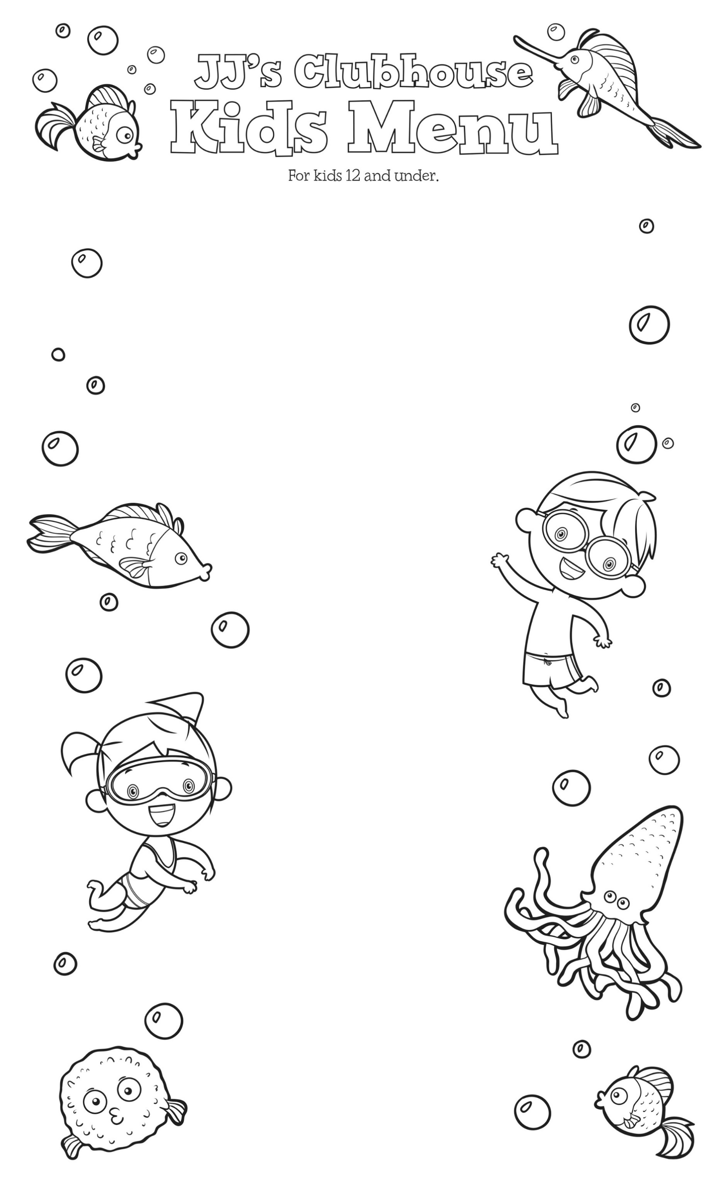

**Kids Salad** $4.95

With garlic toast.

**Pita Pizza** $6.50

One topping.

**Grilled Cheese** $5.50

With fries or mandarin oranges.

**Chicken Tenders** $6.50

With fries or mandarin oranges and choice of dipping sauce.

**2 Hamburger Sliders**…….…. $6.25

With fries or mandarin oranges.

**2 Cheeseburger Sliders**....…$6.95

With fries or mandarin oranges.

**Kids Noodles** $4.50

Choice of plain or buttered. Add marinara for $1.00. Served with garlic toast.

**Mini Corn Dogs** $5.50

With fries or mandarin oranges.



**Pop**

$1.25

**Milk / Chocolate Milk**

$1.50

**Pineapple**

**or**

**Orange Juice**

$2.95

**Buddy’s Grape Soda**

Bottle $4

**1919 Root Beer**

16oz can $4

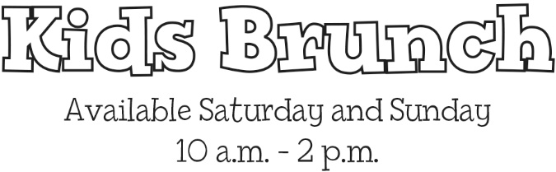

**One Egg, Bacon, & Toast**

$4.50

Kids 12 and under eat for $2.50

ALL DAY!

$2.50 Monday Special valid on kids’ meals only.