All sandwiches are served with your choice of a side.
Add our house smoked bacon to any sandwich for $1.39.
Add a small drink for $1.99!
Side options: Hand seasoned French fries, beans, slaw, potato salad, cheesy potatoes, mac & cheese, mac salad, cornbread, or chips
Sandwiches

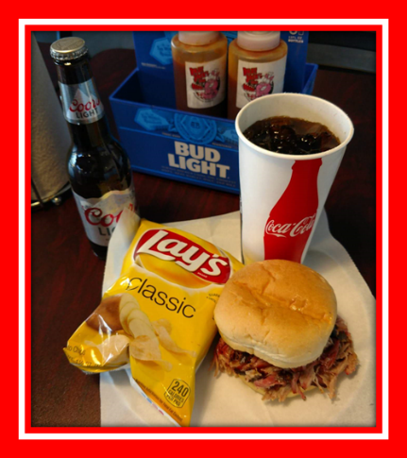
Brisket- Reg size $9.49 Jumbo $11.49
trimmed just right and seasoned with a flavorful rub. Smoked to
perfection to achieve tenderness and yet retain Moisture
Big Red Brisket- Reg size $9.69 Jumbo $11.69
Our award-winning brisket topped with provolone cheese and
our signature BBQ mayo
Brisket & Red hot- Reg size $9.69 Jumbo $11.69
We stacked our award-winning brisket on top a spicy hot link for a
flavorful combination
Reg. size Pork Sandwich (Drink not included)
The Cornhusker- Reg size $9.69 Jumbo $11.69 the same brisket you have come to love topped with slaw.

The Biggerstaff- Reg size $9.69 Jumbo $11.69 Our always popular brisket topped with provolone cheese, red onions, and jalapenos. You can thank the guys at Biggerstaff for this wonderful combination.
Pulled Pork- Reg size $8.29 Jumbo $10.29. Generously rubbed and slow smoked for 12 to 14 hours to give you a pulled pork sandwich you’ll come back for.

Carolina Style- REG size $8.49 Jumbo $10.49 Pulled pork topped with slaw.
Psycho- Reg size $8.49 Jumbo $10.49 you don’t to have to pick between Pork or Brisket you can have them both on this crazy combination.

Pigzilla REG $9.69 JUMBO $11.69 our smoked hot link, topped with pulled pork and then topped with our hand sliced bacon.

Brumm Daddy REG $9.69 JUMBO $11.69 our smoked hot link, topped with pulled pork, brisket, onions, jalapenos, BBQ mayo, and provolone cheese.

Burnt End Sandwich Reg size $9.49
our award winning burnt ends on a bun served with a small side
The Veggie Way $7.09
we top our classic bun with coleslaw, tomato, red onion, olives and provolone cheese then drizzled with sauce, served with a small side.
Kids Meals
served with a bag of gummies, and drink $5.39
2 ribs & a bag of chip, BBQ nachos, or 1/2 a brisket, pork, or turkey sandwich & a bag of chip
Combos
One Meat Combo $11.79
approx. ½ Lb. of your choice of brisket, pork, turkey, or hot links (or mix and match 2 meats) served open face on Texas toast and 2 small sides.
Jack Jr. Combo $12.59
3 ribs, your choice of hot links, pork, or brisket, and 2 small sides. *Sub burnt ends for $1.00 more when available
Jack’s Combo $14.99
3 ribs, pork, brisket and 2 small sides. *Sub burnt ends for $1.00 more when available
Jack’s Phat Combo $26.99
enough to feed at least two: 4 ribs, pork, brisket, and 2 large sides. *Sub burnt ends for $2.00 more when available
Rib combo $13.49
½ slab of ribs and 2 small sides.
Full slab combo $26.99
A full slab of ribs and 2 large sides.
Pork ribs
Seasoned with our special blend of spices and slow cooked for 6 to 8 hours. When you bite into a rib it should be so tender and moist that it pulls cleanly away from the bone.
½ Slab $11.99
full slab $19.99
Jr Combo with Brisket
Add two ribs to any sandwich or combo meal for $3.99
WARNING: Get here early, ‘cuz the ribs and burnt ends won’t last long. To ensure that we serve the best ribs possible we only cook a limited number of ribs each day. We suggest arriving as early as possible as they never last long. Phone orders accepted.

Signature Dishes
Jack’s Loaded Baked Potato $8.99
A baked potato loaded with melted butter, sour cream, cheese, and topped with
your choice of Pork or Brisket, then drizzled with BBQ sauce. *extra meat 2.00 more
*Offered Debbie’s Way $6.99

$1.99 $3.99Burnt Ends (Limited Availability) $11.99
A hidden treasure of the brisket, although prepared and cooked the same as the brisket it has a unique flavor all of its own. As a Phat Jack’s favorite try this melt in your mouth delight served open face on Texas toast. Served with a small side.

BBQ Nachos ¼ order $8.29 ½ order $10.99
full $14.99 (full not available for carry out)
While this nacho may begin typically it’s kicked up a notch with our slow smoked meats then layered with cheese, sour cream, jalapenos, chopped tomatoes, and black olives. *extra meat 2.00 more
*Offered the veggie Way $7.99(1/2 nacho only)

Sundae platter $7.99
Your choice of brisket, pork, turkey, or hot links (or mix and match 2 meats), with beans, coleslaw or potato salad.

By the Pound (Meat and Sauce included only)
Great for family dinners, entertaining, & Tailgating.
Brisket 16.99
Pulled Pork 13.99
Turkey 14.49
Burnt Ends 16.99

YES, WE CATER!!!
Please ask about our catering menu. With many unique options such as our slow cooked brisket & pork, prime rib dinners, banquet style dinners, and that’s just to name a few. We always customize to meet your needs. Remember no event or celebration is too large or small. Also, ask about box lunch catering perfect for lunch meetings.

Side Dishes Sm Lg Qt
Coleslaw $1.99 $3.99 $9.99
Baked Beans $1.99 $3.99 $9.99
Potato Salad $1.99 $3.99 $9.99
Macaroni Salad $1.99 $3.99 $9.99
Cheesy Potato $1.99 $3.99 $9.99
Mac and Cheese $1.99 $3.99 $9.99
Hand seasoned fries. $1.99 $3.99
A Bag of Chips (Lays Variety) $1.25
Cornbread $1.50

Drinks
Fountain drink 24oz (Sm) $1.99 32oz(Lg)$2.29
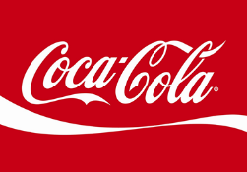
Vintage Soda or Bottled Soda $2.29
Monster Energy Drinks $2.69

