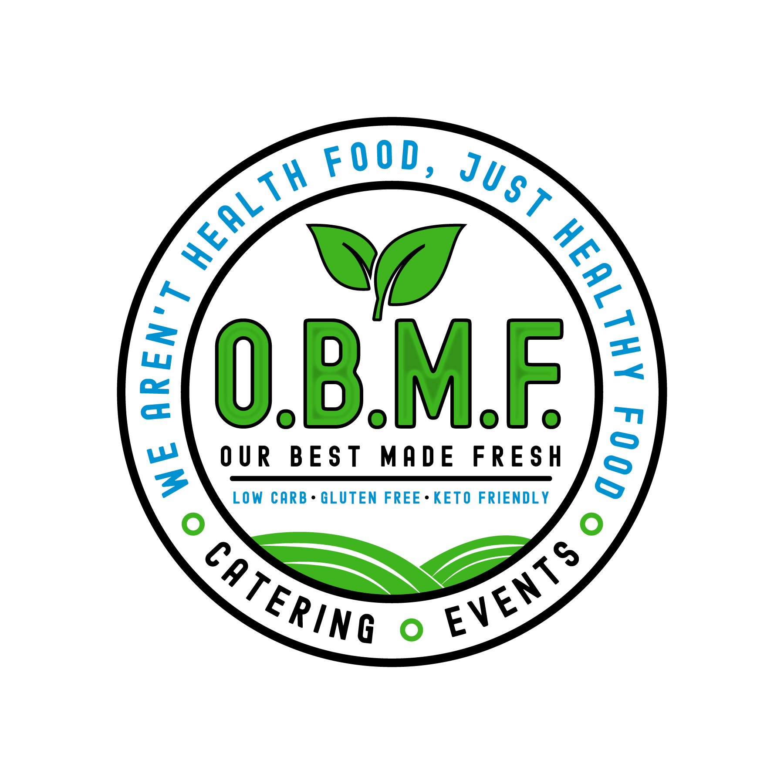
Boxed Lunch Menu
OBMF.com

*Bottled Beverages- $2.00 ea.
Coke, Diet Coke, Coke 0, Sprite, Dr. Pepper, Bottled Water (Fuji or Alkaline)

Salad Wrap Boxed lunch
Individually Packaged
Each box includes your choice of wrap, drink, chips, and a cookie
Our Salad wraps are made with spring mix, sliced Roma tomatoes, and shredded cheese.
Dressing choices: Ranch. Blue Cheese, Honey Mustard, Italian and Balsamic

Marinated portobello mushroom wrap
Grilled chicken wrap
Gluten Free breaded tender wrap
$10.95

Soup and Salad Lunch
Individually Packaged
Includes our house salad, breadsticks, a cookie, and your choice of one of our soup bowls
Soup choices: Potato, Broccoli cheddar, Chicken noodle or Tomato basil.
Dressing choices: Ranch. Blue Cheese, Honey Mustard, Italian and Balsamic
$11.50

Sandwich Box Lunch
Individually Packaged
Includes choice of sandwich, drink, chips, and a cookie
BLT, Grilled Cheese, Grilled or Breaded Tender Sandwich, Pulled Pork, Chicken Salad or Egg Salad
$10.95

OBMF “SPUDS” Boxed Lunch
Individually Packaged
Includes your choice of potato, drink, and a cookie
Butter and sour Cream-$8.00
Loaded-$9.50
Chicken and portobello stuffed-$11.50
Pork and Mac stuffed-$11.50

Burger Box Lunch
Individually Packaged
Includes your choice of burger, chips, drink, and a cookie.
Burgers are served on a toasted bun with lettuce, tomato, and pickles.
Cheeses: Provolone, Cheddar, American and Swiss
Single Smash-$8.50 Double Smash-$12.00 Triple Smash-$14.00
Add Cheese-$1.00 (per patty) Add Bacon-$1.00 (per patty)

Mushroom Swiss Burger
DBL Smash Burger Topped with marinated mushroom and swiss cheese- $14.00

Bacon Bleu Burger
DBL Smash Burger Topped with Bacon and Blue cheese dressing- $15.00

Smokehouse Burger
DBL Smash Burger topped with Cheddar cheese & BBQ pork- $14.00

The Triple Pepper Jack Bacon Burger
DBL Smash Burger Topped with Triple Pepper Gold n Jack cheese, Bacon and a drizzle of burger sauce
$14.00

OBMF SmashBurger
DBL SmashBurger served between 2 Grilled Cheese Sandwiches
with your choice of cheese on the burger and Bacon
$16.25

Wing Co Box Lunch
Your choice of 5 pc or 10 pc wings, includes celery and carrot sticks, drink, and a cookie.
5 pc-$8.50 10 pc-$13.00 Choice of 1 Sauce
Your choice of 15 pc or 20 pc wings, includes celery and carrot sticks, 2 drinks, and 2 cookies.
15 pc-$18.00 20 pc-$22.50 Choice of 2 sauces

Game Day Special
35 pc wing tray-$30
Served with carrots and celery and your choice of 3 sauces

Sauce choices include, Naked Wings, Honey BBQ, Tingle(mild), Blue Tingle (Blue Cheese Crumbles), Boom Boom, Garlic Parm, Jerk, Jam n Jerk, Mango Habanero, Nashville Hot, Lemon Pepper or Blackened. Wings are served with your choice of dressing. (Blue cheese, Ranch or Honey Mustard)

Blackened Grouper Boxed Lunch
Individually Packaged
Includes Blackened Grouper sandwich, drink, chips, and a cookie
6oz. Filet of Grouper, dredged in our special Blackened seasoning blend and grilled to perfection! Served on a bun dressed with lettuce, tomato, salt & pepper with a kick of our Boom Boom sauce and pickles.
$17.95

Flatbread choices (not available as a box lunch)
Our flatbreads are Gluten Free made by Florida based Elaine's Bakery

Cheese Flatbread-$6.50
Topped with garlic aioli spread, mozzarella cheese and a shake of oregano.
Portobello Mushroom-$8.50
Topped with garlic aioli spread, mozzarella cheese, sliced marinated Portobello mushroom, sun dried tomatoes, sweet peppers.
Pepperoni Flatbread-$8.50
Topped with garlic aioli spread, mozzarella cheese, sliced pepperoni and a shake of oregano.
Pepperoni and Bacon Flatbread-$9.75
Topped with garlic aioli spread, mozzarella cheese, sliced pepperoni, bacon crumbles and a shake of oregano.
Bacon Cheeseburger-$11.75
Angus beef, Bacon crumbles, Diced tomatoes and burger sauce drizzle
Chicken Bacon Ranch-$11.75
Grilled chicken, Bacon crumbles and ranch
Boom Boom Chicken Club-$11.75
Gluten free breaded tenders, bacon crumbles and Boom, Boom sauce drizzle
Smokehouse Flatbread-$11.75
Pulled pork, mixed cheese, sweet peppers and BBQ sauce

Desserts
Gluten Free Chocolate chip or Snickerdoodle cookies-3/$3.00
Nut, Dairy and Gluten Free Chocolate chip brownie-$3.00
Decadent Reese's Peanut Butter cookie-$3.00
Banana nut’ Blueberry or Chocolate chip muffin-$4.00

