A new chef-led Fishers kitchen will try to perfect food delivery quality and service
Cheryl V. Jackson
Indianapolis Star
View Comments
AD
0:03
SKIP
With many consumers unhappy with the high delivery fees and shortcomings related to third-party restaurant delivery services, a group of culinary entrepreneurs is unveiling a low-cost alternative with a menu from one of area’s most accomplished chefs.
The delivery zone will be a small one though.
Chef Craig Baker is developing dishes for Room Service on Wheels, a delivery- and pickup restaurant opening in Fishers this summer.
Through a website, customers will be able to order pizzas, sandwiches, salads and wings for delivery but only if they’re within a mile and a half of the operation at 11110 Lantern Road.
The limited radius is key to keeping food quality optimal.
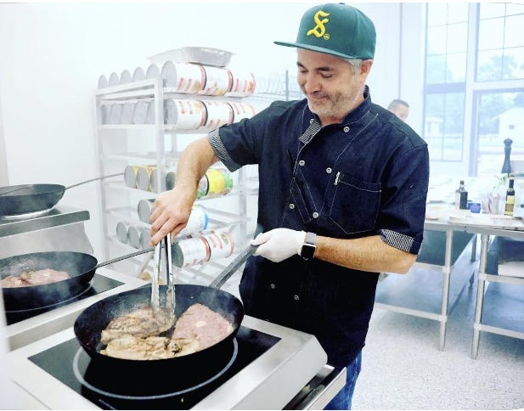
Delivery drivers can use their own cars but also will have use of company-owned bicycles, scooters and golf carts to get food to customers. Curbside pickup also will be available.
Residents at Pullman Pointe Apartments, in particular, could benefit from the service. The complex will have a direct phone line with which to order from a dedicated pool menu to be delivered to the pool area. The 1,500-square-foot kitchen space is connected to the leasing office and social room of the apartment community.
“If you happen to be sitting at the pool at the apartment next door you definitely can just pick up the phone, and we'll bring you anything from a bottle of water to a halibut entrée,” Baker said.
But the service also is being designed to keep delivery fees low, or at zero, and make clear any portion of costs that are going to the drivers.

An idea for better food delivery service sparked during COVID-19
The venture is the brainchild of Randy De John, former managing partner at Casler's Kitchen & Bar in Fishers, which closed in 2017.
The idea was sparked at the beginning of the pandemic, when De John ordered 90% of his meals through delivery.
“I was just amazed by all the flaws: high fees, food that doesn't travel well. On a Friday, and Saturday, it could take an hour and a half, sometimes even two hours to even get your food,” De John said. “That's where I came up with the idea of how I can do this, but much more efficiently, without all the fees? My own people that I hire, not independent people.”
De John, whose time at Casler’s overlapped with Baker for a short period, knew he wanted the chef in on the project.
Baker, a restaurant consultant who runs The AMP food hall at the 16 Tech Innovation District in Indianapolis, was the 2017 World Food Championships winner in the Chef category.
“I've been to all of his restaurants. So I was a fan of his,” De John said.
The menu at the scratch kitchen, still being finalized, will include smashed burgers and pastas, but Baker can’t resist the urge to provide dishes not commonly offered for delivery, such as braised lamb shanks.
“There will be awesome finer dining type options,” he said. “We'll have local flair type dishes, whether it's morel mushrooms or chanterelles later where we can use those ingredients on something as simple as a pizza or something a little more elevated.”

Delivering quality food and service
They’re working on processes and packaging to make sure wings are still crispy and other food remains restaurant fresh when it makes it to customers. The burgers, for example, might be delivered with toppings packaged separately so that they stay cool.
“The most important thing is that our delivery radius is small. So it's about getting food there as quickly as possible, and hot to maintain quality.” Baker said.

