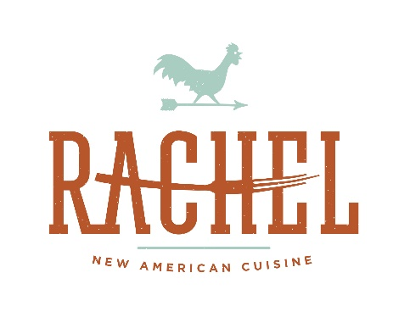

Catering Menu (Lunch)
$150 Minimum 48 Hours’ notice preferred

ASSORTED SANDWICHES MAY INCLUDE: 11⁹⁵ per person
House Smoked Pork Loin 2-year sharp cheddar, turmeric aioli
Grilled Chicken Club house made pancetta, green peppercorn mustard
Fresh Yellow Fin Tuna capers, celery lemon, and EVOO
Grilled and Roasted Vegetables goat cheese mousse spread
House Smoked Atlantic Salmon citrus watercress horseradish
Pastrami zucchini slaw, Madrigal Swiss cheese
Chicken Salad tossed with sundried cherries, candied pecans, apple cider scallion dressing
Locally Sourced Ham Madrigal Swiss cheese, arugula

ONE SIDE INCLUDED WITH SANDWICHES:
Cucumber Salad onion, tomato, topped with feta
Quinoa Salad turmeric infused quinoa, sun dried apricot, golden raisins, chick peas, green onions, and roasted Vidalia onion vinaigrette
Pasta Pearls tomato, red peppers mozzarella, balsamic syrup dressing
Roasted Cauliflower Salad pumpkins seeds
Three Potato Salad celery mustard horseradish dressing
Spicy Zucchini Slaw zucchini, red peppers, carrot, spicy caper dressing

PASTA AND GRILLED CHICKEN: 12⁹⁵ per person
Served with crusty Italian bread herb garlic infused EVOO
Grilled Vegetable Lasagna assorted grilled vegetables, Fontina laced béchamel Pecorino Romano shaving
Grilled Chicken Breast marinated with lemon mustard house spice mixture
Caesar Salad “puttanesco” dressing, crouton crumbs, Asiago cheese

ASSORTED MEAT AND CHEESE PLATTER: 14⁹⁵ per person
Accompanied with Green peppercorn honey mustard and citrus horseradish water cress sauce
Grilled Steak Dijon mustard white wine marinate
Grilled Chicken toasted spice rub and paprika
Two-Year Aged Sharp Cheddar
Madrigal Swiss Cheese

ASSORTED COOKIES AND SQUARES 3⁷⁵ per person

