M A K E I T M E M O R A B L E
MAKE IT FRANKIE'S RISTORANTE
2018 Bridal &Baby
Shower Luncheon Packages
The Old World decor, authentic fresh Italian cuisine
and impeccable service make Frankie's Ristorante
an excellent choice for your upcoming special occasion.
We believe food and celebration go hand in hand.
We put all of our expertise to work for you to make your event remarkable. Included you will find everything from general information and fees, along with additional services.

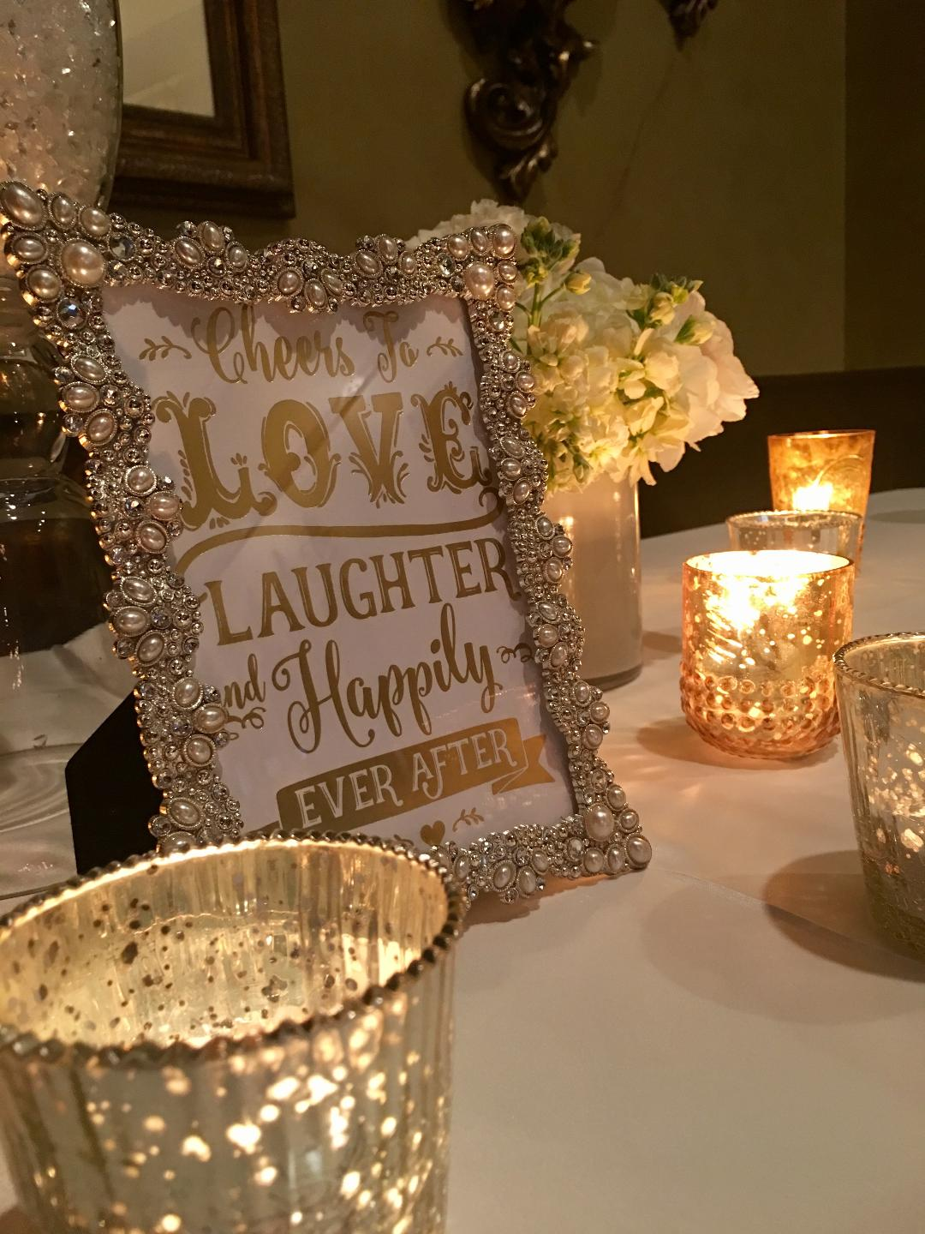

9501 West 171st Street , Tinley Park
7 0 8 . 2 2 6 . 6 9 9 6

Package Customization

We have chosen a variety of our most popular recipes for
the shower luncheon menu appropriate for women. Substitutions may be made, however, doing so may affect final pricing.

Guest Count

A final guaranteed confirmation for the number of guests that will be attending is needed by Noon, four business days prior to your event. If a guest confirmation is not received by the allotted date, the estimate in the contract or the actual number of guests in attendance (whichever is greater) will be used as the final guest count.

Charges for Gratuity and Tax

Applicable state and local taxes of 9.75 percent
will be added to all food and beverage charges.
Please note that a 20 percent service charge will automatically
be applied to the final master tab.

Room Capacity & Food and Beverage Minimums

Our Private Dining Room can accommodate up to 55 guests
maximum and is available from Noon until 3pm
with a $1,200 food & beverage minimum.

Our Main Dining Room can accommodate up to 80 guests
maximum and is available from Noon until 3pm with a
$1,500 food and beverage minimum. Availability is limited.

Deposit & Cancellations
We require $400.00 deposit on all events and a credit card on file.
Deposit is refundable up to 90 days prior to the event.

Miscellanous Charges
Hosts are required to contact the Event Coordinator, Angela
for approval upon bringing a specialty cake or cupcakes from a licensed bakery; there is a $25 service fee to cut, plate and serve these items.
NO other outside food may be brought in for health code reasons.

Luncheon package includes:

American Coffee
Linen Tablecloths and Napkins
Tea Light Candles
Complimentary Personalized Menus
Italian Bread with Parmesan Cheese & Extra Virgin Olive Oil

Each Main Entrée Includes:
Seasonal Vegetables & Red Roasted Potatoes

Custom linens and flowers can be arranged for you
by your Private Dining Manager, Angela for an additional fee.
Please inquire for more information.

Offer your guests the following Alcoholic Beverages
$6 per glass

Mimosa Prosecco Red & White Wine Bloody Mary

$3.50 Soft Drinks
Ice tea, lemonade & Soda

Red or White Sangria $175
(30 servings)

HORS D’OEUVRES SELECTIONS
The following selections are available
family style on each guest table …

Caldo
Hot selections

Calamari Fritti $12.95 per order
Fried calamari served with marinara sauce

Freddo
Cold selections

Mozzarella alla Caprese $9.95 per order
Fresh sliced mozzarella with tomato & basil
drizzled with extra virgin olive oil

Bruschetta alla Romana $8.95 per order
Toasted bread rounds with fresh tomatoes,
basil & herbs drizzled with extra virgin olive oil

LUNCHEON PACKAGE 1
(Available Noon until 3pm)

$22

First Course

Insalata Mista
Mixed greens, tomatoes, cucumbers and
shaved carrots in our Italian dressing

Main Course
(Guests select one)

Pollo Limone
Boneless breast of chicken prepared with a lemon, capers and butter sauce, served with roasted red potatoes & seasonal vegetables

Penne con Gamberetti
Penne pasta prepared with shrimp and fresh seasonal vegetables
sautéed in Extra Virgin olive oil and fresh garlic

Pollo Vesuvio
Boneless breast of chicken with mushrooms, roasted sweet bell peppers & rosemary with Italian white potato wedges in a white wine garlic sauce

Dessert Course
Vanilla Gelato

Package includes American coffee

Upgrade your Dessert
Sea Salt Caramel Gelato & Other Seasonal Flavors Available
(add $1.50 to Package Price)

LUNCHEON PACKAGE 2
(Available Noon until 3pm)

$25

First Course

Insalata Mista
Mixed greens, tomatoes, cucumbers
& shaved carrots in our Italian dressing

Second Course
Frankie’s Famous Rigatoni alla Vodka

Main Course
(Guest selects one)

Pollo Limone
Boneless breast of chicken prepared with a lemon, capers and butter sauce, served with roasted red potatoes & seasonal vegetables

Pollo alla Nina
Boneless breast of chicken prepared with sun dried tomatoes and artichokes in a brandy sauce, served with red roasted potatoes & seasonal vegetables

Saltati Tilapia
Tilapia sauteed with artichokes in a white wine sauce,
served with roasted red potatoes & seasonal vegetables

Dessert Course
Vanilla Gelato

Package includes American coffee

