9501 West 171st Street, Tinley Park
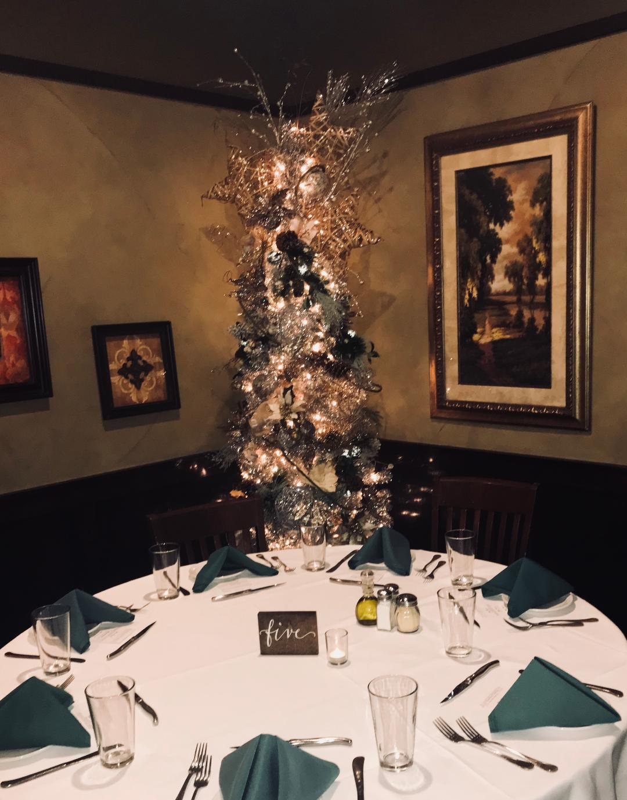
www.frankiesristorante.com

Make it Memorable…
Make it Frankie’s Ristorante

Holiday Party Packages 2018
Thank you for considering Frankie's Ristorante
for your holiday celebration. The Old World decor, authentic Italian cuisine & impeccable service make Frankie's Ristorante an excellent choice for your upcoming event. We believe food and celebration go hand in hand. Included you will find general information & fees, along with additional services and packages. Our packages
are designed to offer options for everyone,
however we are happy to customize a menu to better suite your style and needs.

7 0 8 .2 2 6 . 6 9 9 6

Room Rental and Capacity
The private room can accommodate up to 60 guests & is available for holiday luncheons and dinner; The main dining room is available for private luncheon only and can accommodate up to
85 guests. Availability is limited.
Please speak our event coordinator, Angela.

Guest Count
A final guaranteed confirmation for the number
of guests that will be attending is needed four business days prior to your event.

For parties of 12 or fewer, you may order off the a’la carte menu; we do require a credit card
on file for any party larger than 10 guests.

Cancellations
There is a 50 percent deposit of the food
and beverage minimum (seasonal minimums vary based on the day of the week) needed to secure your reservation; the deposit is refundable up
to 60 days prior to the event.

Charges for Gratuity and Tax
A service charge of 20 percent and applicable
state and local taxes of 9.75 percent will be
added to all food, beverage and liquor charges.

Packages Include
Italian Bread with Parmesan cheese & olive oil
Linen tablecloths & napkins
Tea light candles on guest tables

Complimentary personalized guest menu
with corporate/group name

Each guest will choose one of his/her own selections for the main course at the event
based on the package choice

Custom linens, flowers and décor
can be arranged for you at an additional fee.
Please inquire for more information.

HORS D’OUERVRES SELECTIONS

The following selections are available family style
OR buffet style depending on guest count and room capacity

Arancini with truffle oil & mushrooms (v)
~
Puff pastry filled with
Parma prosciutto & mozzarella
~
Mini meatball in marinara sauce
~
Bacon wrapped date stuffed with goat cheese
~
Cream of potato & bacon soup shooter
~
Mozzarella Caprese flatbread with balsamic (v)
~
Vegetable stuffed mushroom cap (v)
~
Puff pastry with cranberries & brie cheese (v)

Pricing Information
5 selections from above list
$10 per guaranteed guest
(minimum 15 guests)

Bruschetta
(Toasted bread rounds)

Fresh tomatoes, basil & herbs
drizzled with Extra Virgin olive oil
~
Ricotta cheese, roasted grapes & thyme
~
Sliced pears, goat cheese,
crushed walnuts & honey

Pricing Information
Each selections from above list is $1.50 per piece
(minimum 20 pieces per selection)

Jumbo shrimp cocktail shooter $4

HOLIDAY PACKAGE 1 $28

First Course
Zuppa
Cream of potato puree topped with crispy candied bacon

Second Course Add $5 to Package Price
Rigatoni alla Vodka

Main Course
(Guest selects one)

Salmone Capperi
Alaskan wild king salmon topped with Kalamata olives, grape tomatoes and capers in a lemon butter sauce,
served with red potatoes & vegetables of the season

Braciola di Maiale Vesuvio
Grilled pork chop sautéed with bell peppers, sun dried tomatoes, mushrooms & rosemary in a white wine garlic sauce, served over white potato wedges

Pollo Limone
Breasts of chicken prepared with a lemon, butter & capers sauce, served with red potatoes & vegetables of the season

Dessert Course
Vanilla Bean Gelato

HOLIDAY PACKAGE 2 $32

First Course
Insalata Mista
Mixed greens, tomatoes, cucumbers
& shaved carrots tossed with Italian dressing

Second Course Add $5 to Package Price
Rigatoni alla Vodka

Main Course (Guest selects one)

Filetto di Manzo
Petit filet mignon topped with a mushrooms sauce

Pesce Bianco
Panko breaded great lakes whitefish topped with a Champagne lemon cream sauce and pistachios

Pollo alla Nina
Breasts of chicken topped with sun dried
tomatoes & artichokes in a brandy sauce

Entrees served with red roasted potatoes & vegetables

Dessert Course
Salted Caramel Gelato

HOLIDAY PACKAGE 3 $50

First Course
Insalata Inverno di Frankie
Mixed greens, candied pecans, blue cheese
& cranberries tossed with a balsamic vinaigrette

Second Course
Rigatoni tossed with vodka sauce

Main Course (Guests select one)

Filetto di Manzo
8 oz filet mignon with a red wine and blue cheese sauce

Branzino
Seabass topped with a white wine and lemon sauce

Vitello Marsala
Veal medallions with mushrooms & a Marsala wine sauce

Entrees served with red potatoes & vegetables

Dessert Course
Creamy Tiramisu

Vegetarian & vegan menu options available.

HOLIDAY PACKAGE 4 $60

First Course
Insalata di Pera e Noce
Mixed greens, candied walnuts, butternut squash, cranberries, sliced pears & fresh mozzarella cheese
tossed with house made cinnamon cranberry dressing

Second Course
Rigatoni tossed with vodka sauce

Main Course (Guests select one)

Osso di Manzo
12 oz grilled beef t-bone topped with truffle butter

Branzino, Gamberi e Capesante
Seabass, grilled Scottish scallops and domestic shrimp
topped with Extra Virgin olive oil & fresh herbs

Pollo al Peperoni Rossi
Breasts of chicken topped with roasted red bell peppers, mozzarella cheese & a rosemary demi glaze

Entrees served with red potatoes & vegetables

Dessert Course
Banana Fosters Cheesecake

BAR OPTIONS:

Cash Bar:
Each guest is charged for their own drink, as it is served. A $50.00 fee will be charged
for the event’s bartender.

Open Bar:
One tab is run and added to final master bill.
*Packages may be customized to fit your needs.

Bar Packages

House Bar
$21.00 per person for the first hour.
$26.00 per person for two hours.
$30.00 per person for three hours.
~
One drink ordered at a time.
Package includes house brand mixed drinks,
soft drinks, domestic beer & house wine.

Premium Bar
$25.00 per person for the first hour.
$29.00 per person for two hours.
$36.00 per person for three hours.
~
One drink ordered at a time.
Package includes premium brand mixed drinks,
soft drinks, domestic & imported beer & house wine.

Deluxe Bar
$29.00 per person for the first hour.
$35.00 per person for two hours.
$42.00 per person for three hours.
~
One drink ordered at a time.
Package includes deluxe brand mixed drinks, soft drinks, domestic & imported beer and house wine.

HOUSE WINES INCLUDE:

Merlot, Cabernet, Chianti & Pinot Noir
~
Pinot Grigio, Riesling,
White Zinfandel & Chardonnay

