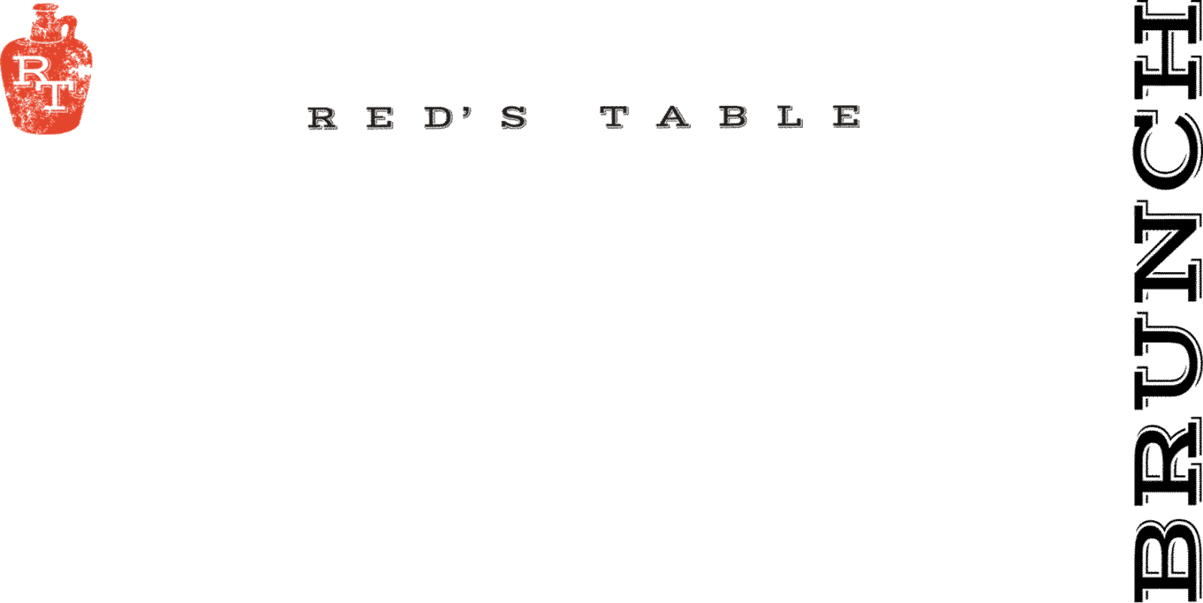

Sides
Hand-Cut Fries 7 Onion Rings with Chipotle Ranch 7
Crispy Truffle Fingerling Potatoes 7 Seasonal Vegetables 9
Fried Brussel Sprouts w/ Gluten Free Ponzu Sauce 7
Side of Bread w/ Butter 3 Cheddar Grits 7
Green Salad Cucumbers, Tomatoes, Pickled Onions 7
Home Fries 5 Two Eggs Any Style 7
Fruit Cup 5 Applewood Smoked Bacon 6
Maple Sausage or Chicken Sausage 5 Sausage Gravy 2
Two Biscuits 6 Two English Muffins 6
Two Biscuits & Sausage Gravy 8 Hollandaise 2

Raw Bar* ½ dz
Oysters: 15 30
ask your server for today’s selections
Cocktail Shrimp 12 24
Appetizers
P.E.I. Mussels
White Wine, Garlic & Grilled Bread 15
_____________________________________________
Steak Kabobs 17 g
Kabobs of Hanger Steak, Red Bell Pepper, Red Onion, Yellow Squash, and Zucchini, accompanied with Coconut Curry and Saffron Raisin Pulao
_____________________________________________
Bang Bang Shrimp 17
Crispy Wonton, Mixed Greens, Chili Soy Ginger, Bang Bang Sauce
_____________________________________________
Chesapeake Crab Dip 18
“Maryland Style”, Old Bay, Chives, Breadcrumbs,
Grilled Rustic Bread
~Add Celery for +$2
_____________________________________________
Chicken Wings 16
Served Naked, House Buffalo, BBQ, or Maple-Sriracha
~Oven Roasted by Request g
_____________________________________________
Goat Cheese Fritters 13 v
Chili-Apricot Jam, Chives, Shredded Parmesan
_____________________________________________
Point Judith Calamari 16
Cherry Peppers, Shishito Peppers, Lemon
Served With Lemon Garlic Aioli & Pomodoro Sauce
_____________________________________________
Soups:
Clam Chowder 6/10
Oyster Crackers, Bacon
_____________________________________________
Chesapeake Bay Crab Bisque 6/10 g
Blue Lump Crab Meat
_____________________________________________
Sandwiches
Gluten Free Bun available upon request +$2 upcharge
~choice of fries, onion rings or salad – or substitute a cup of soup $2
_____________________________________________
Dry Aged Beef Burger 18*
Cheddar Cheese, Caramelized Onions, B&B Pickles
_____________________________________________
Mushroom & Rolled Oat “Burger” 17 v
Red’s House Made Veggie Burger, Dijon Mustard Aioli, Swiss, Caramelized Onions
_____________________________________________
Red’s Fried Chicken Sandwich 17
Cheddar Cheese, Chipotle Ranch, Bacon, Green Leaf Lettuce, and Tomato
~can be grilled upon request
_____________________________________________
Red’s Turkey Sandwich 15
Brioche, Green Leaf Lettuce, Tomatoes, Bacon, Swiss,
House Made Tart Cherry Mayo
_____________________________________________
Chef’s Catch Sandwich MKT
Our Daily Fresh Seafood Sandwich Offering
_____________________________________________

Salads
Red’s Cobb Salad 17 g
Chopped Romaine Lettuce, Egg, Pickled Onions, Bacon, Avocado, Tomatoes, Served with Blue Cheese Dressing on the Side
_____________________________________________
Winter Wedge Salad 17
Iceberg Lettuce, Gorgonzola Cheese, Figs, Crispy Bacon,
Fried Yuca, Blue Cheese Dressing
~can be vegan upon request
_____________________________________________
Tuscan Kale Salad 17 v
Roasted Butternut Squash, Pomegranate, Feta Cheese,
Roasted Parsnips, Candied Pecan, Pomegranate Vinaigrette
~can be vegan upon request
____________________________________________
Sweet Potato Salad 15 g, v
Red Leaf Lettuce, Quinoa, Goat Cheese, Crispy Sweet Potato,
Pickled Apple, Apple Vinaigrette
Protein Add
Chicken 8 Steak 14* Shrimp 12 Scallop 18 Fish MKT*
_____________________________________________
Brunch
Breakfast Poutine 16
Hand-Cut Fries, Two Fried Eggs, Crispy Bacon, Hollandaise, Chives
~Add a Side of Sausage Gravy for $2
_____________________________________________
Shrimp & Grits 20
Chimichurri Marinated Shrimp, Cheddar Grits, Sausage Gravy,
Roasted Red Peppers and Onions
Tiramisu French Toast 17
Brioche Loaf, Whipped Mascarpone Cream, Coffee Caramel, Cocoa Dust
_____________________________________________
Pancakes 12
Scratch Made Lemon Ricotta Pancakes
Choose 1: ~ Pomegranate Orange – Spiced Pomegranate Sauce & Candied Orange
~Blueberry – Blueberries and Powdered Sugar
~Chocolate Chip – Chocolate Chips and Powdered Sugar
Served with Lemon Mascarpone and Maple Syrup
_____________________________________________
Chicken & Waffles 15
Scratch Made Lemon Ricotta Waffles & Buttermilk Fried Chicken
Choice of Maple Sriracha or Sausage Gravy
_____________________________________________
Two Eggs Breakfast 16
Two Eggs Any Style, Home Fries, Country Toast
Choice of Maple Sausage or Applewood Smoked Bacon
_____________________________________________
Croque Madame 18
Hickory Smoked Ham, Gruyère Cheese, Bechamel, Toasted Sourdough,
Topped with an Over-Medium Fried Egg, Served with Home Fries
_____________________________________________
Salmon Benedict* 21
Two Poached Eggs, Smoked Salmon Lox, Arugula, Home Fries,
Toasted English Muffin, Hollandaise
_____________________________________________
Tomato & Spinach Benedict 16
Two Poached Eggs, Sauteed Spinach, Grilled Tomatoes, Home Fries,
Toasted English Muffin, Hollandaise
_____________________________________________
Red’s “Biscuits & Gravy” Benedict 19
Two Poached Eggs, Applewood Smoked Bacon, Sausage Gravy,
Two Buttermilk Biscuits, and Home Fries
_____________________________________________
Marinated Steak & Eggs * 28 g
Two Sunnyside Up Eggs, Crispy Truffle Fingerling Potatoes, Chimichurri
_____________________________________________

g – gluten free v – vegetarian
A 20% gratuity is added to tables of 6 or more

*May contain raw or undercooked ingredients. Consuming raw or undercooked meats, poultry, seafood, shellfish or eggs may increase your risk of foodborne illness. Especially if you have certain medical conditions
11 AM – 3 PM

