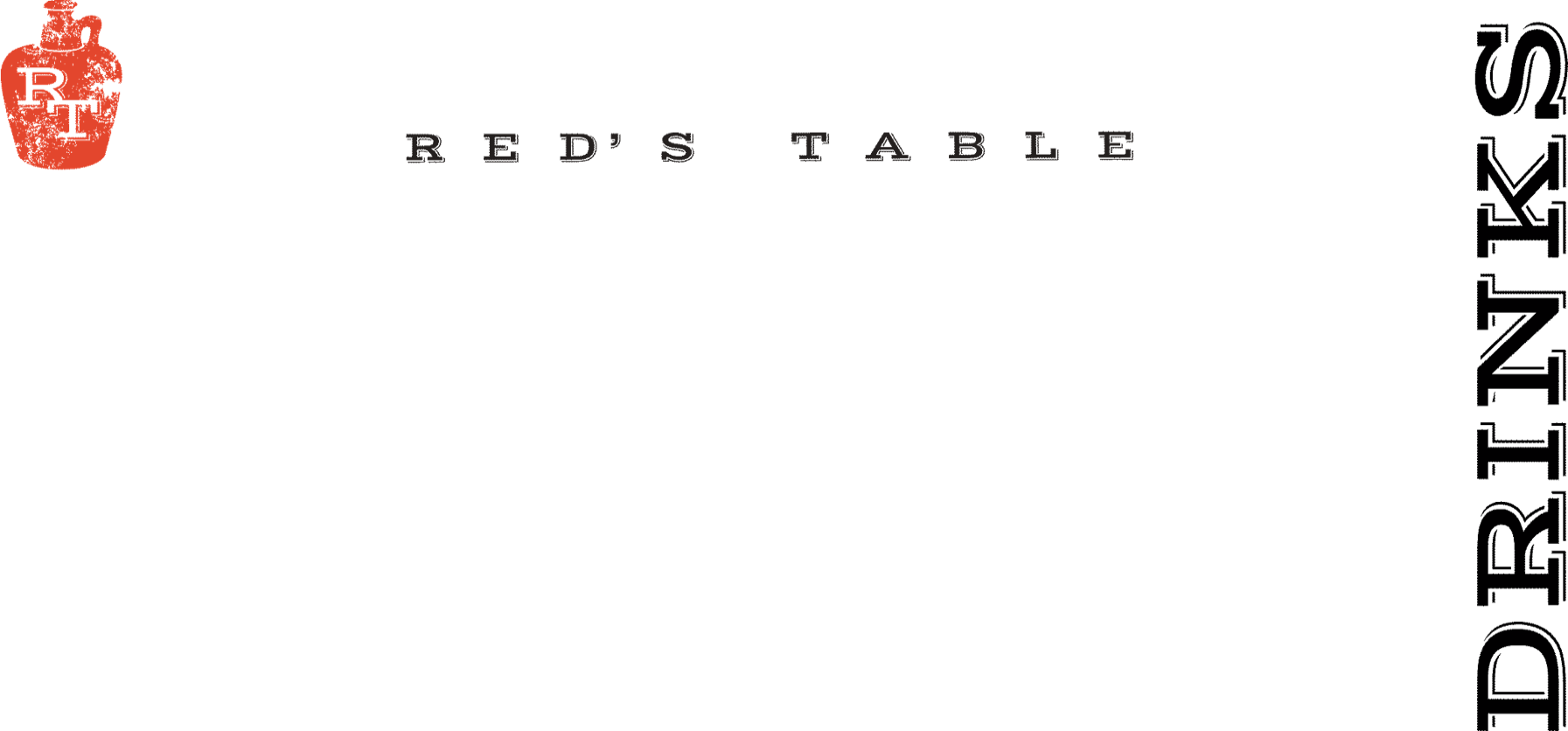
Red’s Signature Cocktails

Black Old Fashioned 14
Jim Beam Rye, Black Walnut Bitters,
Vanilla Brandied Cherry, Smoked Orange

Dead Man Walking 14
Union Mezcal, Honey Mango Limeade, Habanero,
Smoked Paprika Salt Rim

Apple Patch 14
Woodinville Bourbon, Apple Cider, Lemon Juice,
Cinnamon Demerara, Angostura Bitters

Red’s Cosmo 11
Vodka, Rosemary, Lime, Cranberry, Triple Sec

Espresso Martini 13
Espresso Vodka, Kahlua, Baileys, Cream, Cinnamon

Classic Margarita 13
Hornito’s Plata, Triple Sec, Lime, Blue Agave
Hibiscus or Mango +$2
Marg Flights Available for $25
Marg Pitchers Available for $54

House Bloody Mary 10
Add: Bacon $2, Two Shrimp $4

House Mimosa 9
Classic-Pomegranate-Mango-Hibiscus
Mimosa Flights Available for $18
Mimosa Pitchers Available for $43

Wines By The Glass

Sparkling

Cricova Brut Sparkling 9
Moldova

Coté Mas Crémant de Limoux Sparkling 13
Languedoc, France

Rotari Sparkling Rosé 13
Trento, Italy

Whites

Yulupa Chardonnay 9
California

Harken Chardonnay 10
Salinas Valley, California

Les Petite Roucas Sauvignon Blanc 8
Languedoc, France

Montinore Estate Pinot Gris 11
Willamette Valley, Oregon

Nortico Alvarinho 10
Minho, Portugal

Rosé

Renegade Syrah Rosé 13
Columbia Valley, CA

Fossil Point Grenache Rosé 11
San Luis Obispo, CA

Reds

Chasing Lions Pinot Noir 14
Northern California

N x NW Red Blend 10
Columbia Valley, Washington

Skyfall Cabernet Sauvignon 10
Columbia Valley, Washington

Alta Vista Estate Malbec 10
Mendoza, Argentina

Pearmund Petit Verdot 15
Broad Run, Virginia

Seasonal Cocktails

Peppermintini 14
Smirnoff Peppermint Vodka, Sweet Cream

Cantera Negra Espresso Martini 16
Cantera Negra Silver Tequila, Cantera Negra Café,
Café Kreyol Espresso Coffee

Toasted Snowman 13
RumChata, Fireball Whiskey, Sweet Cream, Marshmallow

Winter Jasmine 14
Gray Whale Gin, Aperol, Triple Sec, Lemon Juice,
Honey Simple, Orange Peel

Red’s Sangria 12
N x NW Red Blend, Cointreau, Orange Juice, Pineapple, Brown Sugar

Mocktails

Mango Limeade 8
Mango Juice, Lime Juice, Simple Syrup, Soda Water

Maple Orange Pomegranate Fizz 7
Orange Juice, Pomegranate Juice, Grade A 100% Maple Syrup, Soda Water

Cranberry Pineapple Mule 8
Cranberry, Pineapple, Lime, Honey Simple, Ginger Beer

MargaFREEta 13
Seedlip Notas de Agave, Lime Juice, Agave

Shirley Temple Float 9
Moorenko’s Vanilla Ice Cream, Grenadine,
Ginger Ale, Whipped Cream

Red’s Dinner Events
&
Private Event Inquiries
Email: Ryan @ rtracy@mprdev.com

