Scrambled Eggs 8
w/ bacon or sausage

Belgian Waffle 10
w/ bacon or sausage

Pancake 10
w/ bacon or sausage

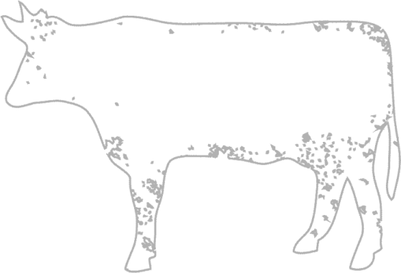
Mac & Cheese 12

Buttered Noodles 8
Served with Shredded Parmesan

Pomodoro Pasta 8
Served with Shredded Parmesan

Chicken Tenders 12
Choice of Fries, Onion Rings, or Baby Carrots

Grilled Cheese 7
Choice of Fries, Onion Rings, or Baby Carrots

Cheese Burger 10
Choice of Fries, Onion Rings, or Baby Carrots

Grilled Chicken Sandwich 12
Choice of Fries, Onion Rings, or Baby Carrots

Steak & Fries 17

Scrambled Eggs 8
w/ bacon or sausage

Belgian Waffle 10
w/ bacon or sausage

Pancake 10
w/ bacon or sausage

Mac & Cheese 12

Buttered Noodles 8
Served with Shredded Parmesan

Pomodoro Pasta 8
Served with Shredded Parmesan

Chicken Tenders 12
Choice of Fries, Onion Rings, or Baby Carrots

Grilled Cheese 7
Choice of Fries, Onion Rings, or Baby Carrots

Cheese Burger 10
Choice of Fries, Onion Rings, or Baby Carrots

Grilled Chicken Sandwich 12
Choice of Fries, Onion Rings, or Baby Carrots

Steak & Fries 17

