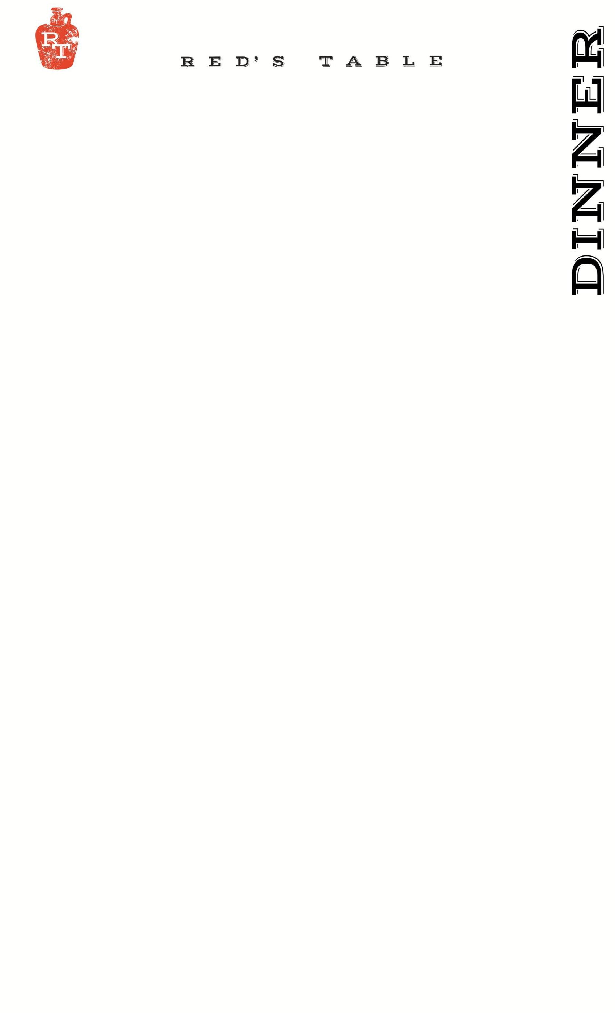78

unE 

Entrees:

**Chef’s Catch MKT**

*Our Daily Fresh Seafood Offering.*

**Lemon Cacio e Pepe with Scallops 27**

*Scratch Made Pappardelle Pasta, Asiago Cheese, Fava Beans*

_____________________________________________

**Eggplant Parmesan Ratatouille 25 v**

*Eggplant, Romesco Zucchini, Red Onion, Red Bell Pepper, Tomato,*

*Garlic, Pomodoro Sauce, Basil and Parmesan. Topped with Aji Verde*

*~can be made vegan upon request*

_____________________________________________

**Crab Croquettes 27**

*A Summer Sofrito of Carrot, Celery, Corn, Eggplant, Onions and Peas.*

*Accompanied with Ricotta Pea Puree and Brown Butter Pickled*

*Shimeji Mushrooms*

_____________________________________________

**Yuzu Miso Tiger Prawns 27**

*Baby Spinach, Romesco Zucchini, Brown Butter Pickled Shimeji Mushrooms, and Romesco Sauce*

_____________________________________________

**Chimichurri Pork Tenderloin 26 g**

*Roasted Corn Puree, Shimeji Mushrooms, Herb Confit Baby Carrots,*

*Peach Au Jus*

_____________________________________________

**Roseda Hanger Steak 35* g**

*House Made Blackened Sweet Potatoes, Dill Parmesan Creamy Roasted Corn. Served with Cowboy Butter Steak Sauce*

_____________________________________________

Sides

Hand-Cut Fries ***7***

Blackened Sweet Potatoes ***7***

Sautéed Spinach ***7***

Dill Parmesan Creamy Corn ***7***

Seasonal Vegetables ***9***

Green Salad Cucumbers, Tomatoes, Pickled Onions ***7***

Onion Rings *with* *Chipotle Ranch* ***7***

Red’s Mac & Cheese ***12***

*Side of Bread w/ Butter* ***3***

Sandwiches:

***Gluten Free Bun available upon request +$2 upcharge***

*choice of fries, onion rings or salad – or substitute a cup of soup $2*

**Dry Aged Beef Burger 18\***

*Cheddar Cheese, Caramelized Onions, B&B Pickles*

_____________________________________________

**Mushroom & Rolled Oat “Burger” 17 v**

*Red’s House Made Veggie Burger, Dijon Mustard Aioli,*

*Swiss, Caramelized Onions*

_____________________________________________

**Red’s Fried Chicken Sandwich 17**

*Cheddar Cheese, Chipotle Ranch, Bacon, Green Leaf Lettuce,*

*and Tomato*

*~can be grilled upon request*

_____________________________________________

**g – gluten free v – vegetarian**

***20% gratuity is added to tables of 6 or more***

Raw Bar:* **½ dz**

**Oysters: 15 30**

*ask your server for today’s selections*

**Cocktail Shrimp 12 24**

Appetizers:

**P.E.I. Mussels**

*White Wine, Garlic & Grilled Bread* **15**

_____________________________________________

**Trio Meatballs 17**

*Mortadella, Pistachio, Veal, Beef, Fennel Seed, Soy Sauce Meatballs covered with Pomodoro Sauce and Melted Mozzarella Cheese, Crostini*

_____________________________________________

**Bang Bang Shrimp 17**

*Crispy Wonton, Mixed Greens, Chili Soy Ginger, Bang Bang Sauce*

_____________________________________________

**Chesapeake Crab Dip 18**

*“Maryland Style”, Old Bay, Chives, Breadcrumbs,*

*Grilled Rustic Bread*

*~Add Celery for +$2*

_____________________________________________

**Chicken Wings 16**

*Served Naked, House Buffalo, BBQ, or Maple-Sriracha*

*~Oven Roasted by Request* **g**

_____________________________________________

**Goat Cheese Fritters 13 v**

*Chili-Apricot Jam, Chives, Shredded Parmesan*

_____________________________________________

**Point Judith Calamari 16**

*Cherry Peppers, Shishito Peppers, Lemon*

*Served With Lemon Garlic Aioli & Pomodoro Sauce*

_____________________________________________

**Marinated Steak Tips 17 g**

*Quinoa Solterito, a combination of Quinoa, Corn, Fava Bean,*

*Red Onion, Peas and Black Olives. Accompanied with Smoked Cotija Cheese and Aji Verde*

Soups:

**Clam Chowder 6/10**

*Oyster Crackers, Bacon*

_____________________________________________

**Chesapeake Bay Crab Bisque 6/10 g**

*Blue Lump Crab Meat*

_____________________________________________

Salads:

**Red’s Cobb Salad 17 g**

*Chopped Romaine Lettuce, Egg, Pickled Onions,*

*Smoked Bacon, Avocado, Tomatoes*

*Served With Blue Cheese Dressing on the Side*

_____________________________________________

**Baby Wedge Salad 13 g**

*Smoked Bacon, Green Onion, Fried Shallots,*

*Melted Heirloom Tomatoes, Blue Cheese Dressing* _____________________________________________

**Grilled Peach Salad 17 ve**

*Baby Spinach, Soy Pickled Watermelon, Farro,*

*Toasted Guajillo Pumpkin Seeds, Yuzu Vinaigrette*

____________________________________________

**Sweet Potato Salad 15 g**

*Red Leaf Lettuce, Quinoa, Goat Cheese, Crispy Sweet Potato,*

*Pickled Apple, Apple Vinaigrette*

Protein Add:

*Chicken* ***8***

*Steak* ***14*\***

*Shrimp* ***12***

*Scallops* ***18***

*Crab Croquettes* ***18***

*Fish* ***MKT*\***

4 – 10 PM

Sides:

*Green Salad: Cucumber, Cherry Tomato, Pickled Red Onion* ***7***

*Sautéed Spinach****7***

*Seasonal Vegetables* ***9***

*Hand-Cut Fries* ***7***

*Onion Rings with Chipotle Ranch* ***7***

*Red’s Mac & Cheese* ***12***

*Side of Bread w/ Butter* ***3***

**Patio Seating: *1 Hour & 30 Min. Time Limit per Table**