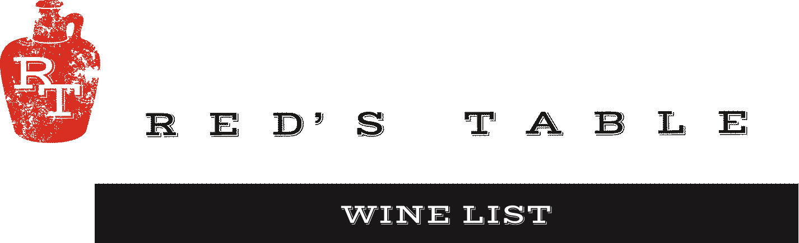

**Bubbles**

Sparkling– A classic pairing with oysters or everyday celebration.

**Cricova Brut** *Moldova* $9 $32

**Cote Mas Crémant De Limoux Brut**  *Languedoc, France* $14 $52

**Rotari Brut Rosé**  *Trento, Italy*  $13 $48

**Chapuy Grand Cru Brut NV** *Champagne, France Blanc de Blancs* — $108

**Beau Joie Champagne Brut** *Champagne, France* —            $136

**White Wine**

Chardonnay– A variety of styles from California. Pair with Oysters, Chicken and Vegetarian dishes.

**Yulupa** *Kenwood, California* $9 $32

**Harken**  *Salinas Valley, California* $10 $36

Pinot Gris– Intensely fruit-forward aromas & the fresh and clean palate offers flavors of citrus. Pair it with just about any meal, especially chicken, fish, and fresh salads.

**Montinore Estate** *Willamette Valley, Oregon* $11 $45

Riesling– QBA. Fruity & Sweet. This Riesling has a wonderful balance of residual sugar & acidity.

**Schloss Vollrads** *Rheingau, Germany* — $58

Sauvignon Blanc– Refreshing & a lovely accompaniment to fish or salad.

**Les Petite Roucas** *Languedoc, France* $8 $28

**Three Brooms** *Blind River, Marlborough, New Zealand* — $46

Albarino – This classic Spanish white brings poached pear, lemon and honey flavors for a beautiful balance that pairs perfectly with goat cheese and mussels.

**Nortico Alvarinho** *Minho, Portugal* $10 $36

Sancerre – An elegant choice in timeless old-world style. This Sauvignon Blanc is beautifully floral.

**Pascal Jolivet Sancerre** *Loire, France* — $87

Rosé – Fresh blends that show a beautiful range of flavors, from very dry to fruit forward in this versatile wine style.

**Fossil Point Rosé**  *San Luis Obispo, California* $11 $40

**Renegade Rosé**  *Columbia Valley, Washington* $13 $48

**Willamette Valley Pinot Noir Rosé** *Willamette Valley, Oregon* — $48

**Anna Codorníu Brut Rosé** *Cava, Spain* — $39

Virginia– Locally sourced

**Pearmund Sunshine (White Blend)** *Broad Run, Virginia* — $56

**Pearmund Petit Manseng**  *Broad Run, Virginia* — $56

Wine Mondays!

50% off All Wines by the bottle all day!



**Red Wine**

Pinot Noir

**Chasing Lions** *Northern California* $14 $52

**R. Stuart Love, Oregon** *Willamette Valley, Oregon* — $72

Red Blends

**N x NW Red Blend** *Columbia Valley, Washington* $10 $36

*Varietals: Merlot, Syrah, Cabernet Sauvignon*

**Omen, Red Blend Sierra Foothills** *Sierra Foothills, California* — $58

*Varietals: Zinfandel, Syrah, Barbera, Petite Syrah*

Malbec- Intenseplum & cassis aromas with subtle vanilla. Pair with roasted game, grilled red meat.

**Alta Vista Estate** *Mendoza, Argentina* $10 $36

Merlot– Deep red color, medium body, and smooth, well-balanced flavor profile.

**Broadside**  *Santa Margarita Ranch, California* $14 $52

Cabernet Sauvignon– A wide variety of styles show off this grape’s versatility and strength. From easy drinking by the glass wines to some of California’s best juice.

**Skyfall**  *Columbia Valley, Washington* $10 $40

**The Fableist 373**  *Paso Robles, California* — $55

Virginia– Locally sourced

**Pearmund Petit Verdot**  *Broad Run, Virginia* $15 $56

**Pearmund Cab Franc**  *Broad Run, Virginia* — $56

**Pearmund Black Ops (Red Blend)** *Broad Run, Virginia* — $56

**Dessert**

Tawny Port

**Taylor Fladgate 10 year** *Douro Valley, Portugal* $14 $66

Ice Wine

**Boundary Breaks** *Lodi, New York*  $23 $98

Wine Mondays!

50% off All Wines by the bottle all day!