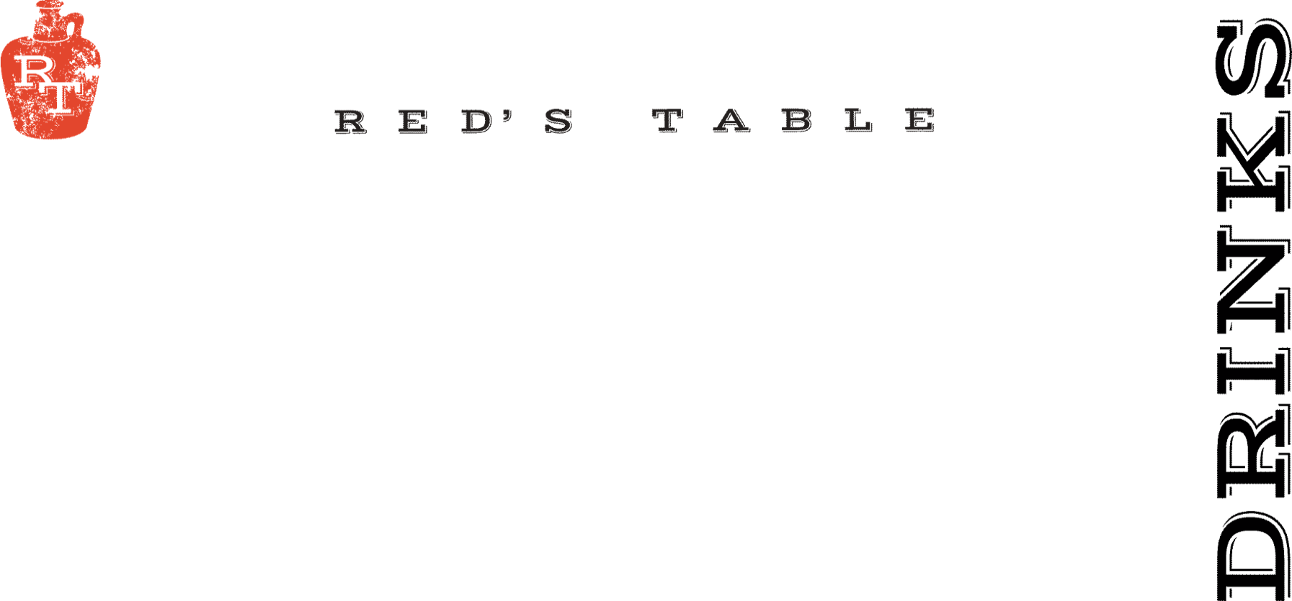
Wines By The Glass

Sparkling

Cricova Brut Sparkling 9
Moldova

Coté Mas Crémant de Limoux Sparkling 13
Languedoc, France

Rotari Sparkling Rosé 13
Trento, Italy

Whites

Yulupa Chardonnay 9
California

Harken Chardonnay 10
Salinas Valley, California

Les Petite Roucas Sauvignon Blanc 8
Languedoc, France

Montinore Estate Pinot Gris 13
Willamette Valley, Oregon

Nortico Alvarinho 10
Minho, Portugal

Rosé

Steininger Cabernet Sauvignon Rosé 11
Niederösterreich, Austria

Fossil Point Grenache Rosé 12
San Luis Obispo, CA

Reds

Chasing Lions Pinot Noir 14
Northern California

Métier Red Blend 12
Columbia Valley, Washington

Skyfall Cabernet Sauvignon 10
Columbia Valley, Washington

Don Nicanor Malbec 11
Mendoza, Argentina

Pearmund Petit Verdot 15
Broad Run, Virginia

Red’s Signature Cocktails

Black Old Fashioned 14
Jim Beam Rye, Black Walnut Bitters,
Vanilla Brandied Cherry, Smoked Orange

Dead Man Walking 14
Mezcal, Honey Mango Limeade, Habanero,
Smoked Paprika Salt Rim

Apple Patch 14
Filibuster Boondoggler, Apple Cider, Lemon Juice,
Cinnamon Demerara, Angostura Bitters

Red’s Cosmo 11
Vodka, Rosemary, Lime, Cranberry, Triple Sec

Espresso Martini 13
Espresso Vodka, Kahlua, Baileys, Cream, Cinnamon

Classic Margarita 13
Hornito’s Plata, Triple Sec, Lime, Blue Agave
Hibiscus or Mango +$2
Marg Flights Available for $25
Marg Pitchers Available for $54

House Bloody Mary 10
Add: Bacon $2, Two Shrimp $4

House Mimosa 9
Classic-Pomegranate-Mango-Hibiscus
Mimosa Flights Available for $18
Mimosa Pitchers Available for $43

Seasonal Cocktails

Verdant Breeze 10
Mint Vodka, Muddled Cucumber, Lemon Juice,
Simple Syrup

Cantera Negra Espresso Martini 16
Cantera Negra Silver Tequila, Cantera Negra Café,
Café Kreyol Espresso Coffee

Hazelnut Boulevardier 14
Old Forester Bourbon, Casals Sweet Vermouth,
Frangelico, Angostura

The Key Note 12
Planteray 3 Stars Rum, Key Lime Juice, Vanilla Bean Syrup, Half N Half, Graham Cracker Crust

Blackberry Bramble Fizz 13
Gray Whale Gin, Blackberry Shrub, Lemon Juice,
Simple Syrup, Soda Water

Red’s Sangria 12
N x NW Red Blend, Cointreau, Orange Juice, Pineapple, Brown Sugar

Lake Punch 10
Vodka, White Rum, Blend of Juices, Sprite

Mocktails

Mango Limeade 8
Mango Juice, Lime Juice, Simple Syrup, Soda Water

Maple Orange Pomegranate Fizz 7
Orange Juice, Pomegranate Juice, Grade A 100% Maple Syrup, Soda Water

Cranberry Pineapple Mule 8
Cranberry, Pineapple, Lime, Honey Simple, Ginger Beer

Red’s Dinner Events
&
Private Event Inquiries
Email: Ryan @ rtracy@mprdev.com

