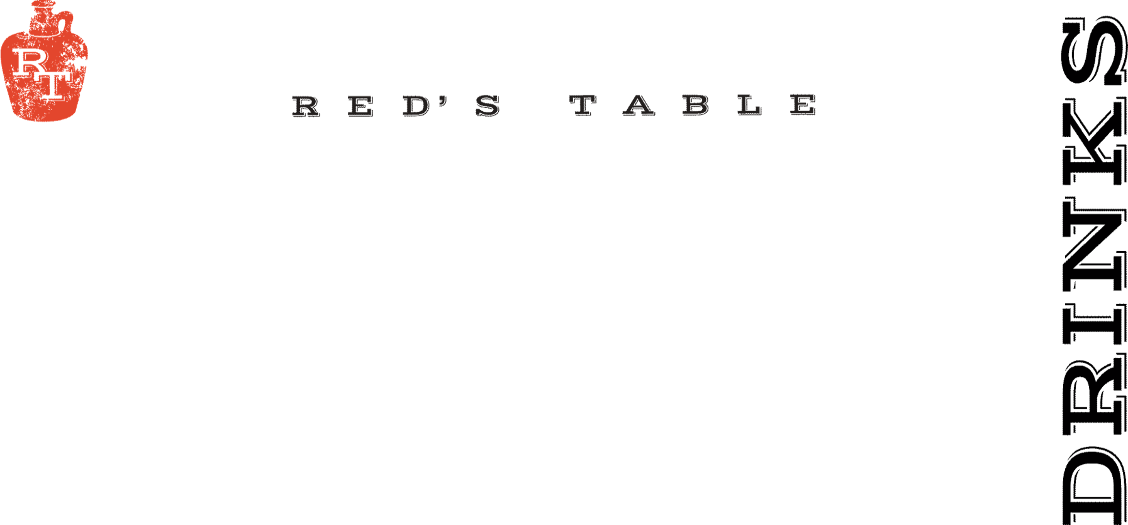
Wines By The Glass

Sparkling

Cricova Brut Sparkling 9
Moldova

Coté Mas Cremant de Limoux Sparkling 13
Languedoc, France

Rotari Sparkling Rosé 13
Trento, Italy

Whites

Yulupa Chardonnay 9
California

Harken Chardonnay 10
Salinas Valley, California

Les Petite Roucas Sauvignon Blanc 8
Languedoc, France

Montinore Estate Pinot Gris 11
Willamette Valley, Oregon

Nortico Alvarinho 10
Minho, Portugal

Rosé

Renegade Syrah Rosé 13
Columbia Valley, CA

Fossil Point Grenache Rosé 11
San Luis Obispo, CA

Reds

Chasing Lions Pinot Noir 14
Northern California

N x NW Red Blend 10
Columbia Valley, Washington

Skyfall Cabernet Sauvignon 10
Columbia Valley, Washington

Alta Vista Estate Malbec 10
Mendoza, Argentina

Pearmund Petit Verdot 15
Broad Run, Virginia

Red’s Signature Cocktails

Black Old Fashioned 14
Jim Beam Rye, Black Walnut Bitters,
Vanilla Brandied Cherry, Smoked Orange

Dead Man Walking 14
Union Mezcal, Honey Mango Limeade, Habanero,
Smoked Paprika Salt Rim

Apple Patch 14
Woodinville Bourbon, Apple Cider, Lemon Juice,
Cinnamon Demerara, Angostura Bitters

Red’s Cosmo 11
Vodka, Rosemary, Lime, Cranberry, Triple Sec

Espresso Martini 13
Espresso Vodka, Kahlua, Baileys,
Cream, Cinnamon

Classic Margarita 13
Hornito’s Plata, Triple Sec, Lime, Blue Agave
Hibiscus or Mango +$2
Marg Flights Available for $25
Marg Pitchers Available for $54

House Bloody Mary 10
Add: Bacon $2, Two Shrimp $4

House Mimosa 9
Classic-Pomegranate-Mango-Hibiscus
Mimosa Flights Available for $18
Mimosa Pitchers Available for $43

Seasonal Cocktails

The Last Ember 13
Kraken Black Spiced Rum, Kahlua, St. Elizabeth’s Dram,
Maple Syrup, Lemon Juice, Angostura Bitters

Desert Bloom 10
Lunazul Reposado, Fuji Apple Juice, Lime Juice,
Cinnamon Demerara, Orange Bitters, Cinnamon Apple

Fireside Old Fashioned 14
Mt. Defiance Smoked Whiskey, Maple Syrup,
Angostura Bitters, Orange Bitters, Elemakule Bitters,
Smoked Orange, Amarena Cherry

Spicy Garden Gimlet 12
House Made Fennel Infused Gin, Lime Juice,
Cucumber, Basil, Jalapeno, Honey Simple

Red’s Sangria 12
N x NW Red Blend, Cointreau, Orange Juice, Pineapple, Brown Sugar

Mocktails

Mango Limeade 8
Mango Juice, Lime Juice, Simple Syrup,
Soda Water

Maple Orange Pomegranate Fizz 7
Orange Juice, Pomegranate Juice, Grade A 100% Maple Syrup, Soda Water

11 oz. Squeeze Bottles To Go

Classic Ranch 9
Chipotle Ranch 9
Maple Sriracha 15
Bang Bang 9
Garlic Aioli 9
Bleu Cheese Dressing 9
White Balsamic Dressing 9

Red’s Dinner Events
&
Private Event Inquiries
Email: Ryan @ rtracy@mprdev.com

