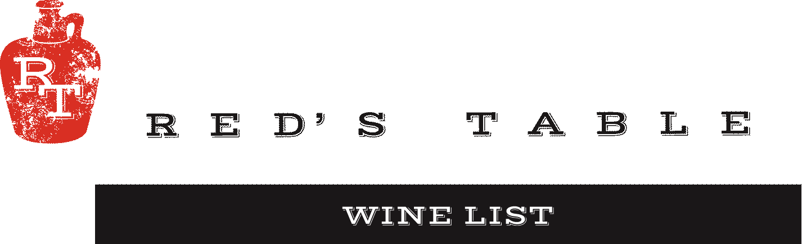

Bubbles
Sparkling – A classic pairing with oysters or everyday celebration.
Cricova Brut Moldova $9 $32
Cote Mas Crémant De Limoux Brut Languedoc, France $14 $52
Rotari Brut Rosé Trento, Italy $13 $48
Chapuy Grand Cru Brut NV Champagne, France Blanc de Blancs — $108
Schramsberg Blanc de Blanc Napa Valley, California — $117
Piper Heidsieck Rosé Sauvage Champagne, France — $136
Devaux Coeur Des Bar Blanc de Noir Champagne, France Blanc de Blancs — $105
Charles Heidsieck Brut Reserve Champagne, France — $142

White Wine
Chardonnay – A variety of styles from California. Pair with Oysters, Chicken and Vegetarian dishes.
Yulupa Kenwood, California $9 $32
Harken Salinas Valley, California $10 $36
Potel Mâcon-Villages Burgundy, France — $68
Cambria “Katherine’s Vineyard” Santa Maria Valley, California — $56

Pinot Gris – Intensely fruit-forward aromas & the fresh and clean palate offers flavors of citrus. Pair it with just about any meal, especially chicken, fish, and fresh salads.
Montinore Estate Willamette Valley, Oregon $13 $48

Sauvignon Blanc – Refreshing & a lovely accompaniment to fish or salad.
Les Petite Roucas Languedoc, France $8 $28
Cloudwatcher California $10 $36
Three Brooms Blind River, Marlborough, New Zealand — $46

Albariño – This classic Spanish white brings poached pear, lemon and honey flavors for a beautiful balance that pairs perfectly with goat cheese and mussels.
Bedell Cellars Albariño North Fork, Long Island New York — $64
Nortico Alvarinho Minho, Portugal $10 $36

Rosé – Fresh blends that show a beautiful range of flavors, from very dry to fruit forward in this versatile wine style.
Fossil Point (Grenache) Rosé San Luis Obispo, California $12 $44
Steininger (Cabernet Sauvignon) Rosé Niederösterreich, Austria $11 $40
Renegade (Syrah) Rosé Columbia Valley, Washington — $48
Anna Codorníu Brut Rosé Cava, Spain — $39

Virginia – Locally sourced
Pearmund Sunshine (White Blend) Broad Run, Virginia — $56
Pearmund Petit Manseng Broad Run, Virginia — $56

South African –
New Dawn White Blend Western Cape, South Africa — $52

Women Owned Wineries – A variety of Wines from Women Owned Wine Makers Throughout the World.
La Cappuccina, Soave Garganega Veneto, Italy — $36

Wine Mondays!
50% off All Wines by the bottle all day!

Red Wine
Pinot Noir
Chasing Lions Northern California $14 $52
R. Stuart Love, Oregon Willamette Valley, Oregon — $72

Red Blends
Métier Red Blend Columbia Valley, Washington $12 $44
Varietals: Syrah, Cabernet Sauvignon, Malbec

Honoro Vera Red Blend Jumilla, Spain $10 $36
Varietals: Grenache, Syrah, Mourvedre

Omen, Red Blend Sierra Foothills Sierra Foothills, California — $58
Varietals: Zinfandel, Syrah, Barbera, Petite Syrah

Malbec - Intense plum & cassis aromas with subtle vanilla. Pair with roasted game, grilled red meat.
Don Nicanor Mendoza, Argentina $11 $40

Merlot – Deep red color, medium body, and smooth, well-balanced flavor profile.
Broadside Santa Margarita Ranch, California — $52

Cabernet Sauvignon – A wide variety of styles show off this grape’s versatility and strength. From easy drinking by the glass wines to some of California’s best juice.
Skyfall Columbia Valley, Washington $10 $40
The Fableist 373 Paso Robles, California — $56

Virginia – Locally sourced
Pearmund Petit Verdot Broad Run, Virginia $15 $56

Italian – A variety of Wines from the region
Il Borro Toscana Borrigiano Tuscany, Italy — $52

Spanish – A variety of Wines from the region
Casa Rojo “Tinta Fina” (100% Tempranillo) Jumilla, Spain — $92
Casa Rojo “Machoman” (100% Monastrell) Jumilla, Spain — $92
Casa Rojo “Vinas Bastardas” (Monastrell, Garnacha, Syrah) Jumilla, Spain — $68

Women Owned Wineries – A variety of Wines from Women Owned Wine Makers Throughout the World.
Mil Historias Bobal Castilla, La Mancha, Spain — $40
Ten Sisters Pinot Noir Marlborough, New Zealand — $52
La Cappuccina, Campo Buri Rosso Veneto, Italy — $76

Dessert

Tawny Port
Taylor Fladgate 10 year Douro Valley, Portugal $14 $66

Ice Wine
Boundary Breaks Lodi, New York $23 $98

Wine Mondays!
50% off All Wines by the bottle all day!

