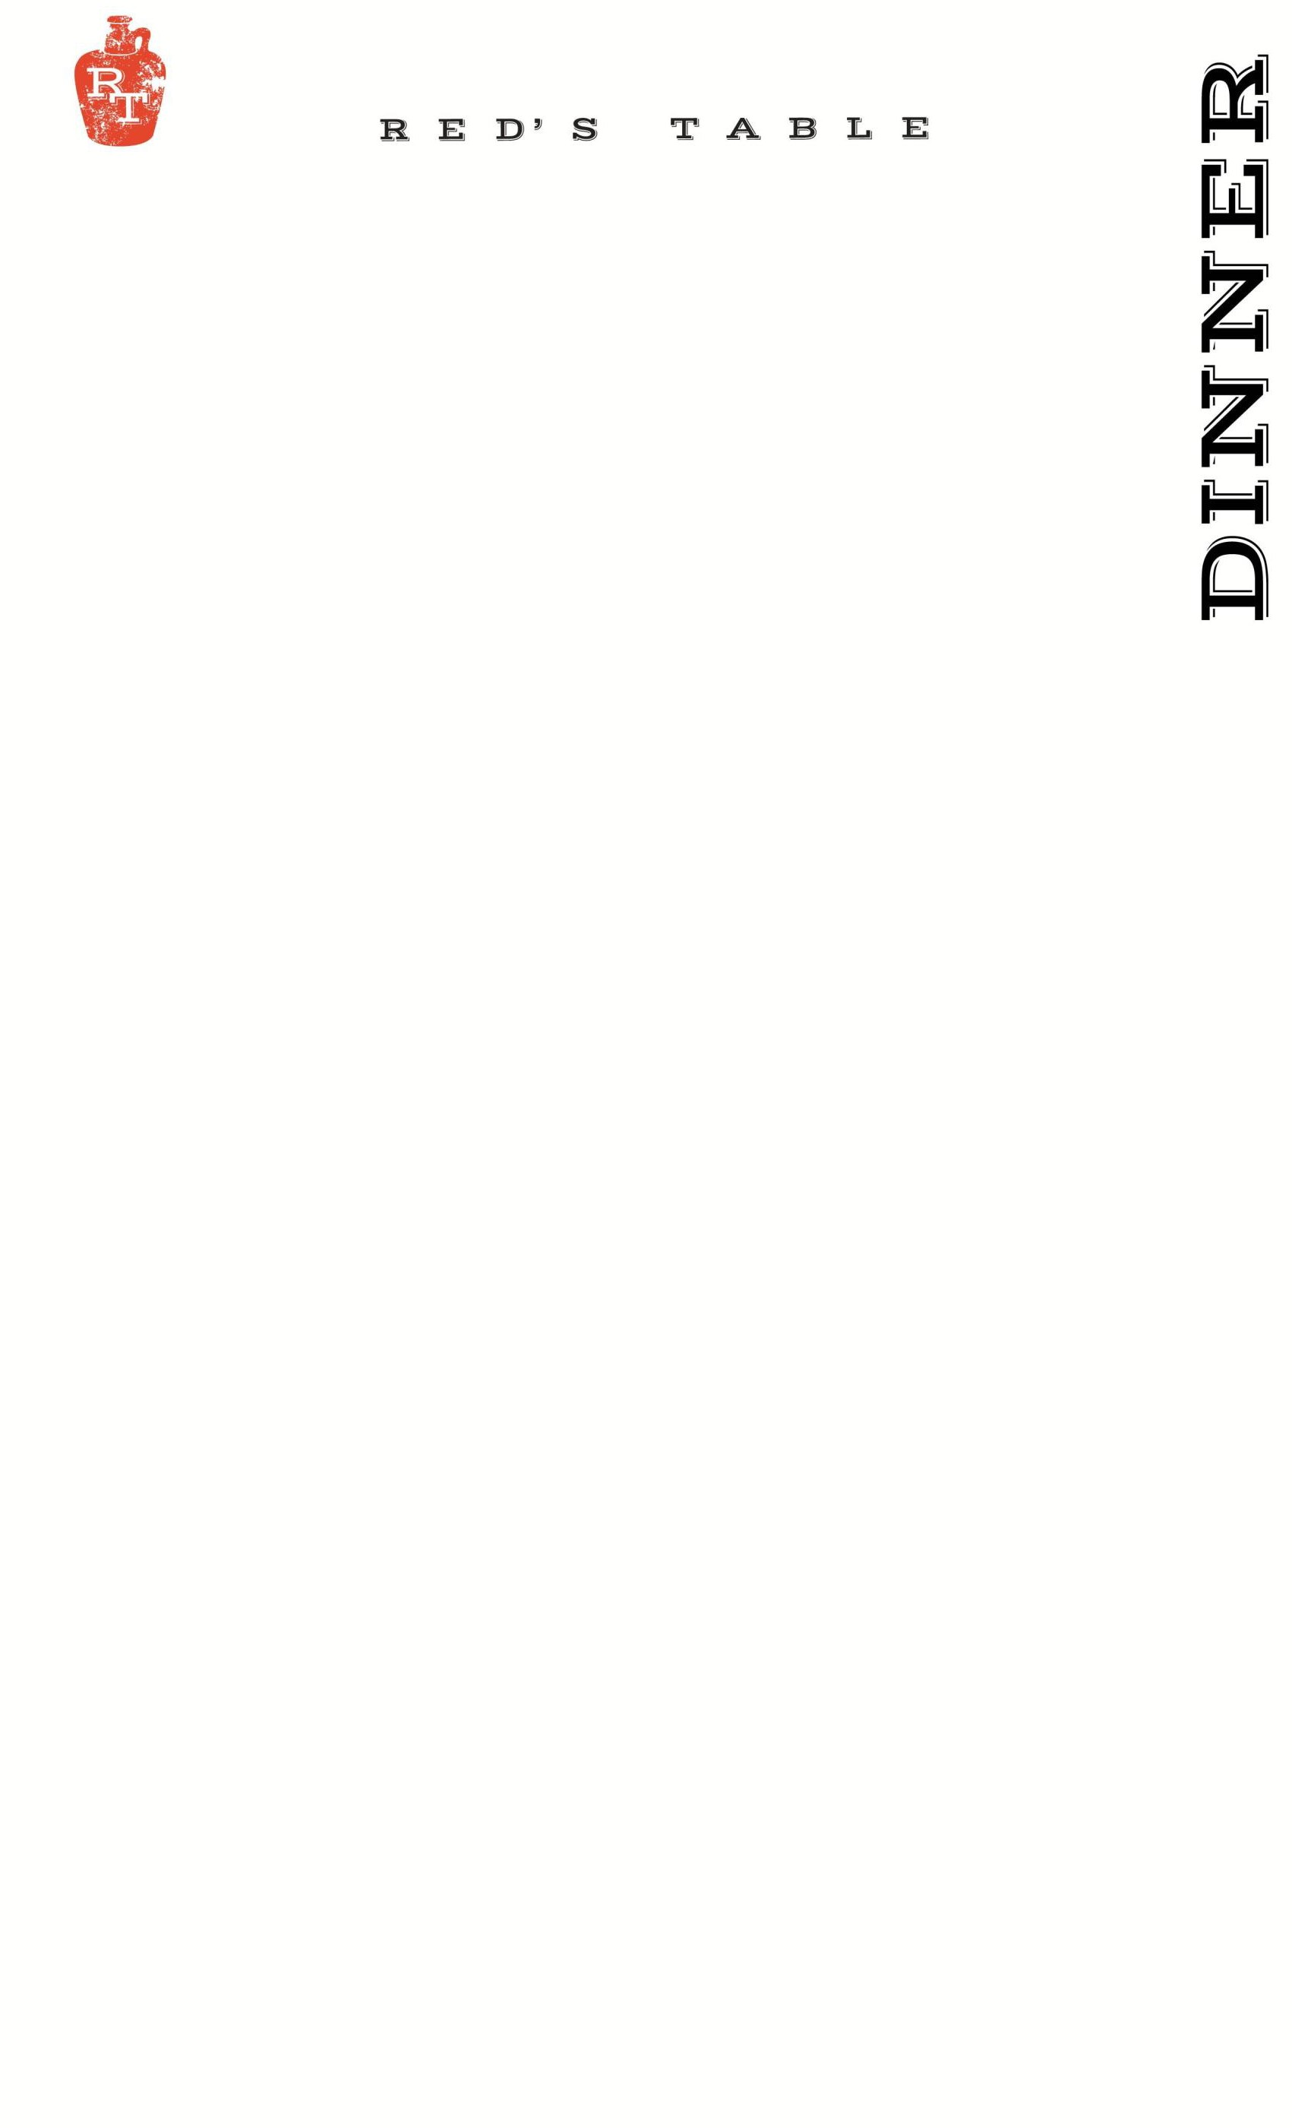
78
unE u
Soups:
Clam Chowder 6/10
Oyster Crackers, Bacon
_____________________________________________
Chesapeake Bay Crab Bisque 6/10 g
Blue Lump Crab Meat
_____________________________________________

Salads:
Red’s Cobb Salad 17 g
Chopped Romaine Lettuce, Egg, Pickled Onions, Bacon, Avocado, Tomatoes, Served with Blue Cheese Dressing on the Side
_____________________________________________
Winter Wedge Salad 17
Iceberg Lettuce, Gorgonzola Cheese, Figs, Crispy Bacon,
Fried Yuca, Blue Cheese Dressing
~can be vegan upon request
_____________________________________________
Tuscan Kale Salad 17 v
Roasted Butternut Squash, Pomegranate, Feta Cheese, Roasted Parsnips, Candied Pecan, Pomegranate Vinaigrette
~can be vegan upon request
____________________________________________
Sweet Potato Salad 15 g, v
Red Leaf Lettuce, Quinoa, Goat Cheese, Crispy Sweet Potato,
Pickled Apple, Apple Vinaigrette

Protein Add:
Chicken 8
Steak 14*
Shrimp 12
Scallops 18
Fish MKT*

Sides
Hand-Cut Fries 7
Crispy Truffle Fingerling Potatoes 7
Sautéed Spinach 7
Fried Brussel Sprouts w/ Gluten Free Ponzu Sauce 7
Seasonal Vegetables 9
Green Salad Cucumbers, Tomatoes, Pickled Onions 7
Onion Rings with Chipotle Ranch 7
Red’s Mac & Cheese 12
Side of Bread w/ Butter 3

Sandwiches:
Gluten Free Bun available upon request +$2 upcharge
~choice of fries, onion rings or salad – or substitute a cup of soup $2

Dry Aged Beef Burger 18*
Cheddar Cheese, Caramelized Onions, B&B Pickles
_____________________________________________
Mushroom & Rolled Oat “Burger” 17 v
Red’s House Made Veggie Burger, Dijon Mustard Aioli,
Swiss, Caramelized Onions
_____________________________________________
Red’s Fried Chicken Sandwich 17
Cheddar Cheese, Chipotle Ranch, Bacon, Green Leaf Lettuce,
and Tomato
~can be grilled upon request
_____________________________________________

Entrees:

Chef’s Catch MKT
Our Daily Fresh Seafood Offering.
Pan Seared Scallop 30 g
Risotto Milanese, Roasted Parsnips, Pattypan Squash, Parmesan
_____________________________________________
Hasselback Roasted Celery Root 25 v
Coffee Butternut Puree, Smoked Feta Cheese, Confit French Carrot,
Oyster Mushroom, Pomegranate Sauce
~can be vegan upon request
_____________________________________________
Short Rib Ragu 28
House Made Bucatini Pasta, Roasted Celeriac, Oyster Mushroom, Parmesan, Garlic Breadcrumbs
_____________________________________________
Shrimp & Saffron 27
House Made Pappardelle Pasta, Creamy Saffron Sauce, Olives,
Pattypan Squash, Parmesan Cheese
_____________________________________________
Roseda Braised Short Rib 32 g
French Onion Mashed Potatoes, Roasted French Carrot, Lacinato Kale,
Cocoa Au Jus, Apple Relish, Crispy Sweet Potato
_____________________________________________
Roseda Hanger Steak 35* g
Crispy Truffle Fingerling Potato, Fried Brussels with Gluten Free Ponzu,
Compote Butter, Chimichurri
_____________________________________________

g – gluten free v – vegetarian

20% gratuity is added to tables of 6 or more

Raw Bar:* ½ dz
Oysters: 15 30
ask your server for today’s selections
Cocktail Shrimp 12 24

Appetizers:
P.E.I. Mussels
White Wine, Garlic & Grilled Bread 15
_____________________________________________
Trio Meatballs 17
Mortadella, Pistachio, Veal, Beef, Fennel Seed, Soy Sauce Meatballs covered with Pomodoro Sauce and Melted Mozzarella Cheese, Crostini
_____________________________________________
Bang Bang Shrimp 17
Crispy Wonton, Mixed Greens, Chili Soy Ginger, Bang Bang Sauce
_____________________________________________
Chesapeake Crab Dip 18
“Maryland Style”, Old Bay, Chives, Breadcrumbs,
Grilled Rustic Bread
~Add Celery for +$2
_____________________________________________
Chicken Wings 16
Served Naked, House Buffalo, BBQ, or Maple-Sriracha
~Oven Roasted by Request g
_____________________________________________
Goat Cheese Fritters 13 v
Chili-Apricot Jam, Chives, Shredded Parmesan
_____________________________________________
Point Judith Calamari 16
Cherry Peppers, Shishito Peppers, Lemon
Served With Lemon Garlic Aioli & Pomodoro Sauce
_____________________________________________
Steak Kabobs 17 g
Kabobs of Hanger Steak, Red Bell Pepper, Red Onion, Yellow Squash, and Zucchini, accompanied with Coconut Curry and Saffron Raisin Pulao
_____________________________________________

4 – 10 PM

Sides:
Green Salad: Cucumber, Cherry Tomato, Pickled Red Onion 7

Sautéed Spinach 7

Seasonal Vegetables 9

Hand-Cut Fries 7

Onion Rings with Chipotle Ranch 7

Red’s Mac & Cheese 12

Side of Bread w/ Butter 3

Patio Seating: *1 Hour & 30 Min. Time Limit per Table

