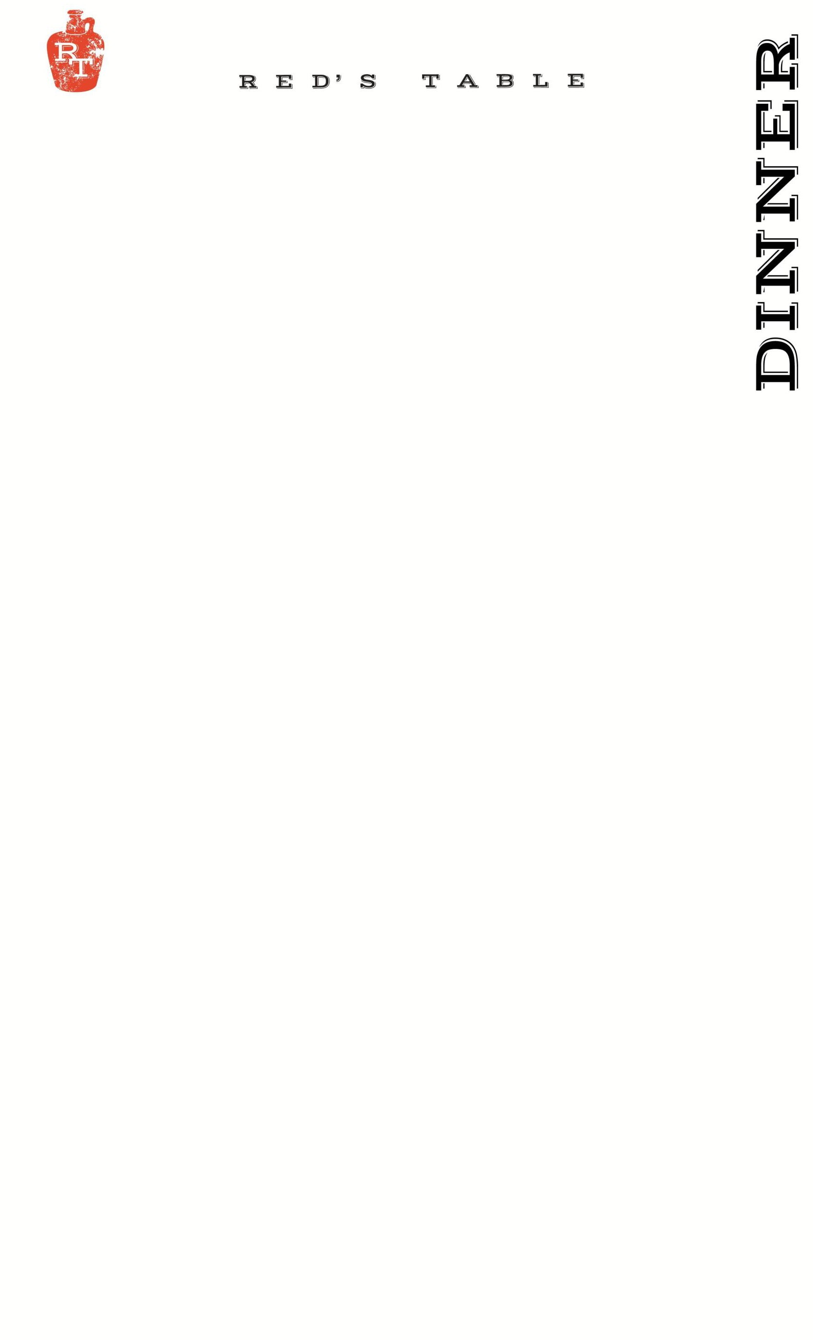
78
unE
Entrees:

Chef’s Catch MKT
Our Daily Fresh Seafood Offering.
Pan Seared Scallop 30 g
Guajillo Delicata Squash Puree, Black Lentils, Braised Cabbage
_____________________________________________
Cauliflower Schnitzel 25 v
Caramelized Onion Puree, Sauerkraut, Pattypan Squash,
Spiced Brandied Cranberry Sauce
~can be vegan upon request
_____________________________________________
Shrimp & Saffron 27
Scratch Made Pappardelle Pasta, Creamy Saffron Sauce, Olives,
Pattypan Squash, Parmesan Cheese
~can be vegan without Shrimp upon request $20
_____________________________________________
Braised Lamb Shank 32 g
Truffle Polenta, Mushroom Stew, Cipollini Onion
_____________________________________________
Roasted Chicken Breast 26 g
White Molé, Red Bhutanese Rice, Pickled Pearl Onions
_____________________________________________
Roseda Hanger Steak 35* g
Potato Pavé, Fried Brussel Sprouts with Ponzu Sauce, Beet Au Jus
_____________________________________________

g – gluten free v – vegetarian
20% gratuity is added to tables of 6 or more

Soups:
Clam Chowder 6/10
Oyster Crackers, Bacon
_____________________________________________
Chesapeake Bay Crab Bisque 6/10 g
Blue Lump Crab Meat
_____________________________________________

Salads:
Fall Cobb Salad 17 g, v
Chopped Romaine Lettuce, Pickled Egg, Green Beans,
Roasted Cinnamon Delicata Squash, Orange Bacon Jam,
Avocado, Gorgonzola Cheese Dressing
~can be vegan upon request
_____________________________________________
Persimmon Salad 15 g, v
Artisan Head Lettuce, Persimmons, Gouda Cheese, Roasted Fennel,
Crispy Serrano Ham, Maple Curry Vinaigrette
~can be vegan upon request
_____________________________________________
Beet & Pumpkin Salad 17 v
Baby Arugula, Candied Walnuts, Goat Cheese Mousse,
Brioche Crostini, Carrot Ginger Vinaigrette
~can be vegan upon request
____________________________________________
Sweet Potato Salad 15 g, v
Red Leaf Lettuce, Quinoa, Goat Cheese, Crispy Sweet Potato,
Pickled Apple, Apple Vinaigrette

Protein Add:
Chicken 8
Steak 14*
Shrimp 12
Scallops 18
Fish MKT*

Sides
Hand-Cut Fries 7
Potato Pavé 7
Sautéed Spinach 7
Fried Brussel Sprouts w/ Ponzu Sauce 7
Seasonal Vegetables 9
Green Salad Cucumbers, Tomatoes, Pickled Onions 7
Onion Rings with Chipotle Ranch 7
Red’s Mac & Cheese 12
Side of Bread w/ Butter 3

Sandwiches:
Gluten Free Bun available upon request +$2 upcharge
~choice of fries, onion rings or salad – or substitute a cup of soup $2

Dry Aged Beef Burger 18*
Cheddar Cheese, Caramelized Onions, B&B Pickles
_____________________________________________
Mushroom & Rolled Oat “Burger” 17 v
Red’s House Made Veggie Burger, Dijon Mustard Aioli,
Swiss, Caramelized Onions
_____________________________________________
Red’s Fried Chicken Sandwich 17
Cheddar Cheese, Chipotle Ranch, Bacon, Green Leaf Lettuce,
and Tomato
~can be grilled upon request
_____________________________________________

Raw Bar:* ½ dz
Oysters: 15 30
ask your server for today’s selections
Cocktail Shrimp 12 24

Appetizers:
P.E.I. Mussels
White Wine, Garlic & Grilled Bread 15
_____________________________________________
Lamb Ragu 16 g
Fried Plantain, Gouda Cheese, Smoked Paprika Aioli
_____________________________________________
Bang Bang Shrimp 17
Crispy Wonton, Mixed Greens, Chili Soy Ginger, Bang Bang Sauce
_____________________________________________
Chesapeake Crab Dip 18
“Maryland Style”, Old Bay, Chives, Breadcrumbs,
Grilled Rustic Bread
~Add Celery for +$2
_____________________________________________
Chicken Wings 16
Served Naked, House Buffalo, BBQ, or Maple-Sriracha
~Oven Roasted by Request g
_____________________________________________
Goat Cheese Fritters 13 v
Chili-Apricot Jam, Chives, Shredded Parmesan
_____________________________________________
Point Judith Calamari 16
Cherry Peppers, Shishito Peppers, Lemon
Served With Lemon Garlic Aioli & Pomodoro Sauce
_____________________________________________
Steak Kabobs 17 g
Kabobs of Hanger Steak, Red Bell Pepper, Red Onion, Yellow Squash, and Zucchini, accompanied with Coconut Curry and Saffron Raisin Pulao

4 – 10 PM

Sides:
Green Salad: Cucumber, Cherry Tomato, Pickled Red Onion 7

Sautéed Spinach 7

Seasonal Vegetables 9

Hand-Cut Fries 7

Onion Rings with Chipotle Ranch 7

Red’s Mac & Cheese 12

Side of Bread w/ Butter 3

Patio Seating: *1 Hour & 30 Min. Time Limit per Table

