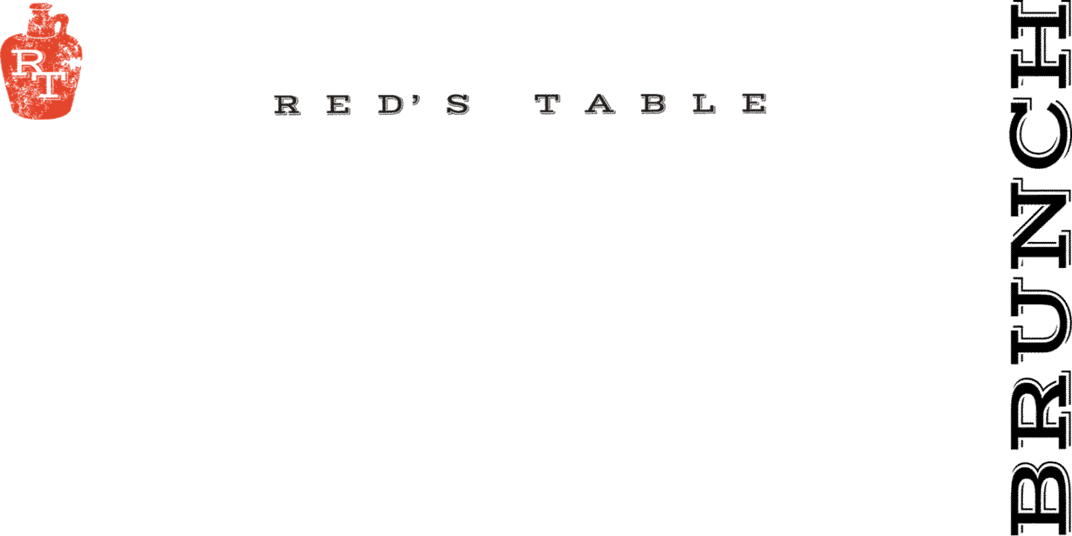
Sides
Hand-Cut Fries 7
Onion Rings with Chipotle Ranch 7
Blackened Sweet Potatoes 7
Seasonal Vegetables 9
Dill Parmesan Creamy Corn 7
Side of Bread w/ Butter 3
Green Salad Cucumbers, Tomatoes, Pickled Onions 7
Home Fries 5 Two Eggs Any Style 7
Fruit Cup 5 Applewood Smoked Bacon 6
Maple Sausage or Chicken Sausage 5 Sausage Gravy 2
Two Biscuits 6 Two English Muffins 6
Two Biscuits & Sausage Gravy 8 Hollandaise 2

Raw Bar* ½ dz
Oysters: 15 30
ask your server for today’s selections
Cocktail Shrimp 12 24
Appetizers
P.E.I. Mussels
White Wine, Garlic & Grilled Bread 15
_____________________________________________
Bang Bang Shrimp 17
Crispy Wonton, Mixed Greens, Chili Soy Ginger, Bang Bang Sauce
_____________________________________________
Chesapeake Crab Dip 18
“Maryland Style”, Old Bay, Chives, Breadcrumbs,
Grilled Rustic Bread
Add Celery for +$2
_____________________________________________
Chicken Wings 16
Served Naked, House Buffalo, BBQ, or Maple-Sriracha
*Oven Roasted by Request g
_____________________________________________
Goat Cheese Fritters 13 v
Chili-Apricot Jam, Chives, Shredded Parmesan
_____________________________________________
Point Judith Calamari 16
Cherry Peppers, Shishito Peppers, Lemon
Served With Lemon Garlic Aioli & Pomodoro Sauce
_____________________________________________
Soups:
Clam Chowder 6/10
Oyster Crackers, Bacon
_____________________________________________
Chesapeake Bay Crab Bisque 6/10 g
Blue Lump Crab Meat
_____________________________________________
Sandwiches
Gluten Free Bun available upon request +$2 upcharge
choice of fries, onion rings or salad – or substitute a cup of soup $2
_____________________________________________
Dry Aged Beef Burger 18*
Cheddar Cheese, Caramelized Onions, B&B Pickles
_____________________________________________
Mushroom & Rolled Oat “Burger” 17 v
Red’s House Made Veggie Burger, Dijon Mustard Aioli, Swiss, Caramelized Onions
_____________________________________________
Red’s Fried Chicken Sandwich 17
Cheddar Cheese, Chipotle Ranch, Bacon, Green Leaf Lettuce, and Tomato
-can be grilled upon request
_____________________________________________
Red’s Turkey Sandwich 15
Brioche, Green Leaf Lettuce, Tomatoes, Bacon, Swiss,
House Made Tart Cherry Mayo
_____________________________________________
Chef’s Catch Sandwich MKT
Our Daily Fresh Seafood Sandwich Offering
_____________________________________________

Salads
Red’s Cobb Salad 17 g
Chopped Romaine Lettuce, Egg, Pickled Onions,
Smoked Bacon, Avocado, Tomatoes
Served With Blue Cheese Dressing on the Side
_____________________________________________
Baby Wedge Salad 13 g
Smoked Bacon, Green Onion, Fried Shallots,
Melted Heirloom Tomatoes, Blue Cheese Dressing _____________________________________________
Grilled Peach Salad 17 ve
Baby Spinach, Soy Pickled Watermelon, Farro,
Toasted Guajillo Pumpkin Seeds, Yuzu Vinaigrette
____________________________________________
Sweet Potato Salad 15 g
Red Leaf Lettuce, Quinoa, Goat Cheese, Crispy Sweet Potato,
Pickled Apple, Apple Vinaigrette

Protein Add
Chicken 8 Steak 14* Shrimp 12
Scallop 18 Fish MKT* Crab Croquettes 18
_____________________________________________
Brunch
Breakfast Poutine 16
Hand-Cut Fries, Two Fried Eggs, Crispy Bacon, Hollandaise, Chives
Add a Side of Sausage Gravy for $2
_____________________________________________
Caramelized Peach French Toast 14
Brioche Loaf, Cinnamon Whipped Cream, Toasted Pecans
_____________________________________________
Pancakes 12
Scratch Made Lemon Ricotta Pancakes
Choose 1 : ~ Banana Frappuccino – Bananas and Coffee Caramel
~Blueberry – Blueberries and Powdered Sugar
~Chocolate Chip – Chocolate Chips and Powdered Sugar
Served with Lemon Mascarpone and Maple Syrup
_____________________________________________
Chicken & Waffles 15
Scratch Made Lemon Ricotta Waffles & Buttermilk Fried Chicken
Choice of Maple Sriracha or Sausage Gravy
_____________________________________________
Two Eggs Breakfast 16
Two Eggs Any Style, Home Fries, Country Toast
Choice of Maple Sausage or Applewood Smoked Bacon
_____________________________________________
Breakfast Sandwich 18
Huevos Ranchero on a Home-Made Jalapeno Cheddar Biscuit,
Chicken Sausage and Mozzarella Cheese. Served with Home Fries.
_____________________________________________
Salmon Benedict* 21
Two Poached Eggs, Smoked Salmon Lox, Arugula, Home Fries,
Toasted English Muffin, Hollandaise
_____________________________________________
Tomato & Spinach Benedict 16
Two Poached Eggs, Sauteed Spinach, Grilled Tomatoes, Home Fries,
Toasted English Muffin, Hollandaise
_____________________________________________
Red’s “Biscuits & Gravy” Benedict 19
Two Poached Eggs, Applewood Smoked Bacon, Sausage Gravy,
Two Buttermilk Biscuits, and Home Fries
_____________________________________________
Steak & Eggs * 28
A Summer Succotash of Bacon, Fava Beans, Peas, Corn, Red Bell Pepper,
Cherry Tomatoes, and Red Onion. Accompanied with Cotija Cheese and
Ranchero Sauce
_____________________________________________

g – gluten free v – vegetarian
A 20% gratuity is added to tables of 6 or more

*May contain raw or undercooked ingredients. Consuming raw or undercooked meats, poultry, seafood, shellfish or eggs may increase your risk of foodborne illness. Especially if you have certain medical conditions
11 AM – 3 PM

