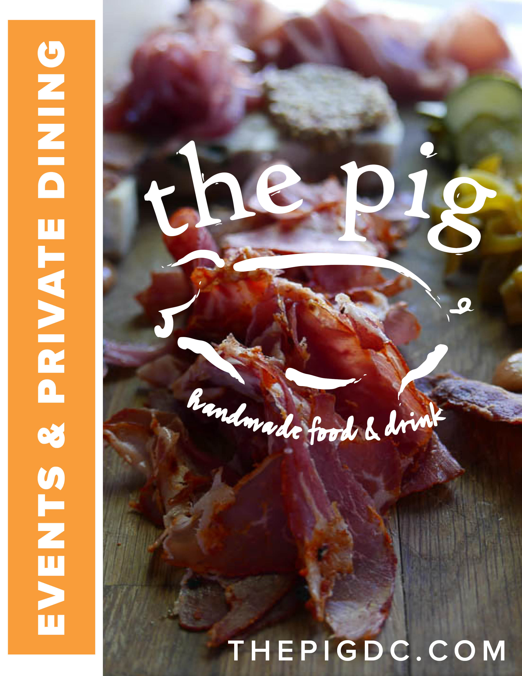


The Pig is a celebration of pork and the whole animal.
Our menu is dedicated to uniquely crafted, seasonal, and local food. Paired with American crafted cocktails, beer, and wine. We welcome our guests with great hospitality in a comfortable setting.
Explore & enjoy the experience.

Important  info | Address:  1320 14th St. NW  Washington DC, 20005  Phone:  (202)290-2821  Email:  thepig@eatwelldc.com
private  event  details | The Pig is perfect for any event, ranging from birthday parties or corporate functions to rehearsal dinners and weddings. The Pig also offers a variety of packages to provide both a menu and budget to fit your unique desires.  All reservations of 20 or more must be coordinated through our Private Events Coordinator.  For more information, contact Ray Bracken at rbracken@eatwelldc.com.
the Space | A warm & rustic feel that is an inviting experience. With a single dining room and full-service bar area we strive to be that neighborhood go to, first date destination, or dining with friends & family alike.

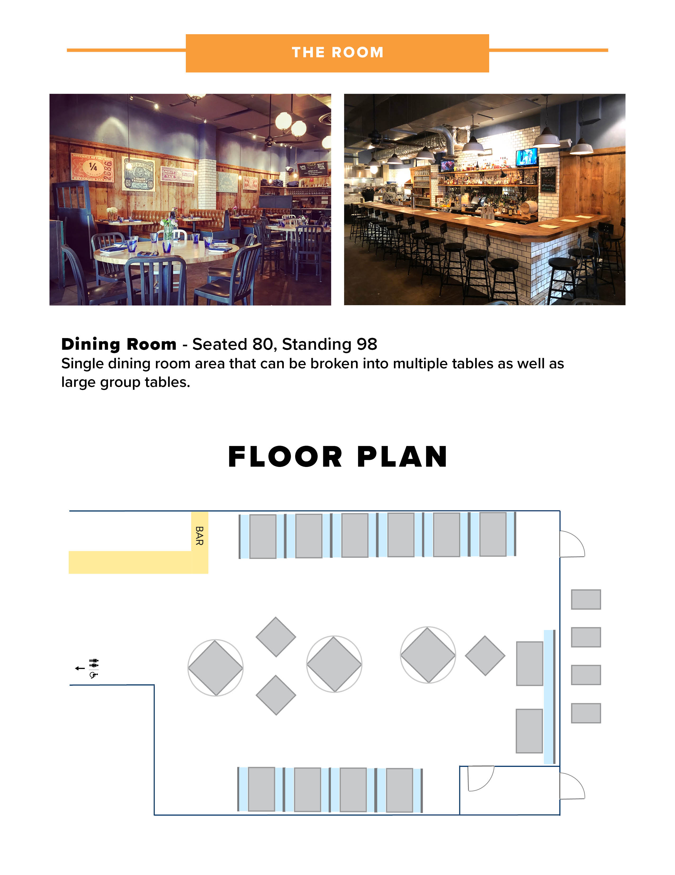

All prices are exclusive of tax and a suggested 20% gratuity. Soft drinks, tea and coffee
is included in the food pricing.

Plated Dinner Tier 1... $32
Choice of two starters & three entrees.
(Excludes Pig Tails & Arancini.)

Plated dinner Tier 2... $37
Choice of three starters, three entrees, & two desserts.
(Excludes Pig Tails & Arancini.)

Plated Dinner Tier 3... $45
Artisanal Charcuterie & Cheese Board
Choice of starter, entree & dessert.

sTARTERS
Harvest Salad (V) mixed greens, citrus vinaigrette, shaved carrots, tomatoes
Kale Salad goat cheese, maple glazed apples, radish, spiced pecans, bacon mustard dressing
Slab Bacon thick cut, au poivre, rosemary maple sauce, cognac mustard
Grilled Pig Tails soy, ginger, & lemongrass braise, dc mumbo sauce, toasted sesame
Tofu Katsu (V) panko crusted silken tofu, tonkatsu sauce, soy cucumber salad
Baked Brie (V) puff pastry wrapped brie, seasonal jam, toasted rustico

entrEes
Seared Branzino mediterranean sea bass, lentil puree, pepper caponata, caramelized fennel
Porchetta house made sausage wrapped in pork belly, sauteed greens, pork jus
Pork Piccata pan seared pork cutlet, sauteed seasonal vegetables, chitarra pasta, meyer lemon jus
Whole Roasted Chicken herbs de provence spice rub, lemon thyme chicken jus
Braised Pork Cheeks soffritto braised pork cheeks, tuscan polenta, rapini, onion agrodolce
Peri Peri Poussin char grilled young chicken, spicy peri peri sauce, saffron rice, spinach, tomatos
Bavette Steak grilled sirloin, heirloom carrots, sauteed swiss chard, mustard tarragon demi glaze
Greek Bean Cassoulet (V) gigante bean stew, alta cucina tomatoes, spinach, yukon potatoes, pesto crostini
Puttanesca Pasta alta cucina puttanesca sauce, chitarra pasta, olives, capers, anchovy, basil, pecorino romano

desserts
Sticky Toffee Pudding vanilla gelato, toasted macadamia nuts, bourbon caramel
Chocolate Cake chocolate peppermint gelato, sour cherry compote, chocolate ganache
Apple Pie Cannoli mini cannoli shell, apple ricotta cream, crumbled bacon, bourbon caramel
Assorted Seasonal Sorbet & Gelato

All prices are exclusive of tax and a suggested 20% gratuity. Soft drinks, tea and coffee
is included in the food pricing. Buffets available only with a full venue buyout.

buffet Dinner Tier 1... $27
Choice of two starters, two entrees, & two sides.
(Excludes Pig Tails & Arancini.)

buffet Dinner Tier 2... $38
Artisanal Charcuterie & Cheese Board
Choice of two starters, three entrees, two sides, & three desserts.

sTARTERS
Harvest Salad (V) mixed greens, citrus vinaigrette, shaved carrots, tomatoes
Brussels Caesar Salad shaved brussel sprouts, croutons, parmesan tuille, blackened caesar
Slab Bacon thick cut, au poivre, rosemary maple sauce, cognac mustard
Grilled Pig Tails soy, ginger, & lemongrass braise, dc mumbo sauce, toasted sesame
Sweet Potato Arancini (V) spiced tomato jam, ricotta salata

entrEes
Porchetta house made sausage wrapped in pork belly, sauteed greens, pork jus
Mojo Braised Pork Shoulder heritage pork, mojo citrus marinade, cilantro crema, pickled onion
Whole Roasted Chicken herbs de provence spice rub, lemon thyme chicken jus
Wild Boar Bolognese pappardelle pasta, cremini mushrooms, basil, truffle pecorino, toasted panko
Pork Makhani yogurt marinated pork shoulder, spiced curry, jasmine rice, coriander roti bread
Roasted Pork Loin fennel & coriander rub, pork jus
Vegetarian entree available upon request.

SIDES
Roasted Yukon Potatoes thyme, charred citrus
Sauteed Seasonal Greens garlic confit, lemon butter
Broccolini dijonnaise, toasted almonds
Heirloom Carrots goat cheese, pumpkin seeds
Mac & Cheese cavatappi, truffle, aged parmesan panko crust

desserts
Sticky Toffee Pudding vanilla gelato, toasted macadamia nuts, bourbon caramel
Chocolate Cake chocolate peppermint gelato, sour cherry compote, chocolate ganache
Apple Pie Cannoli mini cannoli shell, apple ricotta cream, crumbled bacon, bourbon caramel
Assorted Seasonal Sorbet & Gelato

All prices are exclusive of tax and a suggested 20% gratuity. Soft drinks, tea and coffee
is included in the food pricing.

plated brunch Tier 1... $21
Choice of three starters & three entree.

plated brunch Tier 2... $27
Choice four starters, four entrees, & three desserts.

sTARTERS
Crispy French Toast (V) berry cream cheese, maple syrup
Slab Belly Bacon thick cut, au poivre, rosemary maple sauce, cognac mustard
Harvest Salad (V) mixed greens, shaved carrots, tomatoes, citrus vinaigrette
Buttermilk Biscuit pork sausage gravy
Seasonal Fruit Salad (V)

EntrEes
Chilaquiles (V) sunny egg, tortillas chips, charred tomatillo salsa, queso fresco, crema
Steak & Eggs 6oz prime steak, poached eggs, hollandaise, sauteed vegetables
Shrimp & Grits cajun spiced tasso ham gravy, cremini mushrooms, scallions
Pig Slam Breakfast eggs, sausage, bacon, ham, potato wedges, mixed greens
Vegetable Omelet (V) seasonal vegetables, goat cheese, mixed greens, rustico
Pork Benedict cajun spiced hollandaise, poached eggs, heritage pork belly, mixed greens
Chicken Cobb romaine, kale, bleu cheese, tomatoes, radish, bacon, eggs, avocado, green goddess
Pig Dip sliced pork roast, fontina, pork jus, pickles
Pulled Pork Sandwich pulled pork, house bbq sauce, pickles, celeriac slaw

desserts
Sticky Toffee Pudding vanilla gelato, toasted macadamia nuts, bourbon caramel
Chocolate Cake chocolate peppermint gelato, sour cherry compote, chocolate ganache
Apple Pie Cannoli mini cannoli shell, apple ricotta cream, crumbled bacon, bourbon caramel
Assorted Seasonal Sorbet & Gelato

All prices are exclusive of tax and a suggested 20% gratuity. Soft drinks, tea and coffee
is included in the food pricing. Buffets available only with a full venue buyout.

buffet Brunch Tier 1... $23
Choice of two starters & three entrees.

buffet Brunch Tier 2... $32
Choice of two starters, three entrees, two sides, & three desserts.

Appetizers
Crispy French Toast (V) berry cream cheese, maple syrup
Slab Belly Bacon thick cut, au poivre, rosemary maple sauce, cognac mustard
Harvest Salad (V) mixed greens, shaved carrots, tomatoes, citrus vinaigrette
Buttermilk Biscuit pork sausage gravy
Seasonal Fruit Salad (V)

EntrEes
Chilaquiles (V) sunny egg, tortillas chips, charred tomatillo salsa, queso fresco, crema
Steak & Eggs 6oz prime steak, poached eggs, hollandaise, sauteed vegetables
Shrimp & Grits cajun spiced tasso ham gravy, cremini mushrooms, scallions
Pig Slam Breakfast eggs, sausage, bacon, ham, potato wedges, mixed greens
Pork Hash lemongrass braised pork shoulder, caramelized onions, pickled peppers, roasted potatoes
Pulled Pork Sandwich pulled pork, house bbq sauce, pickles, celeriac slaw

SIDES
Mac & Cheese (V) cavatappi, truffle, aged parmesan panko crust
Corn Grits (V) fontina, parmesan, pesto
Home Fries (V) potato wedges, cajun spice
Broccolini (V) dijonnaise, toasted almonds
Heirloom Carrots (V) goat cheese, pumpkin seeds

desserts
Sticky Toffee Pudding vanilla gelato, toasted macadamia nuts, bourbon caramel
Chocolate Cake chocolate peppermint gelato, sour cherry compote, chocolate ganache
Apple Pie Cannoli mini cannoli shell, apple ricotta cream, crumbled bacon, bourbon caramel
Assorted Seasonal Sorbet & Gelato

cocktail party
$20/person
Choice of 4 passed or stationed hors d’oeuvres.
Only available for a full venue buyout.

STANDARD BAR
Beer & Wine (2 hours): $20/person
Choice of two beers, two whites, & two reds.

Open Bar (2 hours): $32/person
Choice of two beers, two whites, & two reds.
Choice of two cocktails from current menu.

PREMIUM BAR
Open Bar (2 hours): $40/person
Choice of three beers, three whites, & three reds.
Choice of three cocktails from current menu.

Brunch BAR
Bottomless (2 hours): $16/person
Pig Bloody’s, Bourbon Bloody’s, & Mimosas.

Open Bar (2 hours): $22/person
Full Brunch Cocktail Menu.

All prices are exclusive of tax and a suggested 20% gratuity.
*(V) Vegetarian Options

