Beverages  SODAS…..1.00  (12oz CANS) COKE, SPRITE, DIET COKE,  ORANGE, AND PEPSI  BOTTLED WATER (16 oz) …..1.00  AGUAS FRESCAS  HORCHATA  SMALL (20 oz)…..2.00  LARGE (32 oz)…..3.00  JAMAICA  SMALL (20 oz)…2.00  Large (32 oz)….3.00  OUR PROTEINS  CARNITAS  TRADITIONAL MEXICAN SLOW COOKED PORK  RES  SHREDDED BEEF IN A TRADITIONAL MOLE SAUCE  POLLO  SHREDDED CHICKEN IN A TOMATO & GUAJILLO SAUCE  LENGUA  BEEF TONGUE SIMMERED IN A BEEF BROTH  Al Pastor  SPICED PORK SHOULDER | 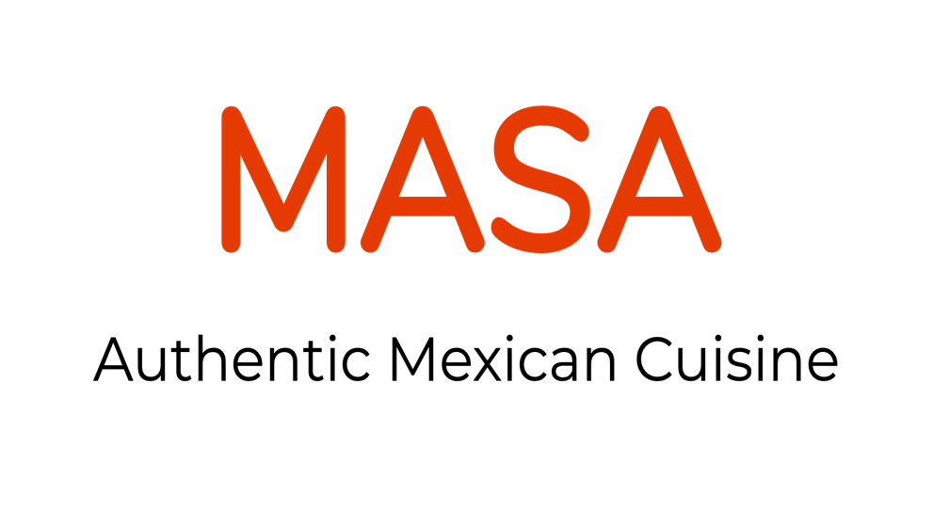  1504 Market St  Harrisburg, Pa 17103  Phone #: 717-829-8761 or  717-893-8405  (CALL AHEAD ORDERING AVAILABLE)  MASATACOINC.COM  @masatacos  . MASA Mexican Food Truck  Closed Mondays  Tu-F 11a–6p  Sa 1030a–6p  Su 10a–5p  (We accept Visa and MasterCard)
Tacos  corn tortillas w/ diced onion, cilantro, sliced jalapeÑo pepper, Wedge of lime, and side of house-made salsa. Choose any protein below.  CARNITAS…….2.50  RES………2.50  POLLO……2.50  LENGUA………..3.00  AL PASTOR…..2.50  BEAN, AVOCADO, & CHEESE….2.50  Bowls  bed of rice and beans, lettuce, onion, tomato, and side of house-made salsa. CHoose any protein below.  CARNITAS…..6.50  RES……..6.50  POLLO….6.50  Lengua…….7.50  Al pastor... 6.50  aVOCADO AND CHEESE…..6.00  SIdes  RICE & BEANS…. 3.00  SOUR CREAM….0.75  AVOCADO….1.00  S | Tortas  MEXICAN SANDWICH W/ MAYO, CHEESE, ONION, LETTUCE, AVOCADO, SLICED JALAPEÑO PEPPERS, AND SIDE OF HOUSE-MADE SALSA. CHOOSE ANY PROTEIN BELOW.  CARNITAS……6.00  RES……6.00  POLLO….6.00  LENGUA…….7.00  Al PASTOR ……6.00  BEAN, AVOCADO, & CHEESE….6.00  Burritos  flour tortilla w/ mexican rice, house-made frijoles, mozzarella cheese, onion, tomato, lettuce, sour cream & salsa. Choose any protein below.  Carnitas…..6.50  Res…..6.50  Pollo…..6.50  Lengua…..7.50  Al Pastor...6.50  Veggie…..6.50  QUESADILLAS  LARGE FLOUR TORTILLA W/ MOZARRELA CHEESE, SIDE OF SOUR CREAM & HOUSE-MADE SALSA  CHEESE….4.50  ANY PROTEIN …..6.50

