C:\Program Files\Microsoft Office\MEDIA\CAGCAT10\j0304933.wmf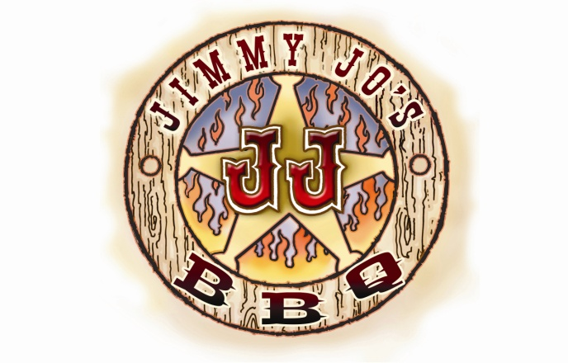  
**815.933.7500 665 N. CONVENT ST. BOURBONNAIS, IL**

**LET JIMMY JO’S DO THE COOKIN THIS EASTER**

**SMOKED PORK LOIN…………$49.95**

**SLOW SMOKED, GARNISHED WITH ROASTED APPLES SERVES 6**

**SMOKED PRIME RIB……………Market Price call**

**SERVED WITH AU-JUS AND HORSERADISH SAUCE SERVES 12-15**

**APPLEWOOD SMOKED TURKEY BREAST $49.95**

**SLOW SMOKED, SERVES 6-8**

**SMOKED HAM.$99.95 or ½ HAM $54.95**

**SLOW SMOKED, BONE IN, GREAT FLAVOR SERVES 12-15**

**WHOLE SMOKED BEEF BRISKET…$159.95**

**SLOW SMOKED FOR 12 HOURS, SERVES 12-15 HUNGRY FOLKS!**

**ORDERS NEED TO BE PLACED BY April 12th , SEE OUR REGULAR CATERING MENU FOR SIDES AND OTHER ITEMS. Slicing fee $10**