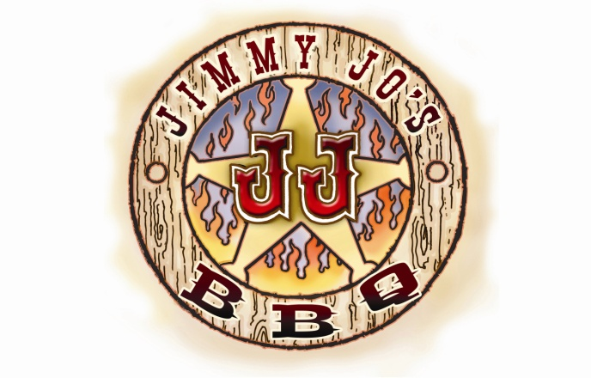
815.933.7500 665 N. CONVENT ST. BOURBONNAIS, IL
LET JIMMY JO’S DO THE COOKIN THIS EASTER
We will be here from 11-2PM for pre-arranged and prepaid orders
SMOKED HAM.$169.95 or ½ HAM $89.95
SLOW SMOKED, BONE IN, GREAT FLAVOR SERVES 20-25
SMOKED PORK LOIN…………$54.95
SLOW SMOKED, GARNISHED WITH ROASTED APPLES SERVES 6-8
Smoked North Atlantic Salmon Side…$69.95
Served warm or chilled. Serves 6-8
WHOLE SMOKED BEEF BRISKET…$219.95
SLOW SMOKED FOR 12 HOURS, SERVES 15-20 HUNGRY FOLKS!
Slicing fee $10

See our regular catering menu
for additional items and sides.

ORDERS NEED TO BE PLACED AND PREPAID BY 04/1/2026.

