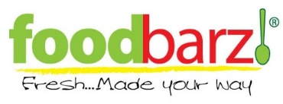
To all our loyal customers we thank you for your support these last 10 years and appreciate your business
We will be open the week of October 27th-31st as a
Grab n’ Go Only
We will be open for breakfast from 7:30am-10:00am and for lunch we will have fresh grab n’ go items
Variety of Sandwiches and Wraps
Premade Fresh Salads in our Saladbar
Parfaits
Tuna Salad, Chicken Salad, and Egg Salad Scoops
Veggies and Ranch
PB & J
Many Prepacked snacks, candy, and beverages
For all our catering customers we are still here for you and will be happy to cater your events anytime
Contact us at catering@foodbarz.com or
call Reena at 847-338-7596

