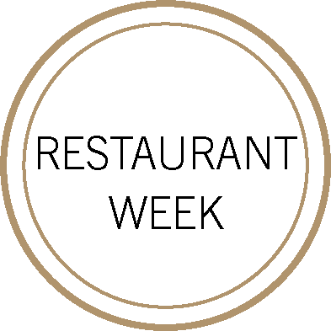
FIRST
ENDIVE AND CHICORY SALAD
candied walnuts, honey vinaigrette, pickled pears
Sylvaner, Dirler-Cadé, Vieille Vignes, Alsace, France 2017
––
MARINATED SQUID
garlic, fine herbs, potato saffron aioli, sourdough croutons
Vermentino, Aia Vecchia, Tuscany, Italy 2018
––
HONEYNUT SQUASH VELOUTÉ
pumpkin seeds, pickled squash, cinnamon
Chardonnay, Limestone, Alexander Valley, Sonoma County, California 2017

SECOND

ORGANIC SCOTTISH SALMON “ MIE DE PAIN“
potato mousseline, roasted parsnips, walnut tapenade
Pinot Noir, Farm to Table, Victoria, Australia 2018
––
GARGANELLI DI GRAGNANO
winter mushroom a la crème, crispy fried shallots, comté
Barbera, Prunotto Fiulot, Asti, Piedmont, Italy 2017
––
BLACK ANGUS FLATIRON STEAK
creamed savoy cabbage, pommes croquettes, grainy mustard jus
Grenache Blend, Brotte, La Marasque, Gigondas, France 2015

DESSERT

PROFITEROLE
cinnamon streusel, brown sugar ice cream, bourbon caramel
Semillon blend, Château Suduiraut 1er Cru, Sauternes, France 1998
––
RED VELVET CAKE
milk chocolate mousse, cocoa nib crumble, cream cheese sorbet
Grenache & Carignan, Domaine La Tour Vieille, Banyuls, Languedoc-Roussillon, France 2016

