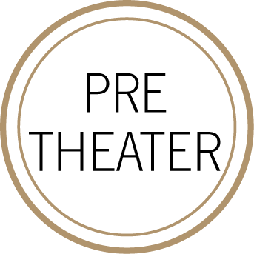
FIRST
BABY GREENS
candied walnuts, radishes, yuzu vinaigrette
––

BUTTERNUT SQUASH VELOUTÉ

pumpkin seeds, croutons
––
MARKET OYSTERS (+5 supp half dozen)
shallot-banyuls mignonette, lemon

SECOND

BRAISED SHORT RIB
creamy polenta, brussels sprouts, gremolata
––
CRISPY DORADO
melted leeks, dill, beurre rouge
––
RIGATONI DI GRAGNANO
mushroom “a la crème“ parmigiano reggiano

THIRD

ROASTED APPLE "SHORTCAKE"
pink lady apple confit, buttermilk biscuit, cinnamon ice cream
––
COCOA NIB PAVLOVA
manjari chocolate mousse, blood orange sorbet
––
CHEF’S SELECTION OF CHEESES (+5 supp)
selection of artisanal cheeses, house made marmalade, toasted baguette

