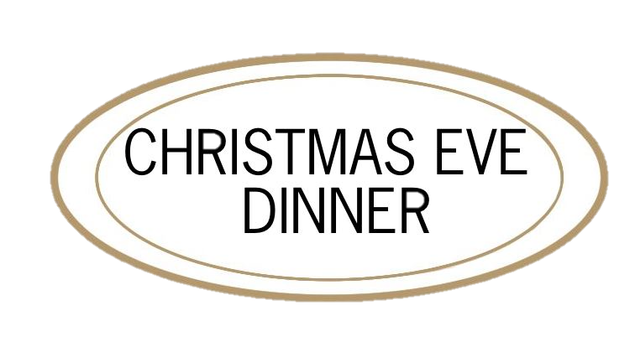
FIRST

Winter Endive Salad
walnuts, smoked duck breast, red wine pears, sourdough croutons
Imperial Egg
duck egg yolk, creamed spinach, smoked salmon, hackleback caviar
Marinated Yellowfin Tuna
sesame dressing, blood orange, pickled pearl onion
Butternut Squash Soup
pumpkin seed oil, crispy coconut shrimp
Perigord Truffle Tagliatelle
creamy mushroom sauce
Foie Gras Terrine
huckleberry compote, toasted brioche, caramelized chestnuts

SECOND

Maine Lobster THERMIDOR
sauce mornay, creamy spätzle
Nova Scotia Halibut
sautéed mushrooms, potato mousseline, périgord truffle sauce
Rohan DUCK BREAST AND LEG
braised red cabbage, poached pears, brioche dumpling
Venison Loin
celery purée, pommes dauphine, juniper berry jus, lingonberry

BEEF Wellington
sauce bordelaise , sautéed baby spinach

THIRD

EGGNOG BAKED ALASKA
graham cracker dacquoise, dried cranberry sorbet,
eggnog ice cream
GINGERBREAD GATEAU
honey poached pears, vanilla mousse, chai ice cream
DARK CHOCOLATE RUM CAKE
devils food cake, rum caramel, goat’s milk ice cream
STICKY TOFFEE PUDDING
dates, lemon crème fraiche, tonka bean ice cream
CHEFS SELECTION OF ARTISINAL CHEESES
house-made marmalade, toasted baguette

