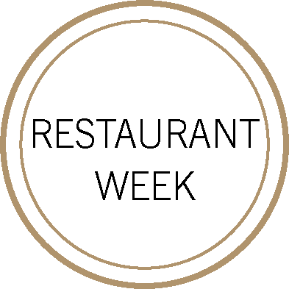
FIRST
MARINATED HEIRLOOM TOMATOES
ricotta, basil pesto
Albarino, Envidia Cochina, ‘Slow is Beautiful’, Rias Baixas, Spain 2016
––
CHARRED OCTOPUS AND SHRIMP
fingerling potatoes, olives, garlic, red bell pepper
Niellucciu/Grenache, Domaine d’E Coce, Yves Lecchia, Patrimonio Corsica, France 2017
––
ARUGULA VELOUTÉ
guanciale, rosemary oil, sourdough croutons
Favortia/Moscato, Cantine Elvio Tintero, Piedmont, Italy 2018

SECOND

CRISPY DORADO
pearl couscous, grilled corn, pickled cherries
Zinfandel, End of Nowhere, Sierra Foothills, Amador County, California 2018
––
GARGANELLI DI GRAGNANO
gorgonzola dolce, baby spinach, toasted pine nuts
Barbera, Prunotto Fiulat, Piedmonte, Italy 2017
––
ROASTED PETIT ROHAN DUCK BREAST
broccoli, italian plums, pommes dauphine
Domaine Le Clos du Caillou, Le Bouquet des Garrigues, Rhône Valley, France 2015

DESSERT

CHEESECAKE MOUSSE
graham cracker crumble, elderflower poached apricots
Moscato, G.D. Vajra, Moscato d’Asti, Piedmont, Italy 2018
––
GIANDUJA TARTE
candied hazelnuts, cocoa nib sucrée, buttermilk ice cream
Pedro Ximenez, Bodegas Toro Albalá, Montilla-Moriles Don PX Gran Reserva 1988

