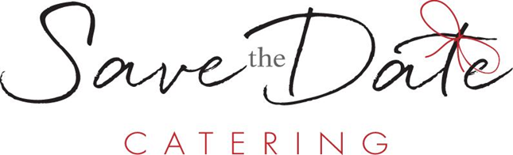

Desserts

Cheesecake Slice
New York $7.00
Classic New York Style Cheesecake with: Graham Cracker Crust, Blueberry Coulis, and Whipped Topping.

Turtle $11.00
New York Cheesecake with: Graham Cracker Crust, Fudge, Caramel, Pecans, Chocolate Drizzle, and Whipped Topping.

Cake Slice
Chocolate $9.75
Five-Layer Chocolate Cake with: Chocolate Filling, Chocolate Drizzle, and Whipped Topping.

Raspberry Ombre $11.50
Four-Layer Raspberry Cake with: Vanilla Icing, Raspberry Coulis, and Whipped Topping.

Carrot $9.75
Three-Layer Carrot With: Cream Cheese Icing, Pecans, Caramel Drizzle, and Whipped Topping.

Tiramisu $11.50
Lady Finger Shortcakes with: Espresso, Mascarpone Cheese, Rum Flavor, and Whipped Topping.

Pie Slice
Pumpkin $5.25
Traditional Pumpkin Pie with: Candied Pecans, Caramel Drizzle, and Whipped Topping.

Apple $5.25
Dutch Apple Pie with: Candied Walnuts, Caramel Drizzle, and Whipped Topping.

Blueberry $5.75
Two-Crust Blueberry Pie with: Candied Walnuts, Blueberry Coulis, and Whipped Topping.

Individuals
New York Cheesecake $6.00
Graham Cracker Crust with: Blueberry Coulis and Whipped Topping.

Red Velvet Cake $6.25
Red Velvet with: Vanilla Frosting, Raspberry Coulis, and Whipped Topping.

Triple Chocolate Mousse $9.50
Chocolate Mouse with: Chocolate Cookie Crust, White Chocolate Mousse, Raspberry Coulis, and Whipped Topping,

Key Lime Pie $6.50
Whipped Key Lime with: Graham Cracker Crust, Toasted Coconut, Caramel Drizzle, and Whipped Topping.

Peanut Butter Pie $6.50
Peanut Butter Cream with: Chocolate Crust, Peanut Butter Candy Crumble, Chocolate Drizzle, and Whipped Topping.

Tiramisu $6.75
Whipped Tiramisu with: Sponge Cake Crust, Cocoa Powder, Raspberry Coulis, and Whipped Topping.

Specialty Items
Petite Fours $1.25 each
Assorted Cakes: Carrot Cake, Red Velvet Cake, Double Chocolate, and Truffle Bon Bons

