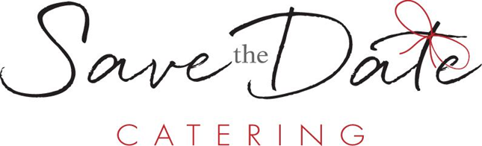

Desserts

Cheesecake Slice
New York $5.95
Classic New York Style Cheesecake with: Graham Cracker Crust, Blueberry Coulis, and Whipped Topping.

Turtle $8.95
New York Cheesecake with: Graham Cracker Crust, Fudge, Caramel, Pecans, Chocolate Drizzle, and Whipped Topping.

Cake Slice
Chocolate $8.50
Five-Layer Chocolate Cake with: Chocolate Filling, Chocolate Drizzle, and Whipped Topping.

Raspberry Ombre $10.50
Four-Layer Raspberry Cake with: Vanilla Icing, Raspberry Coulis, and Whipped Topping.

Carrot $8.75
Three-Layer Carrot With: Cream Cheese Icing, Pecans, Caramel Drizzle, and Whipped Topping.

Tiramisu $9.50
Lady Finger Shortcakes with: Espresso, Mascarpone Cheese, Rum Flavor, and Whipped Topping.

Pie Slice
Pumpkin $4.50
Traditional Pumpkin Pie with: Candied Pecans, Caramel Drizzle, and Whipped Topping.

Apple $4.25
Dutch Apple Pie with: Candied Walnuts, Caramel Drizzle, and Whipped Topping.

Blueberry $4.50
Two-Crust Blueberry Pie with: Candied Walnuts, Blueberry Coulis, and Whipped Topping.

Individuals
New York Cheesecake $4.50
Graham Cracker Crust with: Blueberry Coulis and Whipped Topping.

Red Velvet Cake $5.00
Red Velvet with: Vanilla Frosting, Raspberry Coulis, and Whipped Topping.

Triple Chocolate Mousse $8.00
Chocolate Mouse with: Chocolate Cookie Crust, White Chocolate Mousse, Raspberry Coulis, and Whipped Topping.

Key Lime Pie $5.00
Whipped Key Lime with: Graham Cracker Crust, Toasted Coconut, Caramel Drizzle, and Whipped Topping.

Peanut Butter Pie $5.25
Peanut Butter Cream with: Chocolate Crust, Peanut Butter Candy Crumble, Chocolate Drizzle, and Whipped Topping.

Tiramisu $5.50
Whipped Tiramisu with: Sponge Cake Crust, Cocoa Powder, Raspberry Coulis, and Whipped Topping.

Specialty Items
Assorted Petite Fours $1.00 each
Carrot Cake, Red Velvet Cake, Double Chocolate, Truffle Bon Bons,
Luscious Lemon, Caramel Apple Bars, Brownie, Marble Cheese Truffle.

