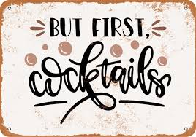
Golden Sidecar
cognac, allspice simple syrup.. brandy w/maple sugar-rimmed coupe

Beacon Hill Sling
whiskey, pure maple syrup…chocolate bitters w/ a burnt orange twist

Pear Sour
brandy, pear nectar juice & fresh lemon juice.. fresh pear slice

Scampo Margarita
tequila, blood orange juice & fresh lime juice

Caramel Apple Mule
vodka, house made caramel & apple cider.. tiny splash of ginger beer

Gentle Wind
rum, yuzu juice, handful of fresh mint..champagne

Sparkling Basil Pomegranate Margarita Mocktail
lime & muddled basil, fresh lime juice, pomegranate juice
splash of sparkling water

