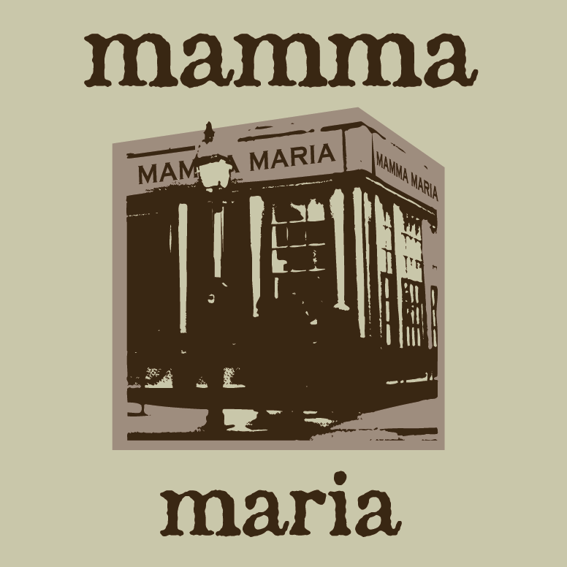

Photos and more details on our website: www.mammamaria.com

History
For many years, Mamma Maria has built a unique reputation for distinctive and memorable private events. The five dining rooms in our 19th century brick townhouse have hosted receptions for numerous Fortune 500 executives and their companies, as well as many local and prominent families.
Equally important is the trust placed in Mamma Maria to preside over many special moments in the everyday lives of our guests –a proposal of marriage, a wedding rehearsal dinner, a surprise milestone birthday party, or a silver anniversary party for parents.
The most unique feature of Mamma Maria is its residential and historical character. Diners have the option of proceeding down a parlor-level hall to our Rossini and Puccini dining rooms, or else up a winding staircase to the Verde, Piccolo and Terrazza dining rooms. Mamma Maria is really five distinct dining areas -- ranging in size from a one-table private enclave for four, to a large dining room which, along with an adjoining terrace, can accommodate up to 70 diners. Complete buyouts for up to 125 can also be arranged.
Another memorable feature of Mamma Maria is the wonderful and striking view of downtown Boston. Our restaurant sits on a small hill overlooking the city. Floor-to-ceiling windows reveal a dramatic panorama contrasting the Boston skyline with the cobblestones of North Square -- the oldest public square in America -- and home to many pivotal figures in American history: Cotton Mather in the 17th century, Paul Revere in the 18th, Charles Dickens and Honey Fitz in the 19th century and Rose Kennedy in the 20th century.
Most importantly, the nationally acclaimed cuisine at Mamma Maria balances authenticity with a commitment to the guiding principle of Italian cuisine, a reliance on local markets. We focus exclusively on the bounty of foods grown and raised here in New England; showcasing them through seasonally appropriate regional Italian dishes. In the fall and winter, our menu -- reflecting the harvest and cooler weather -- focuses on northern Italian and mountain dishes. In the summer, our menu veers to the south - allowing us to highlight the abundance of local produce and the diverse seafood market.

PRIVATE ROOMS

PICCOLO ROOM

Enjoy dining for up to 4 guests in our exclusive second floor private room with a view of historic North Square.

PUCCINI ROOM

This is the ideal setting for family gatherings and business dinners. Accommodates up to 14 guests for dinner at a single table. No additional space for cocktail reception.

TERRACE ROOM

This room is a second floor glass-enclosed balcony overlooking North Square and narrow side streets. French doors open in warm weather to create an al fresco feel. Accommodates up to 28 guests for dinner and 20 guests for cocktails and dinner.

ROSSINI ROOM

This room has a ten foot high picture window with dramatic views of historic North Square. The Rossini is perfect for groups of up to 40 guests for dinner and up to 30 for a cocktails and dinner.
Note: This dining room and its adjacent bathroom are wheelchair accessible.

VERDI ROOM

Our second floor dining room features fabulous skyline views of Boston's financial district and looks down onto North Square. The Verde Room accommodates up to 50 guests for dinner and up to 40 for cocktails and dinner.

VERDI ROOM & TERRACE ROOM

These are adjacent rooms and can accommodate up to 75 guests when used in combination. Please inquire about pricing.

SPRING MENUS

**NOTE: we do not require pre-orders for your guests**

Passed Hors d’oeuvres
(per person)

Baby shrimp scampi-style with fresh herbs 3.75
Braised rabbit with crispy polenta 2.25
Baked mushroom caps with goat cheese crostini 2.25
Stuffed zucchini with lamb sausage 3.25
Pan-fried black and white baby arancini with fontina 3.25
Roasted asparagus with Parma prosciutto 3.50
Salumi sampler with hard cheese 3.50
Seared beef tenderloin with gorgonzola 3.50
Warm tomato ‘bruschetta’on grilled toast points 2.75
Grilled chicken with pear chutney 2.75
Florentine crostini with classic garni 3.25
Seared scallop with herbed butter 3.75
Sliced buffalo mozzarella with pesto 3.50
Seared tuna with white bean puree 3.50
Tuna tartare on housemade chips and citrus glaze 3.50
Seared pork tenderloin “Tonato” 3.25
Buttered poached lobster market*
Venetian baccala with aioli 2.50
Petite eggplant rollatini with panzanella 2.75

Campagna
(4-course)
$60

PRIMO

English pea risotto with sautéed ramps, extra virgin olive oil,
pea tendrils, and spiced terragon pesto,

INSALATE

Crisp bibb lettuce wedge with our lemon pistachio vinaigrette

PRINCIPALLI

Oven-braised Cornish game hen with baby Brussels sprouts,
Meyer lemon, green olives, and black lentils

Orecchiette pasta “ears” from Apulia tossed with
wilted greens, and steamed Falmouth, MA clams

Homemade mushroom ravioli with exotic
and hand-foraged wild mushrooms

Family farm-raised Berkshire pork tenderloin, wood-grilled,
with baby beets, sweet Gorgonzola, and springtime fiddleheads

Bolognese as prepared in the village of Serralunga di Crea
with spicy pepperoncini pasta

DOLCI

Seasonal dessert platters

Mercato
(4-course)
$68

PRIMO
First course served family style***
King Caesar oysters, from Duxbury, MA
baked Florentine-style, with Prosecco zabaglione

Breezy Hill Farm, South Berwick, ME pork polpetti in a cast iron skillet
with toasted fregola pasta and sweet red pepper coulis

Wild asparagus ravioli with grilled asparagus and grated parmesan

INSALATE

Field green mix with sliced pear, toasted almonds and tarragon vinaigrette

PRINCIPALLI

Day boat Gloucester haddock over vialone risotto nero
with Eastham, MA mussels and Point Judith, RI calamari

NY strip steak, sliced, with aged balsamic from Modena,
roasted spring vegetables and black rice pilaf

From the village of Amatrice -- with imported artisanal pasta
sautéed guanciale, San Marzano tomato, and pecorino Romano

Homemade spinach spaghettini tossed with fresh wild shrimp,
snap peas, smoked bacon and sweet corn

Chickering Farm, Westmoreland, NH farm-raised veal pasta tortelloni
with a classic cacciatore sauce

DOLCI

Seasonal dessert platters

Primavera
(4-course)
$75

PRIMO
First course served family style***

Classic Carpaccio -- as created at Harry’s Bar in Venice

Day boat-harvested Maine sea scallops, pan-seared,
with fresh blood orange, baby spinach, an poached fennel

Barolo-braised lamb ravioli with and cucumber yogurt

INSALATE

Fresh favas with pecorino Toscano and crispy parmesan tuile

Or

Warm salad of sautéed black kale (cavolo nero), white beans and radicchio

PRINCIPALLI

Silky pasta agnolotti filled with fresh Maine lobster,
- finished with pan-roasted wild mushrooms, and crumbled guancale

Wild Maryland striped bass, grilled, with a warm salad of white beans and Maine kale

Grilled Black Angus beef tenderloin with Hudson Valley foie gras,
grilled asparagus, and baked carbonara

Slow-cooked Londonderry, VT rabbit, in the Tuscan-style,
with pappardelle pasta, crispy pancetta, and fresh rosemary

Rotisserie-roasted suckling pig, from Quebec with sweet fig jam,
Gorgonzola dolce, tri-colored beets, and toasted faro

DOLCI

Seasonal dessert platters

La Scala
(4 course)
$85

PRIMO

Chef duet of ravioli tasting:

Wild asparagus with grilled asparagus and grated parmesan
&
Fresh Maine lobster finished with crumbled guancale

INSALATE

Fresh buffalo milk mozzarella flown from Campagna, Italy
with sautéed vine-ripened tomatoes and aceto balsamico

or

Warm salad of hand-picked fresh Maine peekytoe crabmeat, frisee, and poached egg

PRINCIPALLI

Maine day boat - harvested sea scallops, pan-seared, with cider-glazed
spaghetti squash and spinach-infused vialone risotto

Florentine-style farm-raised buffalo strip steak, wood grilled and sliced,
with white asparagus and fresh sea beans

Veal shank osso buco in the classic-style with saffron risotto Milanese

Locally-caught Nova Scotia halibut, pan-seared, with fresh morels,
fresh herb salsa verde, and creamy parsnips

Spring lamb three ways: grilled rib chop, roasted lamb loin, and
homemade lamb ravioli with wild ramps, and baby carrots

DOLCI

Seasonal dessert platters

Pranzo
$40
***Lunch only

PRIMO

Imported artisanal salumi sampler with panzanella, spiced oil, and Parmigiano

Or

English pea risotto with sautéed ramps, extra virgin olive oil,
pea tendrils, and spiced terragon pesto,

PRINCIPALLI

Wild asparagus ravioli with grilled asparagus and grated parmesan

Wood-grilled pork tenderloin, over toasted farro, with
tri-colored baby beets, Gorgonzola Dolce, and Verrill Farm vegetables

Oven-braised Cornish game hen with baby Brussels sprouts,
Meyer lemon, green olives, and black lentils

Bolognese as prepared in the village of Serralunga di Crea
with spicy pepperoncini pasta

Local Gloucester, MA haddock with a warm salad of white beans and Maine kale

DOLCI

Seasonal dessert platters

Vegetarian Options
(Can be substituted into any menu)

Antipasti

Baby Brussels sprouts, roasted tomatoes
local seasonal squash, and black lentils

Field watercress with a warm salad of local beets –
candy stripe, golden and cabernet – and crumbled goat cheese

Springtime white and green asparagus in a warm salad
with a savory asparagus flan and fried salt-cured capers

Handmade uovo in raviolo alla San Domenico with fresh black truffles

Warm salad of sautéed tri-colored cauliflower,
delicata squash, hen-of-the-woods mushrooms, and grilled radicchio

Hand-foraged king mushroom, “Carpaccio-style” with black truffles and Parmigiano

Fresh buffalo milk mozzarella flown from Campagna, Italy
with sautéed vine-ripened tomatoes and aceto balsamico

Grilled eggplant rollatini – filled with panzanella
and goat cheese-- finished with a fresh plum tomato marinara

Principali

Saffron-infused risotto with roasted eggplant,
Jerusalem artichokes and a trio of local baby beets

Warm vegetable plate glazed with aged balsamic from Modena-
-- featuring grilled Verrill Farm vegetables and a crispy Abruzzese saffron polenta

Homemade fettuccine with mixed wild mushrooms,
black truffle, black kale, and spinach

Pasta alla chitarra with toasted pine nuts
and sautéed pea tendrils

Homemade mushroom ravioli with exotic
and hand-foraged wild mushrooms

Wild asparagus ravioli with grilled asparagus and grated parmesan

Recent Feedback

“The event was absolutely wonderful!
Thank you very much for your energetic spirit,
high level of service, and gourmand food. Our clients were completely blown away had many accolades of your restaurant and of the event. We sincerely appreciate your incredible professionalism and excellent and precise delivery.”
~
“It was a great evening for our group and your staff was great!
They were on top of everything and for those who had specific food issues, they were able to accommodate special requests. Thank you again for your assistance in the planning of this event and we look forward to our next visit to Mamma Maria!”
~
“The party was a great success! Your staff was wonderful and very accommodating!​ Everyone had a fabulous time and the birthday girl couldn't have been more surprised! Thank you!!”
~
“The evening was perfect!
Your chefs and staff did a wonderful job making it a very special evening.
We are deeply grateful to you all. Thank you.”
~
“We absolutely love your restaurant! Everything was terrific. I certainly see why TripAdvisor has you ranked in the Top 20 in Boston!”
~
“Thanks you and your team so much Jennifer; the venue, food and especially the service was outstanding, a very memorable evening in all aspects. Thanks you for making this event easy for us to plan.
Enjoy your summer, please pass on my family’s thanks to the entire crew.”
~
“I just wanted to thank you so, so much for everything you've done over the last few months. You really worked with me to use the two spaces appropriately and to come up with the perfect spring luncheon menu. My bridal shower was absolutely the best day ever. The rooms were set up perfectly; the staff was incredibly friendly, professional, and dressed so nicely for the occasion. The menu was out of this world, and everyone was raving about every single dish. I think we were all eating off of each other's plates just to get a bite of everything! The compliments are flowing in from family and friends saying the ambiance, the flowers, the service, everything was top notch.
So please accept a million thank you's from my family and I,
and please extend my notes to the staff that worked the event. “
~
We had a wonderful time. The food, service, and atmosphere all exceeded expectations.
You have a very special place, and we appreciate you accommodating us.

