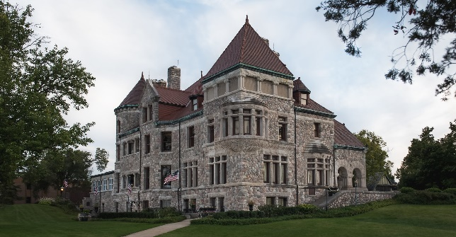

**Studebaker Grill**

**& Brewing Company**

**Historic Experiences**

Sunday Brunch Menu

Lighter Side

Fresh Fruit Plate – 12

pineapple, berries, sliced melon,

grapes, sweet yogurt dip

Sunday Quiche – 12

smoked gouda, ham, spinach,

forest mushroom sauce, fresh fruit.

Shareable Belgian Waffles – 12

blueberry topping, strawberry glaze, maple syrup, whipped cream

Virtual Omelet Bar– 14

choice of ingredients:

smoked ham, apple bacon, mushrooms, cheddar/jack cheese, onions, jalapenos

studebaker potatoes

Grilled Brie French Toast – 14

raspberry syrup, toasted pecans, candied bacon, whipped cream

Entrees

Sausage Poutine – 14

house fries or sweet potato fries,

cheese curds, ale beer cheese

**Shrimp & Grits – 16**

**southern style, cheddar/jack cheese,**

**bacon bits, scallions**

**Southern Biscuits & Gravy – 14**

**homestyle sausage gravy, buttermilk biscuits, studebaker potatoes**

**Crab Cake Benedict – 18**

**lump crab cakes, poached egg, hollandaise sauce, studebaker potatoes**

**-traditional eggs benedict - 12**

**Studebaker Prime Rib – 22**

**toasted brioche, captured juices, creamy horseradish, studebaker potatoes**

Beverages

Sweet Treats

Desserts

Cinnamon Roll Sundae – 7

warmed, caramel drizzle,

vanilla bean ice cream

Chef’s Selections – 7

variety of desserts

Mimosa’s – 7

Orange, pineapple, cranberry,

pomegranate.

Bellini – 8

Peach, mango, guava

Screwdrivers – 8

Orange, grapefruit, cranberry

Classic Bloody Mary– 9

Tito’s Vodka, celery, lime, olive,

