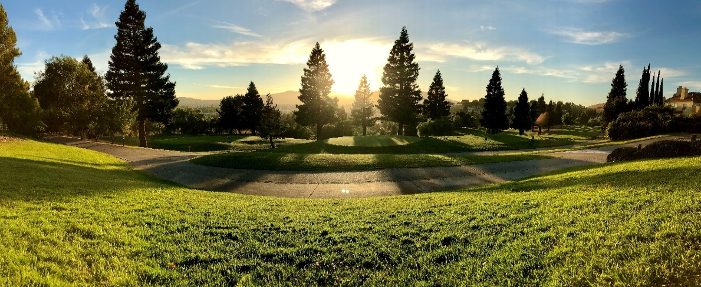

**Breakfast Menu**

**Served Friday thru Sunday 9:00am - 11:00 AM**

**Build Your Own Omelet** **| 12**

Three eggs, cheddar & jack cheese, toast, and side of breakfast potatoes

***Select Two*:** Bacon, ham, sausage, avocado, mushrooms, tomato, bell peppers, zucchini, onions, garlic, blue cheese, Swiss cheese, salsa, sour cream

A*dditional items .75*

**Canyon Lakes Omelet | 13**

Cheese,bacon, ham, sausage, onion, mushroom, bell pepper, breakfast potatoes

**Vegetable Omelet | 12**

Cheese, sour cream, zucchini, bell pepper, mushrooms, avocado, breakfast potatoes

**Ham Frittata** | 12

Black forest ham, swiss cheese, bacon, onion, mushrooms, sour cream, breakfast potatoes

**Santa Fe Frittata | 12**

Sauteed onions & peppers, jalapeno, cheese, sour cream, guacamole, pico de gallo

**Vegetable Frittata | 10**

Mushroom, bell pepper, onion, cheese, crème fraiche, breakfast potatoes

**Croissant Beignets | 10**

Fried beignets topped with powdered sugar & served with maple syrup & wild berry compote

**Sides**

Side of toast (2) or English Muffin **2**

Side of bacon, sausage, ham or turkey **3**

Fresh Baked Goods **3**

Side of Fruit 6

**Fresh 16oz Fruit Smoothie 6**

Strawberry Banana

Blueberry Banana

Raspberry Banana

Mixed Berry & Greek Yogurt

**Beverages**

Coffee $2 | Hot Cocoa $4 | Juices $4

Sodas $3 | Mimosa $10 | Bloody Mary $10 | Irish Coffee $12 | Screwdriver $9 | Craft Beers Starting at $6

**Breakfast Sandwich** **| 6**

2 fried egg, cheddar, lemon aioli, on an English muffin

Choice of: bacon, sausage, ham or turkey

**Pesto Egg Sandwich** **| 8**

Fried egg, cheddar, bacon, avocado, hot sauce, tomato pesto, English muffin

**Breakfast Burrito | 9**

Flour tortilla, 3 scrambled eggs, bacon, dry rubbed potato, cheese, fire roasted salsa

**Egg Breakfast | 10**

Three eggs, choice of meat, fire roasted salsa, breakfast potatoes, choice of toast

**Pancake Breakfast | 9**

4 Buttermilk pancakes, two eggs, bacon or sausage

**French Toast | 9**

Three Texas toast dipped in cinnamon orange batter, powdered sugar, syrup

**Pancake Sliders | 9**

Mini pancakes sandwiches, sausage, fried egg, syrup, powdered sugar

**Guacamole Egg Sliders | 8**

2 Fried eggs, mini brioche buns, jack cheese, bacon, guacamole, aioli, tomato, onion

**Monte Cristo | 9**

Cinnamon orange battered Texas toast, ham, swiss, syrup, with a wild berry compote

**Avocado Toast | 8**

Toasted sourdough, poached eggs, caramelized onions, avocado, house spicy