 ­­

**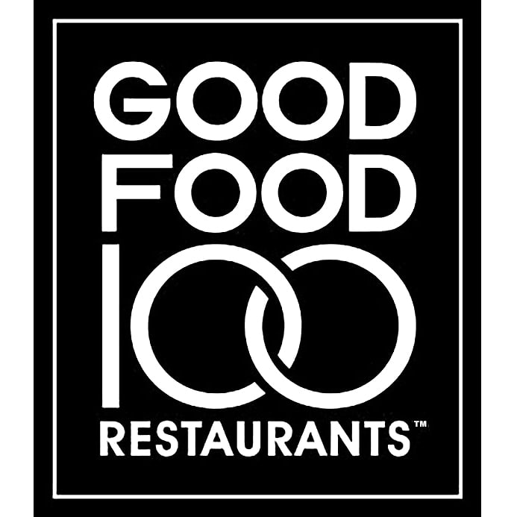

­secondi 

**served a la carte**

*\**Eggplant Parmigiana 20

tomato, mozzarella, spaghetti marinara

*\**Pollo alla Diavola 24

half chicken, chili, piccante oil

*+\**Whole Crispy Redfish 26

baby leek, carrot puree, pistachio

*+*»*Braised Pork Shoulder 28

cannellini bean, butternut squash, braising greens

contorni 

**side dishes**

*\**Crispy Potatoes 6

sage, rosemary

*\**Roasted Beets 10

orange vinaigrette, roasted garlic

shaved baby fennel

*\**House Salad 7

lemon, olive oil

*\**Spaghetti Marinara 7

- sub aglio e olio

- sub arrabbiata +2

antipasti 

**salumi e mozzarella**

*»*+*Salumi Plate 18

prosciutto di parma, house-made meats, pecorino cheese

-------------------------

*\**Campania, Buffalo Milk D.O.P. 13/26

*\**Burrata 19

cerignola olive tapenade, pickled pepper, mint

-------------------------

alongside salumi e mozzarella…

*\**Celery Pugliese 3 *\**Pesto Garganico 6

*\**Marinated Olives 5 *»\**Prosciutto di Parma 6

*\**Tomatoes + Basil 6 *\**Imported Anchovies 4

*\**Senise Peppers 4 Fig Vin Cotto 3

Extra House-made Focaccia 2

**antipasti**

House-made Focaccia 4

garlic, oregano

*+\**Fritto Misto Grande 16

calamari, red fish, vegetables, lemon

Heirloom Tomato Panzanella 15

fall vegetables, croutons, red wine vinaigrette

*»*Supplì al Telefono 12

crispy risotto, prosciutto, mozzarella

*»*Meatballs 12

pork, beef, marinara, house-made focaccia

Primi 

Penne alla Norma 14/28

eggplant, tomato, ricotta salata

Spaghetti Cacio e Pepe 11/22

pecorino romano, cacio de roma, black pepper

*»*Rigatoni Carbonara 12/24

guanciale, farm egg, black pepper

*»*Bucatini all’Amatriciana 13/26

guanciale, red wine-tomato sauce, red onion

Rabbit Agnolotti 16/32

roasted apple, sage, hazelnut

Goat Cheese + Hatch Chile Ravioli 16/32

hatch green chile, almond pesto

Cavatelli Ragu 15/30

braised lamb and beef, parmesan

***executive chef: Paul C Reilly*****| *chef de cuisine: Russ Fox***

**Coperta proudly works with local farms and ranches**

*\*These menu items can be made gluten-free.*

*+ These items are served raw or undercooked. | »These items contain pork.*

*The consumption of raw or undercooked eggs, meat, poultry,*

*seafood or shellfish may increase your risk of food borne illness.*

*Not all menu ingredients are listed. Please inform your server of any food allergies or sensitivities.*

*4% Wages & Benefits charge applied to each check | Limit 4 checks per table, please.*

***Food and Wine of Rome and Southern Italy***

wines by the Glass

*wines by the bottle available online*



***­Vino da Tavola***

*glass 9 ~ mezzolitro 26 ~ litro 51*

Bianco- Inzolia

Rosato- Montepulciano

Rosso- Barbera



***­Vino Spumante***

N/V Lucchetti Brut Rosato, Lacrima, Le Marche 13

***Vino Bianco***

2016 Librandi, Cirò Bianco, Greco, Calabria 11

2018 Cantine Colosi, Inzolia Blend, Sicily 10

2018 Principe Pallavicini Frascati, Malvasia Blend, Lazio 10

***Vino Rosato***

2019 Regaleali Le Rose, Nerello Mascalese, Sicily 11

***Vino Rosso***

2018 Umani Ronchi Podere, Montepulciano d’Abruzzo, Abruzzo 10

2017 Di Majo Norrante, Sangiovese, Molise 11

2017 Michele Alois Campole, Aglianico, Campania 15

2017 Luccarelli, Negroamaro, Puglia 12

About us 

**Coperta celebrates Roman trattoria fare and “cucina del mezzogiorno”, the food and wine of Southern Italy. Seasonal vegetables and the freshest seafood are featured prominently in our cuisine, as well as meat and game from local, responsible sources. It is a simple cuisine of sustenance, using only what the earth and sea can seasonally provide--nothing more and nothing less. We proudly work with Colorado’s best farmers and ranchers to bring the highest quality Southern Italian experience to Denver.**

**Grazie!**



**Guanciale-**Salt-cured pork jowl

**Panzanella-**“Wet bread,” salad with dressed croutons

**Pecorino**-“Sheep,” can refer to cheese or wine

**Senise**- Mild pepper of Basilicata

**Supplì**-“Surprises,” Italian street food of crispy risotto &

tomato sauce

**Coperta-“**blanket,” symbolizing comfort and warm hospitality

**Arrabbiata**-“Angry,” a spicy tomato sauce

**Bucatini-**Pasta shape; similar to spaghetti, with a hollow center

**Cavatelli-**Pasta shape; crescent with ridges.

**alla Diavola**-spicy sauce ‘of the devil’

**Fritto Misto-**“Mixed fry,”

fried squid and vegetables

W and b CHARGE 

glossary 

**As of February 5, 2020, we have added a 4% ‘wages & benefits’ charge to each check. A portion of this charge is given directly to the talented kitchen team that prepared your meal.**

**The remainder of the charge augments benefits for the entire staff, including vacation pay and health & wellness benefits.**