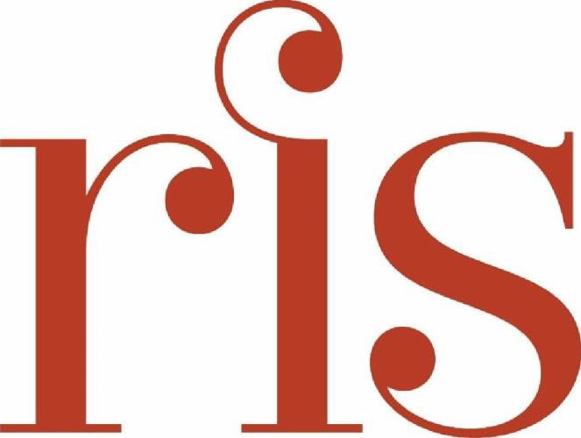

2275 L Street NW, Washington, DC 20037

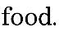
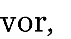
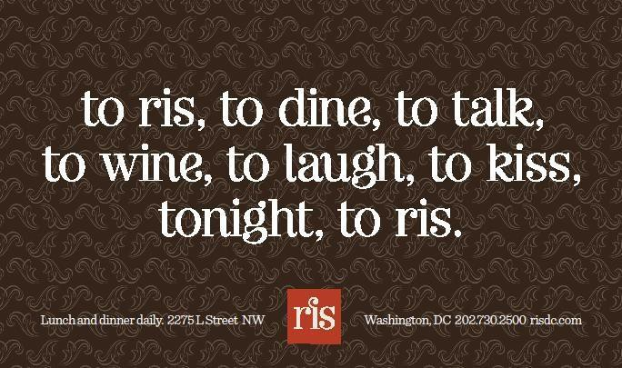

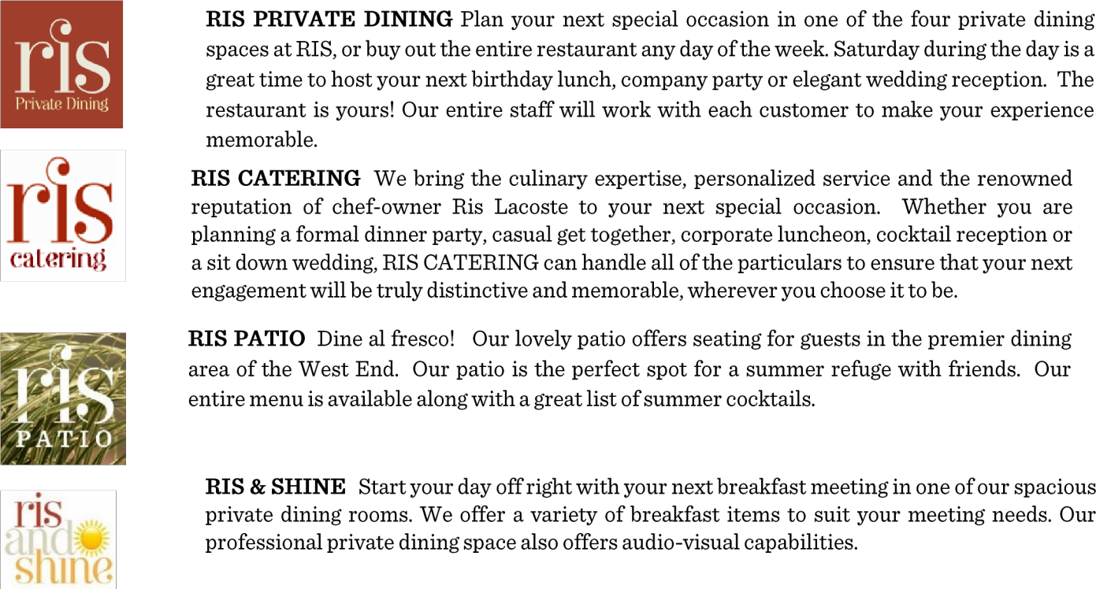
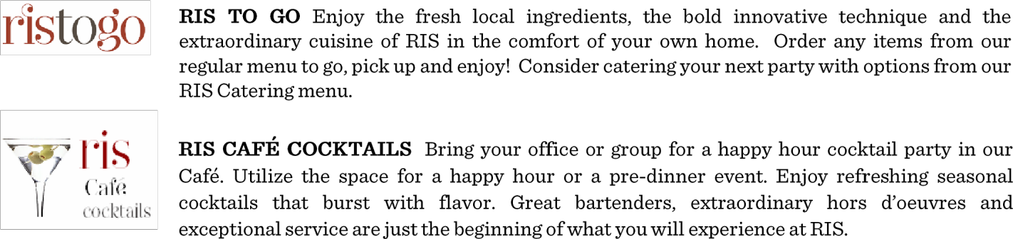
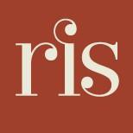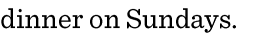

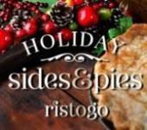
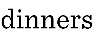

RIS Private Dining
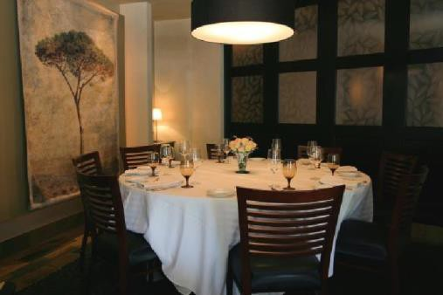
RIS has four beautiful private dining spaces to choose from when planning your next special occasion. We can accommodate from 6 to 50 guests in our private dining rooms whether you are hosting a business meeting or a special social event. We also offer a full restaurant buyout for a larger affair.

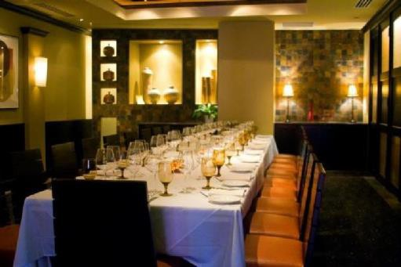
The State Room is our most intimate dining room with one round table seating maximum of 10 guests.

The Federal Room accommodates up to 35 guests. 1 Long Table seats up to 20 guests, 5 Round Tables for up to 35guests.

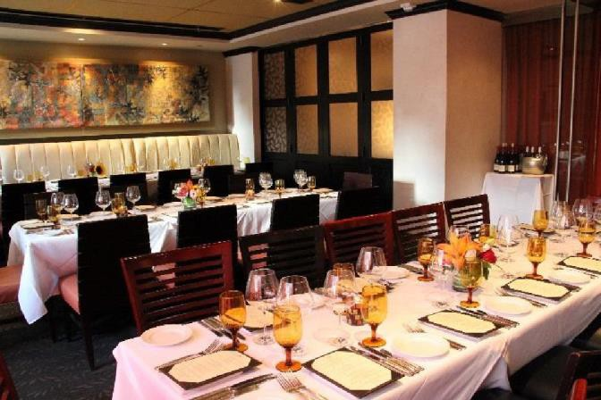
The Main Dining Room can seat up to 40 guests. Partitioned off from our fine dining room, it has its own private entrance.
The Main Dining Room coupled with the adjacent State Room allows for a total maximum seating of 50 guests.

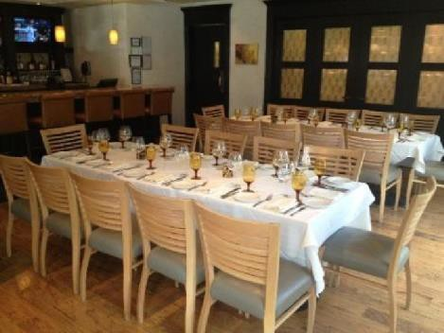
The Café is a semi-private space in the front of the restaurant that a perfect space for a cocktail reception prior to dinner and accommodates up to 29 guests for a seated event. The Café is also a perfect space for a cocktail reception prior to dinner.

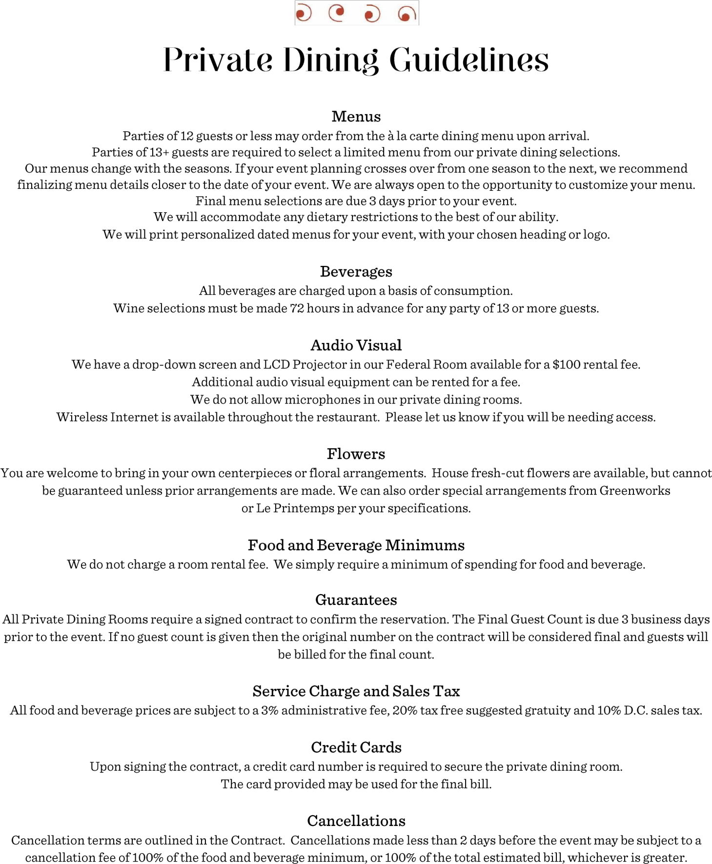

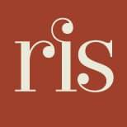

Hors d’Oeuvres
Priced per piece with a minimum of 12 pieces per order

Hot
Fried Scallops 4
on fried lemons with tartar sauce Mini Lump Crab Cakes 4 with mustard crème fraîche
Chimichurri Hanger Steak Skewers 4 marinated in chimichurri sauce and grilled Gougeres 2
warm Gruyère cheese puffs

Mini Quiche 3
choice of: quiche Lorraine – bacon, onion, Gruyère OR cauliflower, mushroom and Gruyère
Roasted Curried Cauliflower 3
pomegranate, mint, lemon, honey and Greek yogurt Sliders 4
cheeseburger, crab cake, codfish

Sweet Potato Empanadas 3
orange honey yogurt sauce Beef Empanadas 4 spicy red pepper sauce

Spinach, Potato and Feta Phyllo Squares 3
dill, lemon (minimum of 24)

Braised Lamb Shank Tzatziki 4
on black bread with cucumber, yogurt, radish and pomegranate

Stuffed Cremini Mushroom Caps 3
squash, goat cheese, dried apricot

Italian Meatballs 3
marinara sauce

Beef Short Rib Crostini 4
on black bread with onion jam and horseradish cream

Honey Fried Chicken 4
chili peanut sauce

Grilled Flat Breads 3
Chef’s selection of vegetarian and vegan toppings

Shrimp Tempura 4
yuzu, napa cabbage slaw, sriracha
Cold
Shrimp Cocktail 4
jumbo shrimp, lemon, cocktail sauce
Smoked Salmon Rillettes Crostini 4 smoked and fresh salmon pâté with cornichons Goat Cheese, Fig and Olive Crostini 3 honey, orange, olive oil
Caprese Skewers 3
mozzarella, basil, balsamic glaze pickled onions
Pimento Cheese Biscuits 3
feta, cheddar and cream cheese on dropped biscuits

Deviled Eggs 2
Chef’s choice, pickled vegetables Chicken Salad Sliders 4 apricots, walnuts, rice and grapes
Watermelon and Feta 3
balsamic and mint
Grilled Peach and Blue Cheese Crostini 3
honey butter

Small Plates

Fresh Ricotta Gnudi 6
herbed ricotta, minted pine nuts, cured lemon, spinach and a crumble of feta

Miniature Cauliflower 6
spaghetti squash, lentils, pine nuts, yogurt, pomegranate

Grilled Cheese and Tomato Soup 6

Displayed Items
each serves 10-12 guests

Charcuterie Platter $100
House made and artisanal cured meats and charcuterie, fennel crisps, toast, pickles and sauces
Artisanal Cheese Platter $100
honey, house made jams, crackers, toast, fruit and nuts

Charcuterie and Artisanal Cheese Combination $100

Mediterranean Platter $100
hummus, spanakopita, marinated olives and feta, roasted eggplant, tzatziki and toasted pita

Seasonal Vegetable Platter $100
fresh, roasted, grilled and pickled vegetables
with various dipping sauces

Casual Breakfast
Perfect for your breakfast meeting
Chefs Selection Breakfast Breads and Pastries $30 per dozen Assorted Breakfast Meats $5 per person
ham, bacon and sausage

Smoked Salmon Platter $150

Serves 10-12 guests
whipped caper cream cheese, roasted tomato, pickled red onion, egg salad, bagels

Fresh Fruit Platter $100

Serves 10-12 guests

Deep Dish Quiche $60
Serves 8-10 guests
choose from Quiche Lorraine or Market Vegetable

Yogurt Parfait with Berries, Honey and Almond Oat Granola $8 each

Breakfast Sandwich $8 each
Bagel or English Muffin Egg, Bacon and Cheese

Breakfast Burritos $10 each
Scrambled eggs, potatoes, cheese and chilies

Breakfast Buffet

$38 per person

Yogurt, honey, granola and berries Select Two Entrées:
Eggs Benedict fresh roasted ham and spinach on toasted English muffin with hollandaise
Deep Dish Quiche Lorraine with onions, bacon and Gruyère Cheese
Market Vegetable Quiche with Gruyère Cheese
Market Vegetable Scramble *gluten free
Steak Scramble *gluten free hanger steak, caramelized onions and cheddar cheese
Breakfast Burrito scrambled eggs, potatoes, cheese and chilies
Smoked Salmon and Bagels whipped caper cream cheese, roasted tomato, pickled red onion, egg salad, bagels

Home Fries
Biscuits with butter and house made jam

Coffee, juice, tea

Early Summer Lunch
2 courses $35 3 courses $45
Includes coffee, tea, soft drinks
Appetizers: select 2

Soup of the Day

Mixed Green Salad
soft lettuces with Gruyère cheese, tarragon and Champagne mustard vinaigrette

Blue Cheese and Blue Berry Salad
soft lettuces, honey grilled peaches, toasted pistachios and pickled blueberries

Fried Green Tomatoes
lemon aioli and tomato caper vinaigrette

Fresh Ricotta Gnudi
spinach, minted pine nuts, tomat, Parmesan

Entrées: select 3

Grilled Rainbow Trout
beets and horseradish cream, buttered cabbage and kale, pickled mustard seed, Anna potato

Chicken Milanese
lemon-asiago crust, prosciutto and arugula salad, garlic roasted potatoes, aioli, tomato caper vinaigrette

Crown of Cauliflower (vegetarian option)
roasted spaghetti squash and French green lentils, raisins, pine nuts, pomegranate and mint lemon, honey and Greek yogurt

Steak Frites
grilled hanger steak, aioli, spinach, tomatoes and steak sauce, fries

Hoisin Glazed Jumbo Shrimp
sesame scallion rice, napa cabbage slaw, yuzu and sriracha sauces

Seasonal Quiche with salad or fries

Chicken Salad Sandwich apricots, rice, grapes, walnuts and sage, with salad or fries

Desserts
Duo of Mini Desserts chef's choice of miniature desserts
Cookie Platter chef's choice of three cookies, always to include our famous chocolate macaroons

Early Summer Dinner

3-Course Dinner $65
Appetizers: choose 2

Soup of the Day

Mixed Green Salad
soft lettuces with Gruyère cheese, tarragon and Champagne mustard vinaigrette

Tomato, Feta and Watermelon Salad
white balsamic vinaigrette, basil and mint

Entrées: choose 3

Grilled Atlantic Salmon
beets and horseradish cream, buttered cabbage and kale, pickled mustard seed, Anna potato

Chicken Milanese
lemon-asiago crust, prosciutto and spinach salad, garlic roasted potatoes, aioli, tomato caper vinaigrette

Licorice Braised Beef Short Ribs
mashed potatoes, horseradish cream, roasted Summer vegetables, onion crisps and pickled onion butter

Crown of Cauliflower
roasted spaghetti squash and French green lentils, raisins, pine nuts, pomegranate and mint lemon, honey and Greek yogurt

Fresh Ricotta Gnudi
minted pine nuts, cured lemon, spinach and tomato

Shrimp and Scallop Risotto
Summer squash and eggplant pesto, Parmesan, cured lemon, balsamic glaze

3-Course Dinner $75
Appetizers: choose 3

Soup of the Day

Mixed Green Salad
soft lettuces with Gruyère cheese, tarragon and Champagne mustard vinaigrette

Jumbo Lump Crab Cake (select as an appetizer or entrée)
green bean, corn and potato succotash with bacon vinaigrete and corn cream

Scallop Margarita
chilies, lime, orange, tequila ice, avocado, sour cream, tortilla chips

Salmon Tartare
wasabi cream, sriracha aioli, wakame, tobiko, wonton crisps

Tomato, Feta and Watermelon Salad
white balsamic vinaigrette, basil and mint

Fried Green Tomatoes
lemon aioli and tomato caper vinaigrette

Entrées: choose 3

Grilled Atlantic Salmon
beets and horseradish cream, buttered cabbage and kale, pickled mustard seed, Anna potato

Chicken Milanese
lemon-asiago crust, prosciutto and spinach salad, garlic roasted potatoes, aioli, tomato caper vinaigrette

Shrimp and Scallop Risotto
Summer squash and eggplant pesto, Parmesan, cured lemon, balsamic glaze

Grilled Argentinian Beef Tenderloin
on crushed olive oil potatoes, grilled red onions and citrus,
grilled Summer vegetables and Chimichurri sauce

Licorice Braised Beef Short Ribs
mashed potatoes, horseradish cream, roasted Summer vegetables, onion crisps and pickled onion butter

Crown of Cauliflower
roasted spaghetti squash and French green lentils, raisins, pine nuts, pomegranate and mint lemon, honey and Greek yogurt

Mushroom Crusted Icelandic Cod
fennel and mushroom bread pudding, Pernod cream, spinach

Desserts: choose 1 or 2

Butterscotch Pudding
butterscotch sauce, cocoa crisps, whipped cream ** gluten free

Classic Flan
caramelized peaches

Warm Peaches and Cream Streusel with Vanilla Ice Cream
baked peaches and custard with pecan cinnamon streusel

Bittersweet Chocolate Semifreddo
raspberry sauce

Flourless Chocolate Torte
seasonal berries and whipped cream ** gluten free

Seasonal Berry Sorbet
fresh berries and short bread cookies ** gluten free, dairy free

Trio of Mni Desserts
Chef’s choice of mini desserts – available for the entire party only

Daily Slice
cake or pie of your choice, served with ice cream – available for the entire party only

