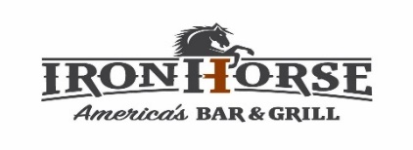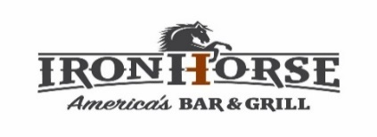
11-3 M-F

Lunch Menu
5317 W. 151st Street Leawood KS 66224 - 913.701.6943 for Carry Out of Curbside Orders
Pick 2 for $11 Combo
- ½ Order Chicken Strips - freshly breaded chicken cooked to golden perfection
- Salmon Cakes – 2 salmon patties made from fresh salmon, lemon dill, diced onions, egg and panko breadcrumbs
- Cup of “Rustic” Onion Soup - caramelized yellow onions in a bold beef stock covered in melted swiss cheese and a side of Texas toast - Add $3 for Bowl
- Cup of Creamy Tomato Soup - roasted ripe tomatoes, sauteed yellow onions, carrots, blended with cream then strained for that ultra-creamy soup – Add $3 for Bowl
- ½ Iron Horse Grilled Cheese - whiskey bacon marmalade (chefs’ secret recipe) fresh guacamole and balsamic marinated tomatoes with Havarti cheese on grilled Texas Toast
- ½ Iron Horse Burnt End Chili - a western style smoky chili made with burnt ends cut from our in-house smoke brisket with fresh herbs, roasted chilies, spices, and tomatoes in a rich beef base topped with sour cream, shredded cheddar cheese and scallions
- Side Salad - Fresh cut lettuce, ripe tomatoes, shredded carrots, red onion and shredded cheddar cheese with your choice of dressing (ranch, honey mustard, avocado creame, balsamic vinaigrette, jalapeno ranch)
- Full Side Order of Roasted Root Vegetables
- Full Side Order of Fresh Fruit Cup
- Full Side Order of Honey Glazed Carrots
- Full Side Order of Smoked Gouda Mac-N-Chez
- Full Side Order of Layered Au Gratin Potato with shredded cheese, bacon, cheese sauce, and thinly sliced onions
- Full Side Order of Freshly Sliced Potato Chips
- Full Side Order of Hand Cut Rosemary Truffle Fries
- Full Side Order of Toasted Parm Broccoli - florets sauteed w/butter, parmesan breading, and grated parm cheese

Lunch Specials
- The Great American Burger - a 1/2 pound of fresh Angus ground chuck, cheese (American, Pepper Jack, Swiss, Cheddar, Havarti) lettuce, fresh ripe tomato, red onion, and pickles on a grilled potato bun w/house made chips - 13
- Fish Sandwich - crispy Atlantic Cod cooked to perfection served on a toasted potato bun with lettuce, tomato and onion with our house made dill caper tartar sauce and chips on the side -11
- Iron Horse Chili Dog - ¼ lb all beef frank smothered in “Iron Horse” Burnt End Chili tucked in a toasted bun with shredded cheddar cheese, diced red onions, and diced jalapenos on the side - 11
- Rosemary Grilled Chicken - a fresh rosemary marinated grilled chicken breast served with cilantro and lime rice - 13
- Spicy Bacon Ranch Chicken Sandwich - grilled rosemary chicken, topped with jalapeno ranch, crisp lettuce, tomato, red onion, strips of applewood bacon & pepper jack cheese on a toasted potato bun w/ house made chips - 13
- Fish N’ Chips - crispy beer battered fresh cod fried to perfection served with house made dill caper sauce and a side of house made chips - 12

